

CAPSTONE PROJECT REPORT
Report 4 – Software Design Specification

– Hanoi, June 2026 –

Table of Contents
I. Record of Changes 3
II. Software Design Document 4
1. High Level Design 4
1.1 Software Architecture 4
1.2 Package Diagram 4
1.3 Database Design 5
2. Detailed Design 7
2.1 <Feature/Function Name1> 7
2.2 <Feature/Function Name2> 8
3. Class Specifications 8
3.1 package_name1 8
4. Other Design Specifications 9

I. Record of Changes
Date | A*  M, D | In charge | Change Description
*A - Added M - Modified D - Deleted

II. Software Design Document

1. High Level Design

1.1 Software Architecture

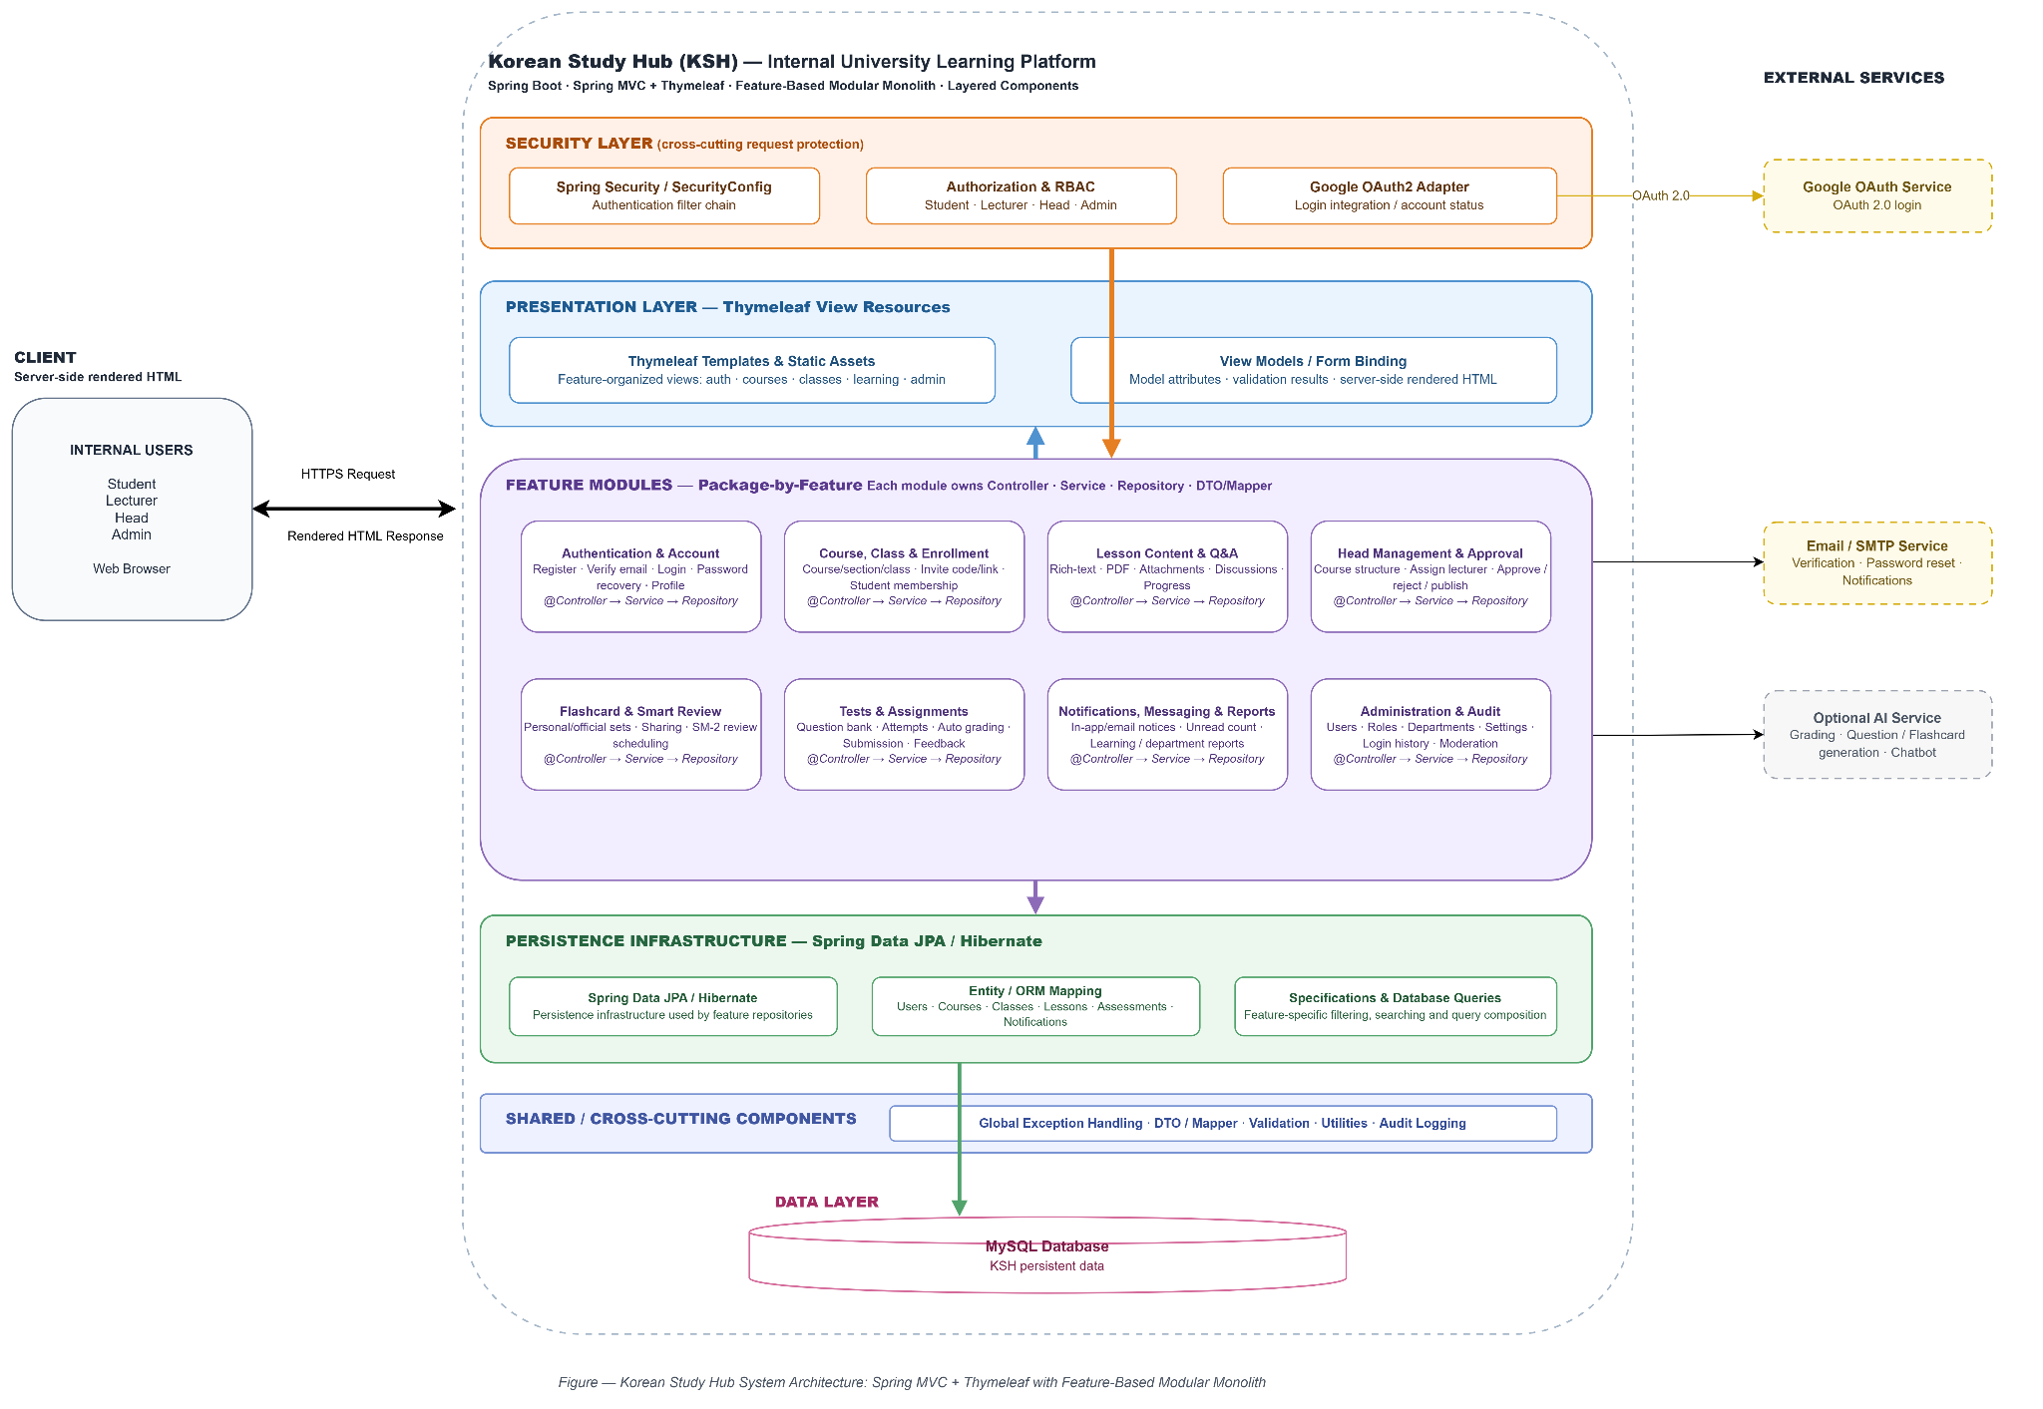 -

1.2 Package Diagram
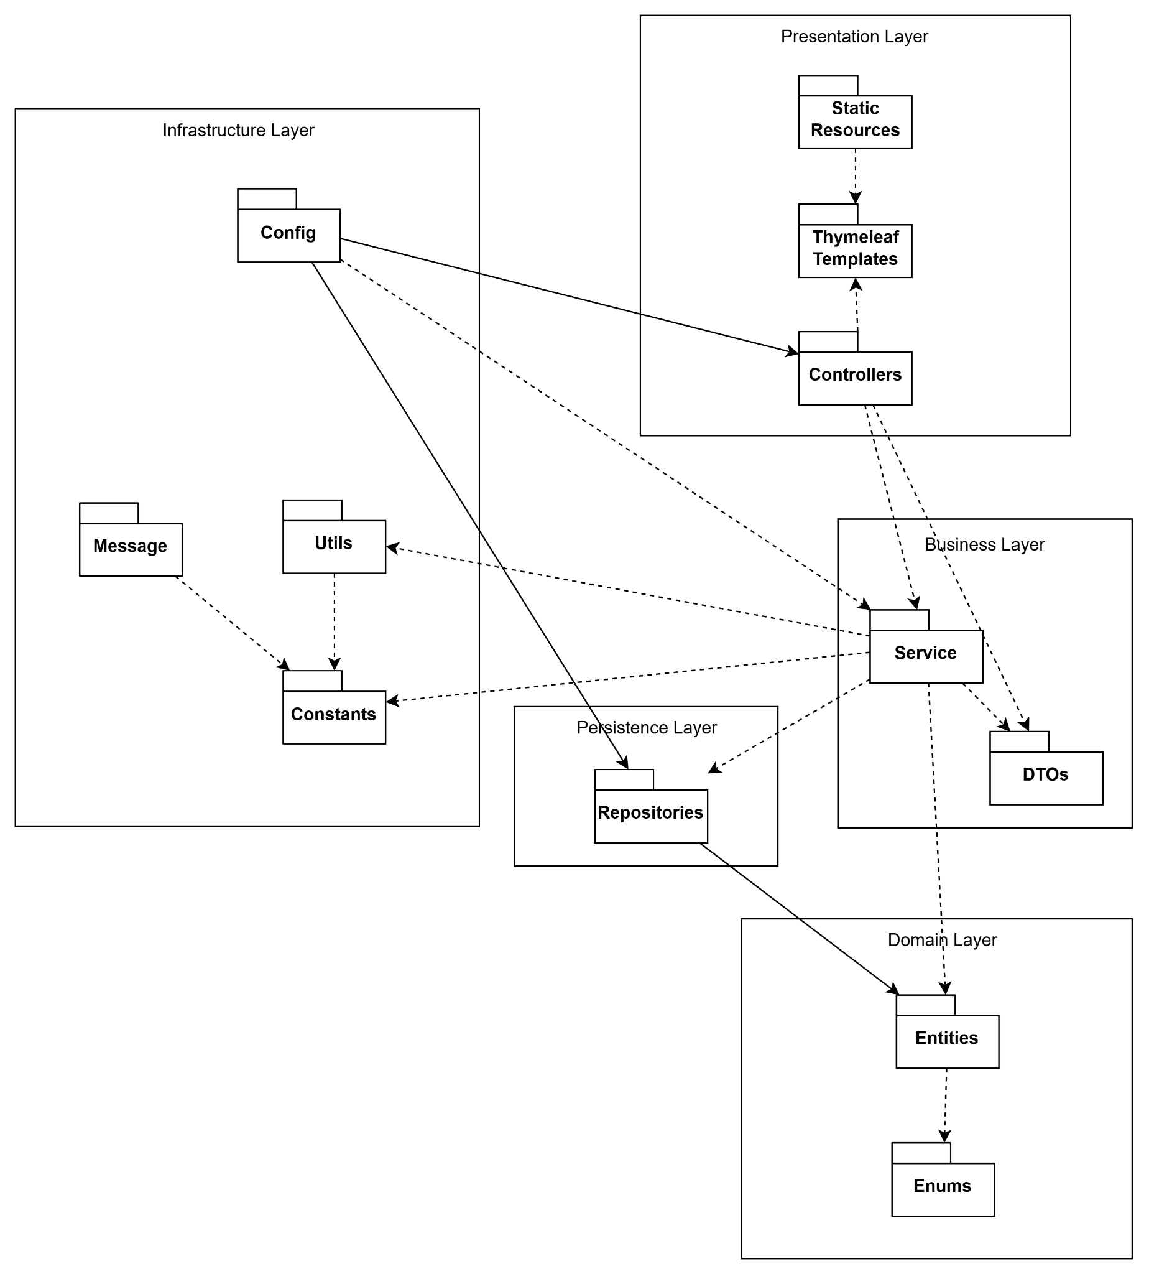

Package descriptions
No | Package | Description
01 | Config | Contains application configuration classes, including Spring Security, JWT authentication, Web MVC configuration, and other system-level settings.
02 | controller | Handles HTTP requests from users, processes input data, invokes business services, and returns Thymeleaf views or responses.
03 | service | Contains business logic and application workflows. Coordinates data processing between controllers, repositories, and other components.
04 | repository | Provides data access functionality using Spring Data JPA. Responsible for querying and persisting data to the database.
05 | entities | Contains JPA entity classes representing business objects and database tables.
06 | dto | Contains Data Transfer Objects used for transferring data between layers and reducing direct exposure of entities.
07 | enums | Defines enumeration types used throughout the system, such as user roles, account status, course status, and premium status.
08 | constant | Stores application-wide constant values, including configuration keys, system parameters, and fixed values.
09 | message | Stores system messages, validation messages, error messages, and user-facing notification content.
10 | utils | Provides reusable utility classes and helper functions such as file processing, date handling, string manipulation, and common operations.
11 | templates | Contains Thymeleaf view templates used to render user interfaces for learners, managers, and administrators.
12 | static | Contains static frontend resources including CSS, JavaScript, images, audio files, and uploaded content.

1.3 Database Design
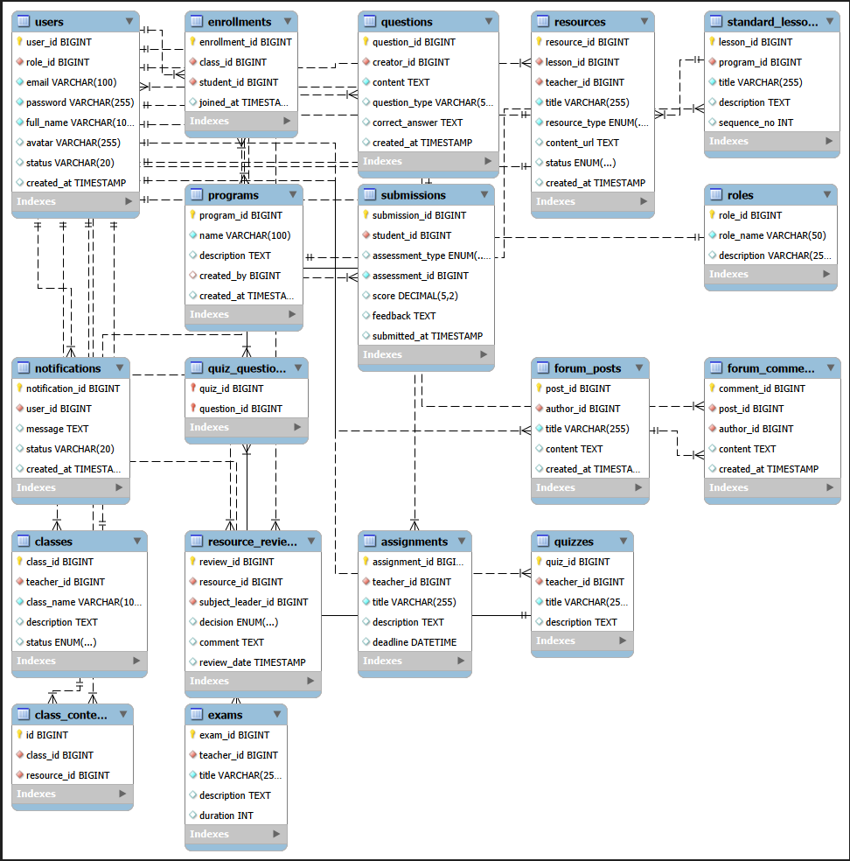

1.3.1 roles

No | Field | PK | FK | UN | NN | Description
01 | id | x |  |  | x | Unique auto-incrementing identifier for each role.
02 | name |  |  | x | x | Role name
03 | description |  |  |  |  | Detailed description of the role's permissions.

1.3.2 users

No | Field | PK | FK | UN | NN | Description
01 | id | x |  |  | x | Unique auto-incrementing identifier for each user account.
02 | role_id |  | x |  | x | FK linking to role(id) to define user permissions.
03 | user_name |  |  | x | x | Unique username for account login.
04 | email |  |  | x | x | Unique email address for login and password recovery.
05 | password_hash |  |  |  | x | Securely hashed password string.
06 | full_name |  |  |  |  | User's complete legal name.
07 | avatar_url |  |  |  |  | URL path to the user's profile image.
08 | is_active |  |  |  | x | Account status flag (active or banned). Defaults to TRUE.
09 | is_premium |  |  |  | x | Premium account status flag. Defaults to FALSE.
10 | premium_expires_at |  |  |  |  | Expiration date of the premium subscription (NULL if free user).
11 | email_verified |  |  |  | x | Email verification status flag. Defaults to FALSE.
12 | created_at |  |  |  | x | Timestamp of account registration.
13 | updated_at |  |  |  | x | Timestamp of the most recent profile update.

1.3.3 password_reset_tokens

No | Field | PK | FK | UN | NN | Description
01 | id | x |  |  | x | Unique identifier for the password reset token record.
02 | user_id |  | x |  | x | FK linking to users (id).
03 | token |  |  | x | x | Unique random string used for secure password reset verification.
04 | expires_at |  |  |  | x | Expiration date and time of the specific token.
05 | used |  |  |  | x | Flag indicating if a token has been consumed. Defaults to FALSE.
06 | created_at |  |  |  | x | Timestamp when the token was requested.

1.3.4 auth_sessions

No | Field | PK | FK | UN | NN | Description
01 | id | x |  |  | x | Unique identifier for the user session.
02 | user_id |  | x |  | x | FK linking to users (id).
03 | refresh_token |  |  | x | x | Unique token used to rotate JWT access tokens.
04 | ip_address |  |  |  |  | IP address of the logged-in client device.
05 | user_agent |  |  |  |  | Browser or device signature details.
06 | expires_at |  |  |  | x | Expiration date and time of the active session.
07 | created_at |  |  |  | x | Timestamp of session initiation.

1.3.5 courses

No | Field | PK | FK | UN | NN | Description
01 | id | x |  |  | x | Unique identifier for the course.
02 | title |  |  |  | x | Name of the Korean course.
03 | description |  |  |  |  | Detailed description of course syllabus and goals.
04 | thumbnail_url |  |  |  |  | URL path to the course cover image.
05 | level |  |  |  | x | Course proficiency tier
06 | is_premium |  |  |  | x | Flag restricting course to premium users. Defaults to FALSE.
07 | is_published |  |  |  | x | Public visibility flag. Defaults to FALSE.
08 | created_by |  | x |  |  | ID of the creator (Admin/Manager).
09 | created_at |  |  |  | x | Timestamp when the course was created.
10 | updated_at |  |  |  | x | Timestamp of the last course content modification.

1.3.6 lessons

No | Field | PK | FK | UN | NN | Description
01 | id | x |  |  | x | Unique identifier for the lesson.
02 | course_id |  | x |  | x | FK linking to courses (id).
03 | title |  |  |  | x | Title of the lesson.
04 | description |  |  |  |  | Brief overview of the lesson content.
05 | section_type |  |  |  | x | Skill focus category
06 | order_index |  |  |  | x | Sorting index for linear curriculum navigation. Defaults to 0.
07 | is_premium |  |  |  | x | Flag restricting lessons to premium users. Defaults to FALSE.
08 | is_published |  |  |  | x | Public visibility flag for the lesson. Defaults to FALSE.
09 | created_at |  |  |  | x | Timestamp when the lesson was created.
10 | updated_at |  |  |  | x | Timestamp of the last lesson metadata modification.

1.3.7 vocabulary_cards

No | Field | PK | FK | UN | NN | Description
01 | id | x |  |  | x | Unique identifier for the vocabulary flashcard.
02 | lesson_id |  | x |  | x | FK linking to lessons (id).
03 | korean_word |  |  |  | x | The vocabulary word in Hangul.
04 | vietnamese_meaning |  |  |  | x | Vietnamese translation/definition of the word.
05 | pronunciation |  |  |  |  | Romanization or International Phonetic Alphabet (IPA) guide
06 | audio_url |  |  |  |  | URL path to pronunciation audio file
07 | example_sentence_kr |  |  |  |  | Korean context example sentence.
08 | example_sentence_vn |  |  |  |  | Vietnamese translation of the context example.
09 | image_url |  |  |  |  | URL path to an illustrative flashcard image.
10 | order_index |  |  |  | x | Display sequence order within the lesson. Defaults to 0.
11 | created_at |  |  |  | x | Timestamp when card was created.
12 | updated_at |  |  |  | x | Timestamp of the last card data update.

1.3.8 vocabulary_progress

No | Field | PK | FK | UN | NN | Description
01 | id | x |  |  | x | Unique identifier for the flashcard progress entry.
02 | user_id |  | x | x | x | FK linking to users (id).
03 | card_id |  | x | x | x | FK linking to vocabulary_cards (id).
04 | status |  |  |  | x | Spaced repetition memory tier
05 | times_reviewed |  |  |  | x | Cumulative review count for this word. Defaults to 0.
06 | last_reviewed |  |  |  |  | Date and time of the last review attempt.
07 | next_review |  |  |  |  | Scheduled target time for next spaced repetition review.
08 | created_at |  |  |  | x | Timestamp when the user first interacted with this card.
09 | updated_at |  |  |  | x | Timestamp of the latest progress update.

1.3.9 grammar_contents

No | Field | PK | FK | UN | NN | Description
01 | id | x |  |  | x | Unique identifier for the grammar structure.
02 | lesson_id |  | x |  | x | FK linking to lessons (id).
03 | title |  |  |  | x | Structural grammar title
04 | explanation |  |  |  | x | Deep pedagogical breakdown of usage rule definitions.
05 | usage_examples |  |  |  |  | Stringified JSON array storing contextual sentence examples.
06 | order_index |  |  |  | x | Display sequence order within the lesson. Defaults to 0.
07 | created_at |  |  |  | x | Timestamp when grammar content was created.
08 | updated_at |  |  |  | x | Timestamp of the last content adjustment.

1.3.10 grammar_exercises

No | Field | PK | FK | UN | NN | Description
01 | id | x |  |  | x | Unique identifier for the grammar practice question.
02 | grammar_id |  | x |  | x | FK linking to grammar_contents (id)
03 | exercise_type |  |  |  | x | Format tier
04 | question |  |  |  | x | The objective question prompt or query string.
05 | correct_answer |  |  |  | x | The correct expected answer string.
06 | options |  |  |  |  | JSON array configuration of options for multiple choice
07 | explanation |  |  |  |  | Answer key rationale text.
08 | order_index |  |  |  | x | Display order of questions in the practice module. Defaults to 0.
09 | created_at |  |  |  | x | Timestamp when question was generated.

1.3.11 listening_contents

No | Field | PK | FK | UN | NN | Description
01 | id | x |  |  | x | Unique identifier for the listening module asset.
02 | lesson_id |  | x |  | x | FK linking to lessons (id).
03 | title |  |  |  | x | Descriptive title for the audio activity.
04 | audio_url |  |  |  | x | URL pointing directly to the reference media track file
05 | transcript |  |  |  |  | Written script of the speech audio content.
06 | show_transcript |  |  |  | x | Setting to display or mask transcript text prior to tasks. Defaults to FALSE.
07 | duration_sec |  |  |  |  | Media file length calculated in seconds.
08 | order_index |  |  |  | x | Navigation order tier for multi-module presentation. Defaults to 0.
09 | created_at |  |  |  | x | Timestamp when the media context profile was initiated.
10 | updated_at |  |  |  | x | Timestamp of the latest media properties update.

1.3.12 listening_questions

No | Field | PK | FK | UN | NN | Description
01 | id | x |  |  | x | Unique identifier for the listening question item.
02 | listening_id |  | x |  | x | FK linking to listening_contents (id).
03 | question |  |  |  | x | Comprehension prompt evaluated against audio playback.
04 | question_type |  |  |  | x | Standard design classification tier. Defaults to 'multiple_choice'.
05 | options |  |  |  | x | Hardcoded JSON list schema containing text options
06 | correct_answer |  |  |  | x | Character matching correct value key ('A', 'B', 'C', or 'D').
07 | order_index |  |  |  | x | Sequencing value index for interactive forms.
08 | created_at |  |  |  | x | Timestamp when question item was created.

1.3.13 reading_passages

No | Field | PK | FK | UN | NN | Description
01 | id | x |  |  | x | Unique identifier for the reading passage body text.
02 | lesson_id |  | x |  | x | FK linking to lessons (id).
03 | title |  |  |  | x | Title headline of the reading story.
04 | content |  |  |  | x | Main body prose text written in Korean for user comprehension.
05 | order_index |  |  |  |  | Positional array hierarchy reference flag. Defaults to 0.
06 | created_at |  |  |  | x | Timestamp when resource text was saved.
07 | updated_at |  |  |  |  | Timestamp when copy modifications last occurred.

1.3.14 reading_questions

No | Field | PK | FK | UN | NN | Description
01 | id | x |  |  | x | Unique identifier for the reading question item.
02 | passage_id |  | x |  | x | FK linking to reading_passages (id).
03 | question |  |  |  | x | Evaluative item question testing comprehension of reading text.
04 | question_type |  |  |  | x | Task strategy classifier logic ('multiple_choice', 'true_false').
05 | options |  |  |  |  | JSON formatting array containing string options (NULL for true/false).
06 | correct_answer |  |  |  | x | Target key resolving item score (e.g. 'A', 'B', 'true', 'false').
07 | order_index |  |  |  | x | Sorting rank coordinate index value within active sheet.
08 | created_at |  |  |  | x | Timestamp of evaluation object initialization.

1.3.15 quizzes

No | Field | PK | FK | UN | NN | Description
01 | id | x |  |  | x | Unique identifier for the test/quiz entity.
02 | lesson_id |  | x |  |  | FK linking to lessons (id).
03 | course_id |  | x |  |  | FK linking to courses (id).
04 | title |  |  |  | x | Test heading name or module classification flag.
05 | quiz_type |  |  |  | x | Evaluative context label ('lesson_quiz', 'final_test').
06 | time_limit_min |  |  |  |  | Countdown duration allowance in minutes (NULL means untimed).
07 | is_published |  |  |  | x | Active release state toggle flag. Defaults to FALSE.
08 | created_at |  |  |  | x | Timestamp of quiz profile definition.
09 | updated_at |  |  |  | x | Timestamp of the most recent modifications to the exam profile.

1.3.16 quiz_questions

No | Field | PK | FK | UN | NN | Description
01 | id | x |  |  | x | Unique identifier for individual quiz questions.
02 | quiz_id |  | x |  | x | FK linking to quizzes (id).
03 | question |  |  |  | x | The core content statement text of the quiz item.
04 | question_type |  |  |  | x | Mechanics class tier ('multiple_choice', 'fill_in_blank', 'matching').
05 | options |  |  |  |  | Complex JSON string options payload array matching options blocks.
06 | correct_answer |  |  |  | x | Answer key template validator string used for grading matching logic.
07 | points |  |  |  | x | Numeric weight scale value earned for a correct response. Defaults to 1.
08 | order_index |  |  |  | x | Sorting array prioritization value configuration.
09 | created_at |  |  |  | x | Timestamp when row entity record was established.

1.3.17 quiz_attempts

No | Field | PK | FK | UN | NN | Description
01 | id | x |  |  | x | Unique identifier for a single quiz performance event instance.
02 | user_id |  | x |  | x | FK linking to users (id).
03 | quiz_id |  | x |  | x | FK linking to quizzes (id).
04 | score |  |  |  |  | Score earned expressed as a percentage value (0.00 to 100.00).
05 | total_points |  |  |  |  | Sum total achievable weight matrix capability of the exam.
06 | earned_points |  |  |  |  | Absolute raw tally aggregate point score captured by candidate.
07 | passed |  |  |  |  | Score metric evaluation target resolution status flag.
08 | started_at |  |  |  | x | Automated date tracker mapping start clock initialization.
09 | submitted_at |  |  |  |  | Complete terminal submission date record validation.
10 | attempt_number |  |  |  | x | Count track monitoring user re-tests. Must equal 1 for final_test.

1.3.18 quiz_answers

No | Field | PK | FK | UN | NN | Description
01 | id | x |  |  | x | Unique tracking record mapped to individual response items.
02 | attempt_id |  | x |  | x | FK linking to quiz_attempts (id).
03 | question_id |  | x |  | x | FK linking to quiz_questions (id).
04 | user_answer |  |  |  |  | Pure response string captured via input fields or radio buttons.
05 | is_correct |  |  |  |  | Evaluation indicator matching key criteria accuracy profile flag.
06 | points_earned |  |  |  | x | Segmented points matrix value yield capture profile. Defaults to 0.

1.3.19 leaderboard_snapshots

No | Field | PK | FK | UN | NN | Description
01 | id | x |  |  | x | Unique serial record value code identifier.
02 | user_id |  | x | x | x | FK linking to users (id).
03 | course_id |  | x | x | x | FK linking to courses (id).
04 | total_score |  |  |  | x | Accumulated point matrix profile calculated for a user. Defaults to 0.
05 | rank |  |  |  |  | Computed leaderboard placement within the specified course.
06 | updated_at |  |  |  | x | Timestamp of the last metric indexing update.

1.3.20 lesson_progress

No | Field | PK | FK | UN | NN | Description
01 | id | x |  |  | x | Unique database track assignment index token.
02 | user_id |  | x | x | x | FK linking to users (id).
03 | lesson_id |  | x | x | x | FK linking to lessons (id).
04 | status |  |  |  | x | Course lifecycle tracker metric ('not_started', 'in_progress', 'completed').
05 | completed_at |  |  |  |  | Specific timestamp tracking final page flag completion.
06 | created_at |  |  |  | x | Record initialization stamp tracker code.
07 | updated_at |  |  |  | x | Most recent active progression tracking update state.

1.3.21 course_progress

No | Field | PK | FK | UN | NN | Description
01 | id | x |  |  | x | Unique table sequence indicator index asset.
02 | user_id |  | x | x | x | FK linking to users (id).
03 | course_id |  | x | x | x | FK linking to courses (id).
04 | total_lessons |  |  |  | x | Snapshot calculation tracking absolute course asset list count.
05 | completed_lessons |  |  |  | x | Cumulative counter recording verified completed unit structures.
06 | completed_lessons |  |  |  | x | Calculated ratio of progress metric depth (0.00 to 100.00).
07 | status |  |  |  | x | Registration workflow stage label ('enrolled', 'in_progress', 'completed').
08 | enrolled_at |  |  |  | x | Timestamp recording initial course registration.
09 | completed_at |  |  |  |  | Target confirmation timestamp verifying fulfillment of graduation rules.

1.3.22 premium_plans

No | Field | PK | FK | UN | NN | Description
01 | id | x |  |  | x | Unique identifier for the subscription item package.
02 | name |  |  |  | x | Subscription tier tier title profile identity
03 | duration_days |  |  |  | x | Days of entitlement granted by plan purchase.
04 | price |  |  |  | x | Monetary value specification parameter requirement mapping fee.
05 | currency |  |  |  | x | Standardization label code parameter tracking value. Defaults to 'VND'.
06 | is_active |  |  |  | x | ales availability status control toggle. Defaults to TRUE.
07 | created_at |  |  |  | x | System timestamp documenting initial layout construction.

1.3.23 payment_transactions

No | Field | PK | FK | UN | NN | Description
01 | id | x |  |  | x | Unique system transaction sequence reference ledger token.
02 | used_id |  | x |  | x | FK linking to users (id).
03 | plan_id |  | x |  | x | FK linking to premium_plans (id).
04 | amount |  |  |  | x | Absolute currency collection weight metric tracking total cost paid.
05 | currency |  |  |  | x | Denomination unit label code parameter metric. Defaults to 'VND'.
06 | gateway |  |  |  |  | Target settlement processor label identity
07 | gateway_tx_id |  |  |  |  | External audit clearing number tracked from merchant services.
08 | status |  |  |  | x | Settlement progress condition label
09 | payment_request_at |  |  |  | x | Timestamp marking when payment checkout process started.
10 | payment_result_at |  |  |  |  | Timestamp capturing the exact response processing callback.
11 | created_at |  |  |  | x | Internal system ledger database creation log index tracking timestamp.

1.3.24 premium_subscriptions

No | Field | PK | FK | UN | NN | Description
01 | id | x |  |  | x | Unique identity serial record tracking ledger.
02 | user_id |  | x | x | x | Unique (1-1) FK linking to users (id)
03 | plan_id |  | x |  | x | FK linking premium_plans (id).
04 | transaction_id |  | x |  |  | Fk linking to payment_transactions (id)
05 | starts_at |  |  |  | x | Timestamp marking validation clock start boundary.
06 | expires_at |  |  |  | x | Subscription end date boundary confirming transition to free status.
07 | is_active |  |  |  | x | Functional feature gating validator parameter flag. Defaults to TRUE.
08 | created_at |  |  |  | x | Registration entry tracking record generation event time.
09 | updated_at |  |  |  | x | Active extension tracking update timestamp.

1.3.25 audit_logs

No | Field | PK | FK | UN | NN | Description
01 | id | x |  |  | x | Unique identifier for the subscription item package.
02 | name |  |  |  | x | Subscription tier tier title profile identity
03 | duration_days |  |  |  | x | Days of entitlement granted by plan purchase.
04 | price |  |  |  | x | Monetary value specification parameter requirement mapping fee.
05 | currency |  |  |  | x | Standardization label code parameter tracking value. Defaults to 'VND'.
06 | is_active |  |  |  | x | ales availability status control toggle. Defaults to TRUE.
07 | created_at |  |  |  | x | System timestamp documenting initial layout construction.

1.3.26 system_configs

No | Field | PK | FK | UN | NN | Description
01 | id | x |  |  | x | Unique identifier for the subscription item package.
02 | name |  |  |  | x | Subscription tier tier title profile identity
03 | duration_days |  |  |  | x | Days of entitlement granted by plan purchase.
04 | price |  |  |  | x | Monetary value specification parameter requirement mapping fee.
05 | currency |  |  |  | x | Standardization label code parameter tracking value. Defaults to 'VND'.
06 | is_active |  |  |  | x | ales availability status control toggle. Defaults to TRUE.
07 | created_at |  |  |  | x | System timestamp documenting initial layout construction.

1.3.27 system_notifications

No | Field | PK | FK | UN | NN | Description
01 | id | x |  |  | x | Unique identifier for the subscription item package.
02 | name |  |  |  | x | Subscription tier tier title profile identity
03 | duration_days |  |  |  | x | Days of entitlement granted by plan purchase.
04 | price |  |  |  | x | Monetary value specification parameter requirement mapping fee.
05 | currency |  |  |  | x | Standardization label code parameter tracking value. Defaults to 'VND'.
06 | is_active |  |  |  | x | ales availability status control toggle. Defaults to TRUE.
07 | created_at |  |  |  | x | System timestamp documenting initial layout construction.

1.3.28 content_reviews

No | Field | PK | FK | UN | NN | Description
01 | id | x |  |  | x | Unique identifier for the subscription item package.
02 | name |  |  |  | x | Subscription tier tier title profile identity
03 | duration_days |  |  |  | x | Days of entitlement granted by plan purchase.
04 | price |  |  |  | x | Monetary value specification parameter requirement mapping fee.
05 | currency |  |  |  | x | Standardization label code parameter tracking value. Defaults to 'VND'.
06 | is_active |  |  |  | x | ales availability status control toggle. Defaults to TRUE.
07 | created_at |  |  |  | x | System timestamp documenting initial layout construction.

2. Detailed Design

2.1 Authentication

2.1.1 Class Diagram
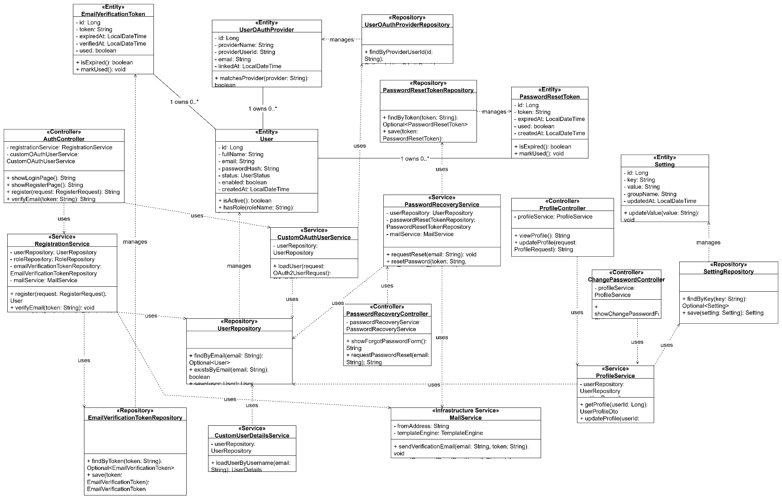

2.1.1 Login by email and password
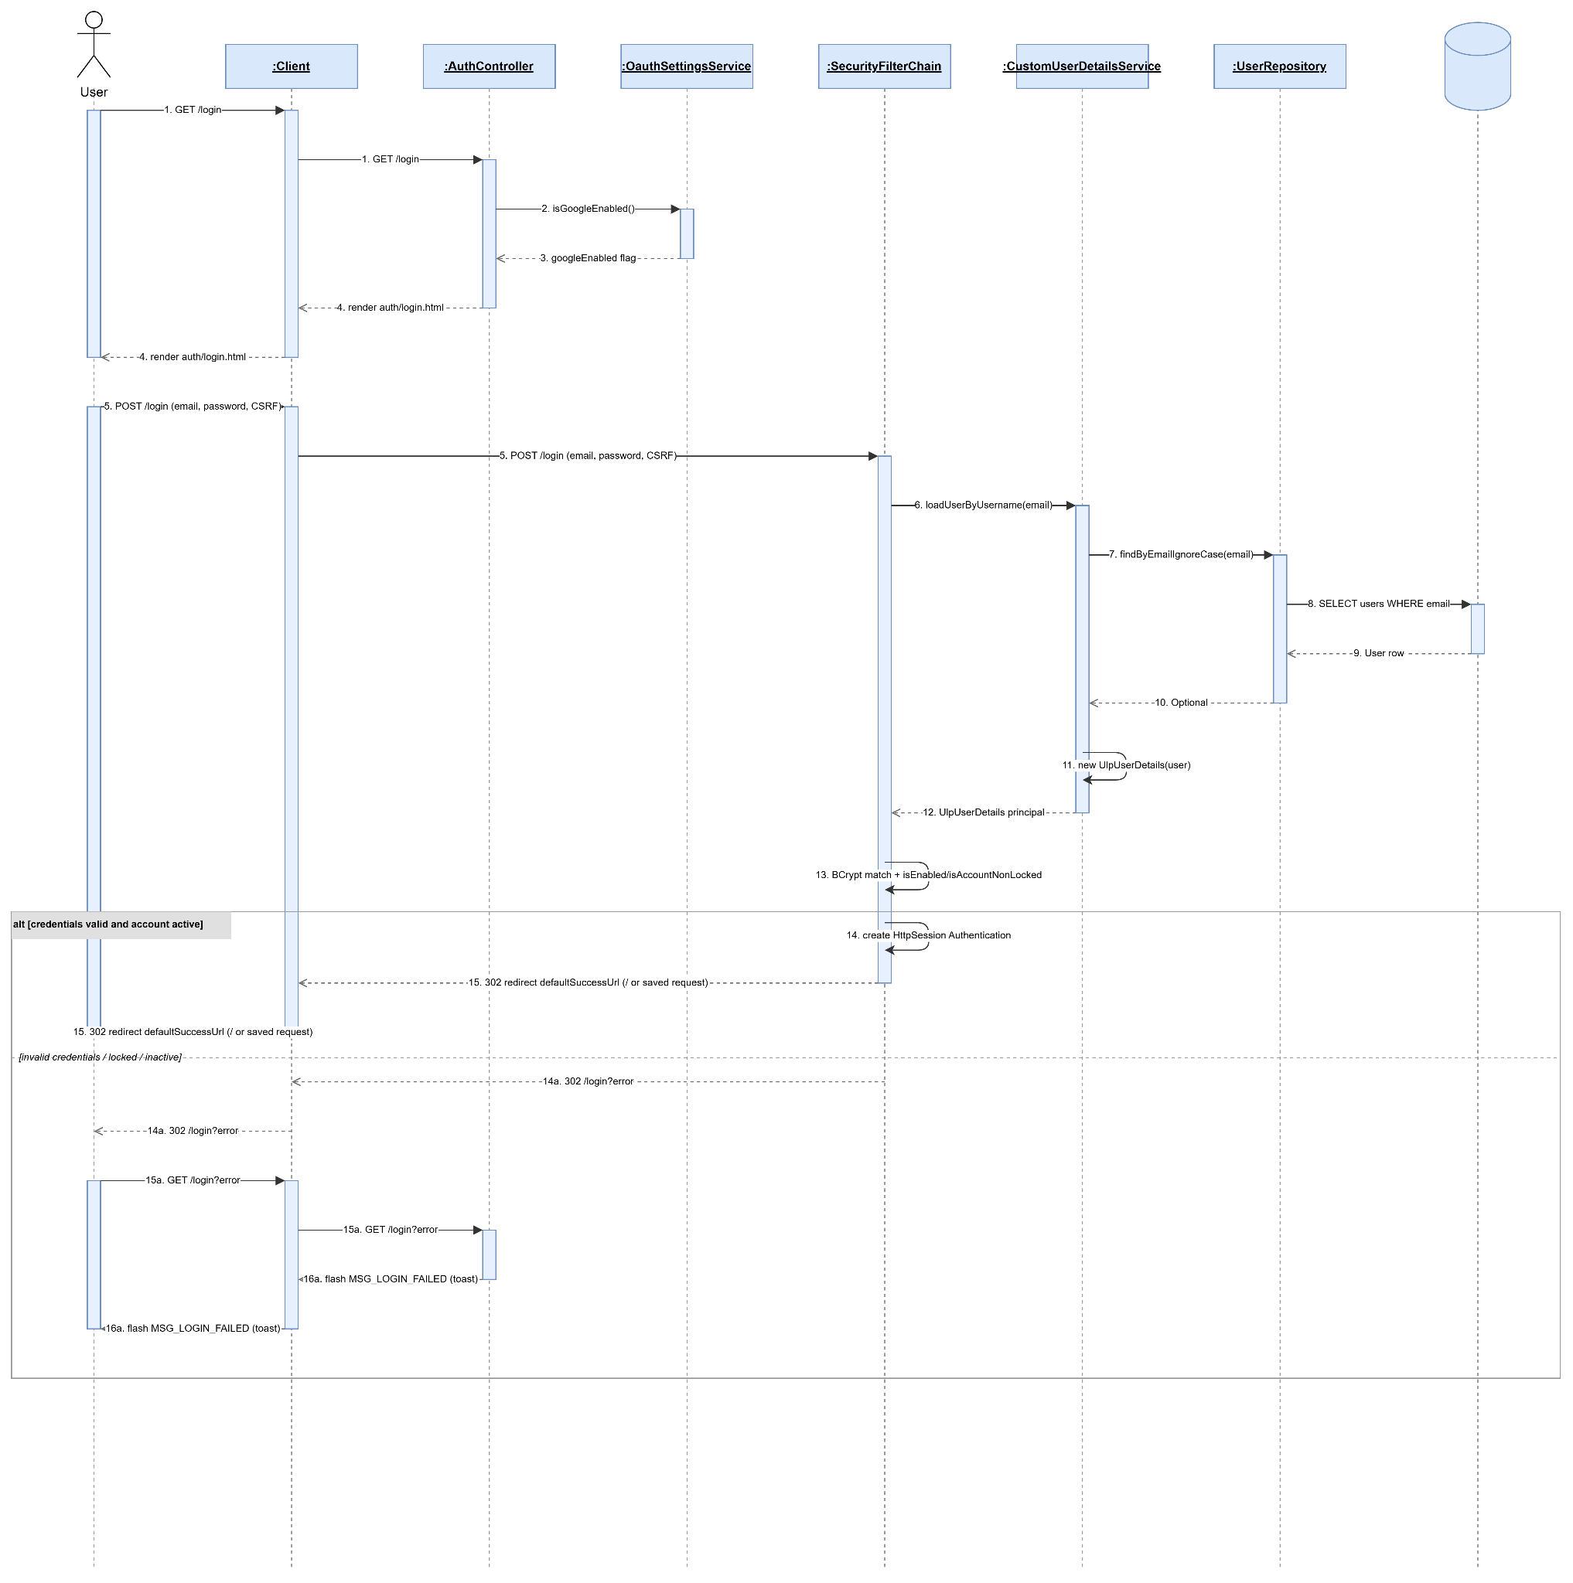

2.1.2 Login by gg authentication

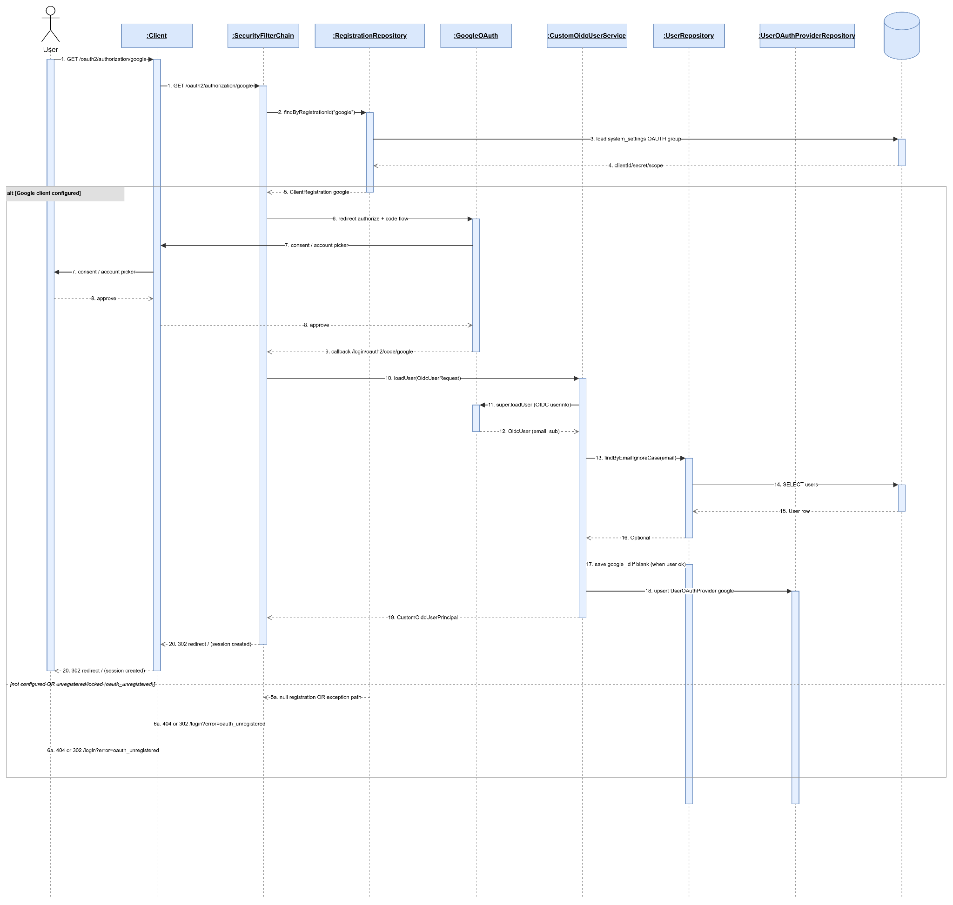

2.1.3 Reset password

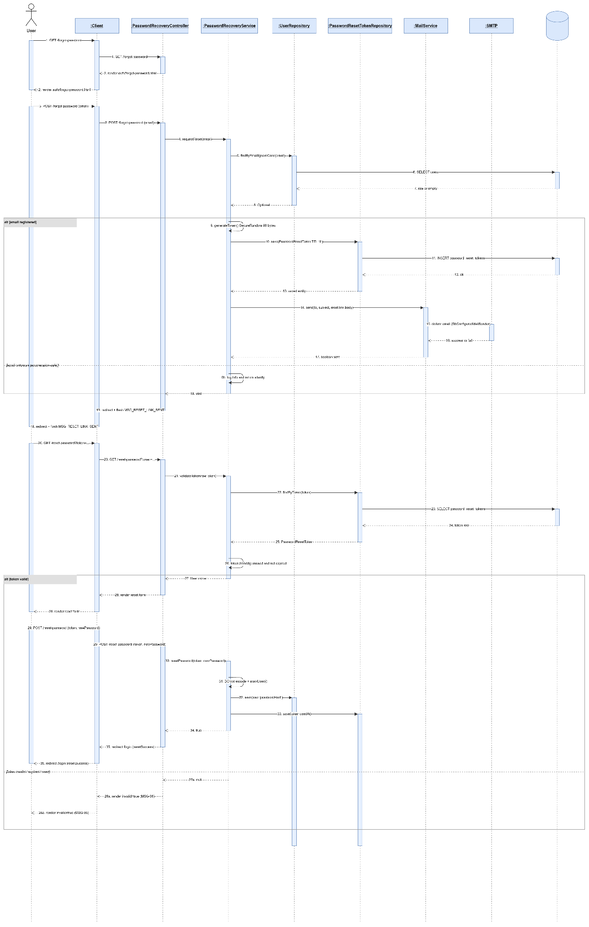

2.2 Manage Class

2.2.1 Class Diagram
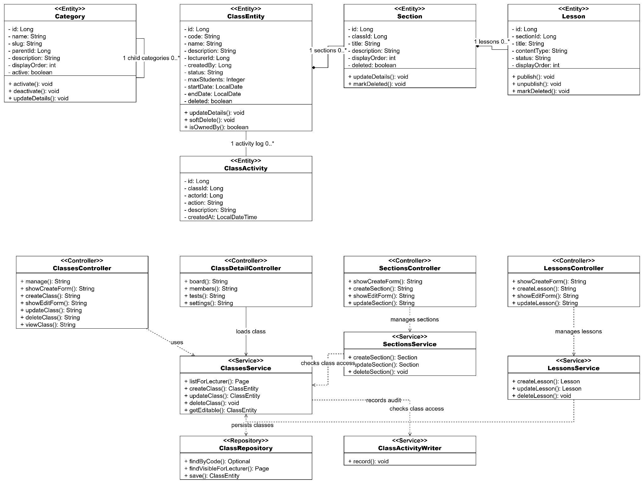

2.2.1 Create class
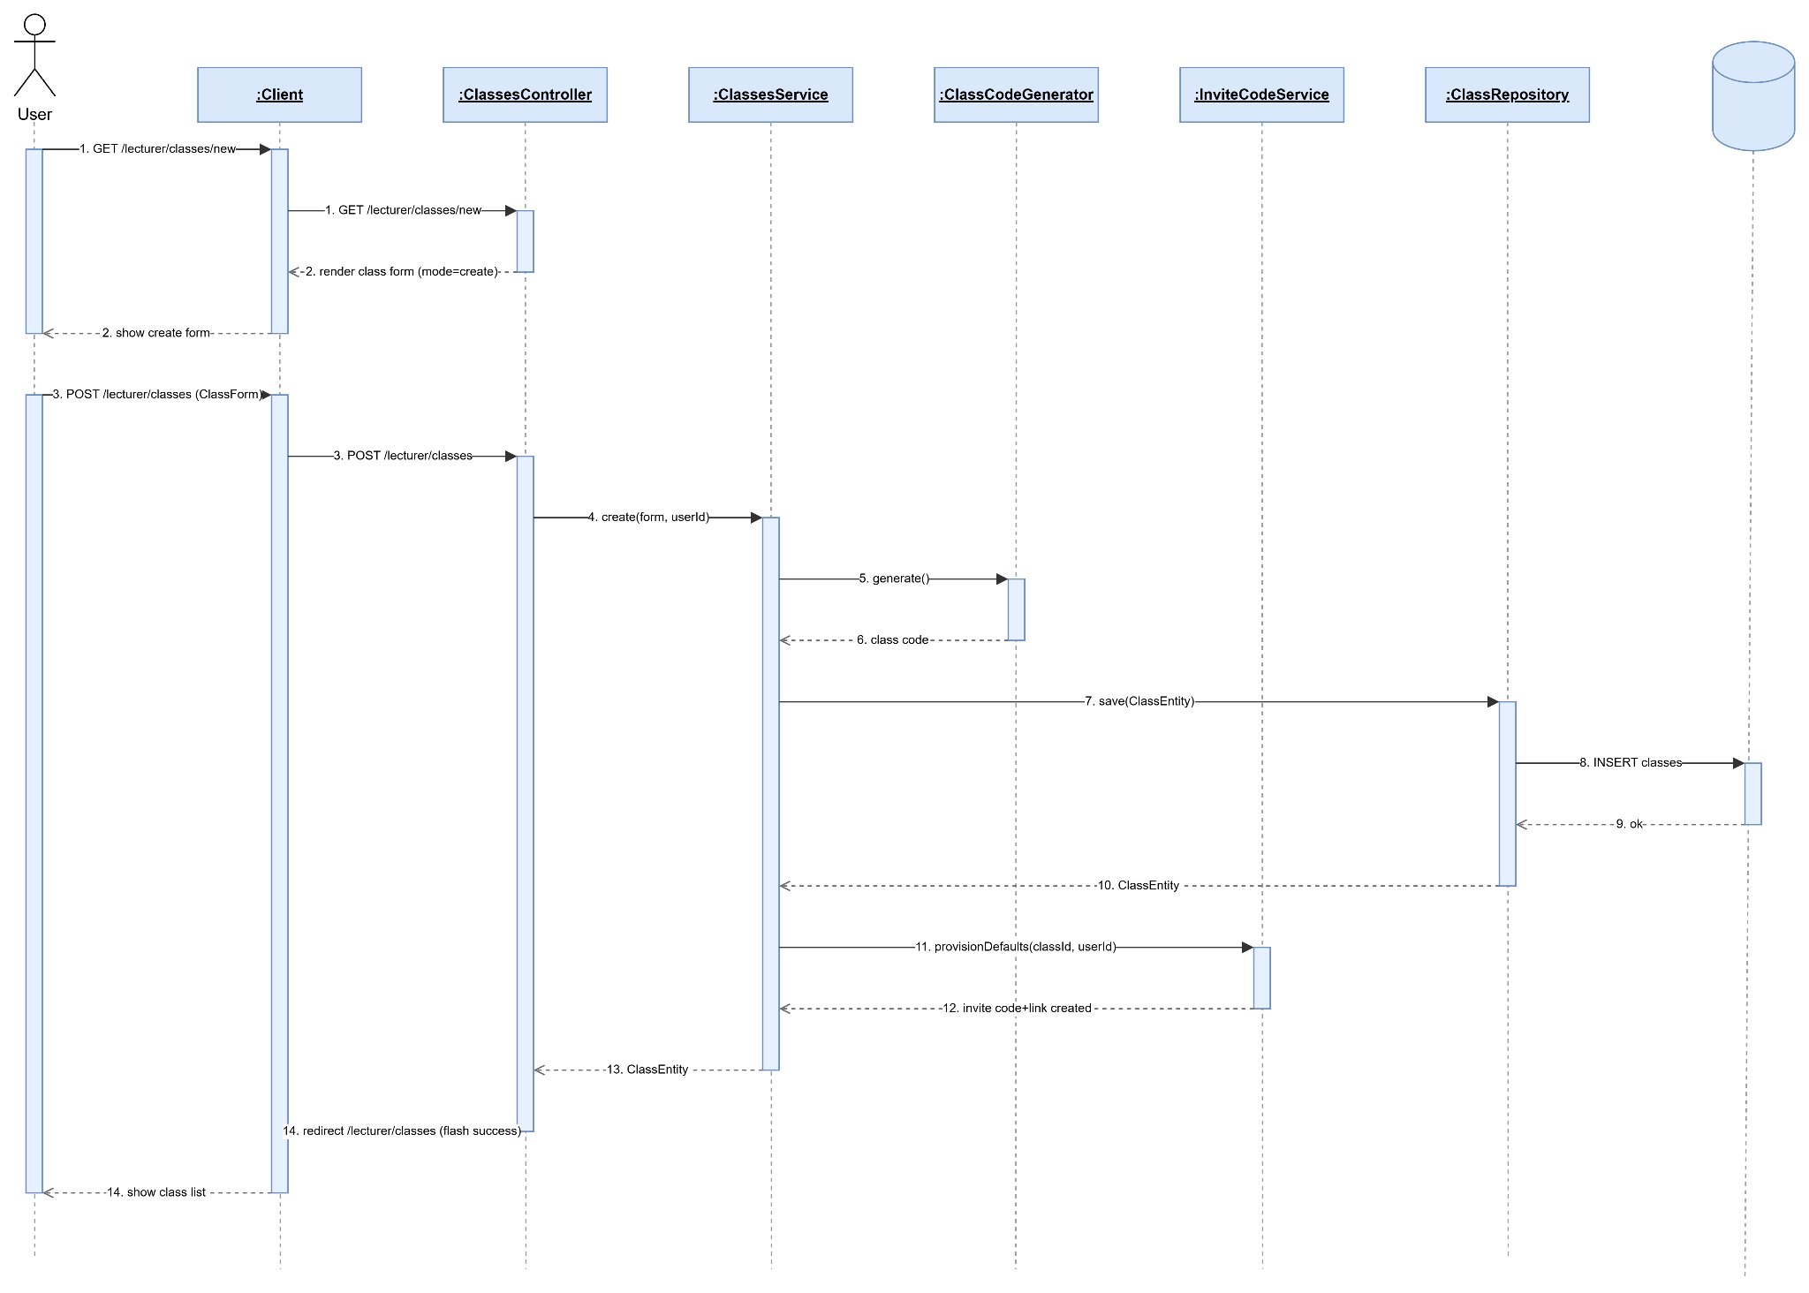

2.2.2 View Own Class (Lecturer)
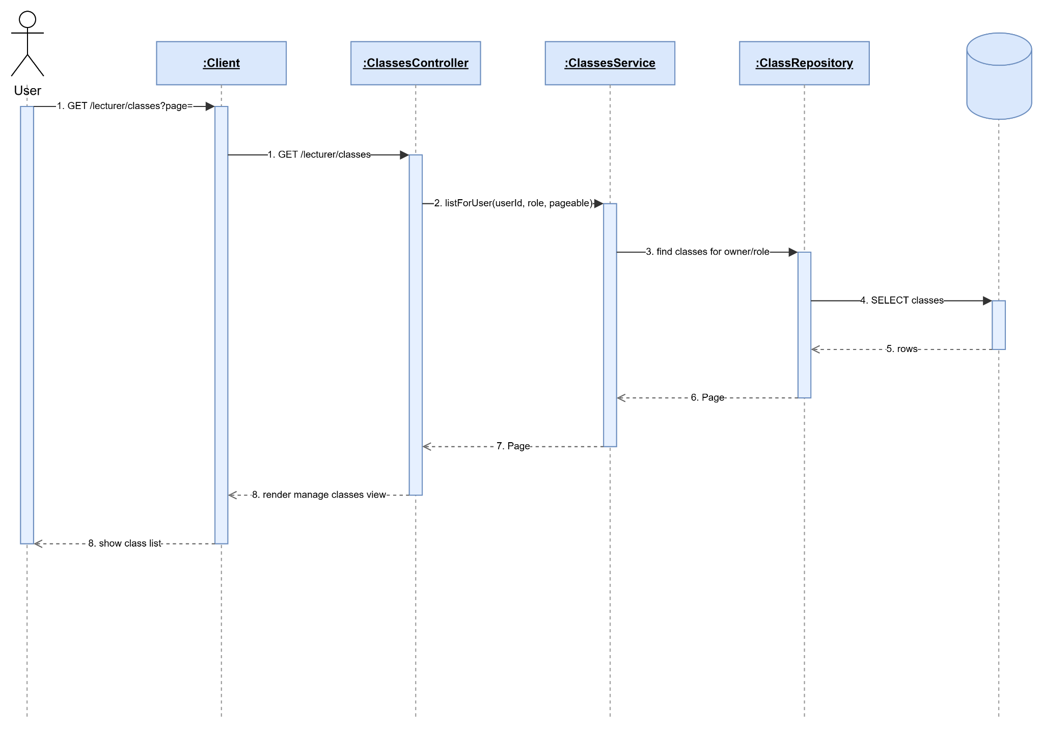

2.2.3. Update class
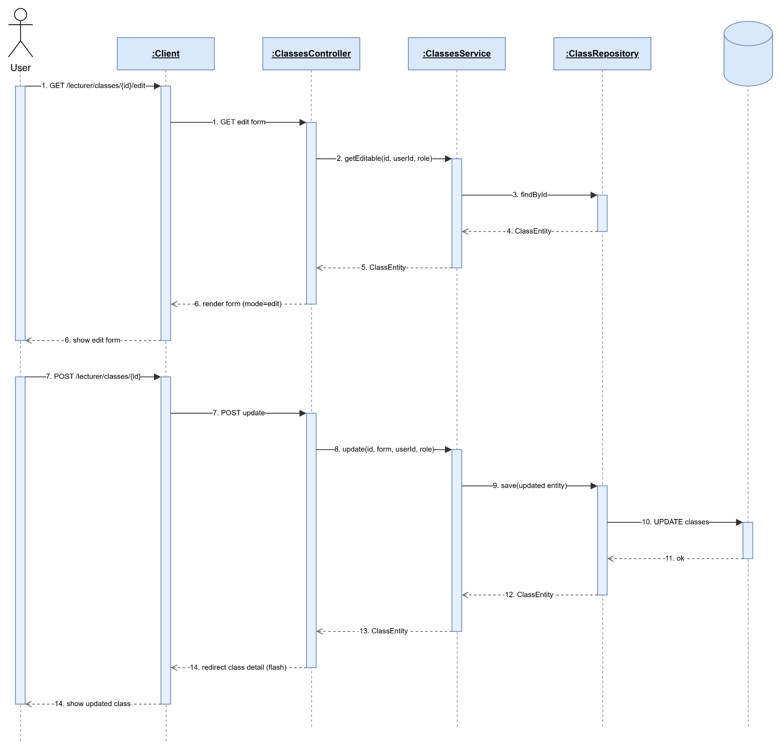

2.2.4. Delete class
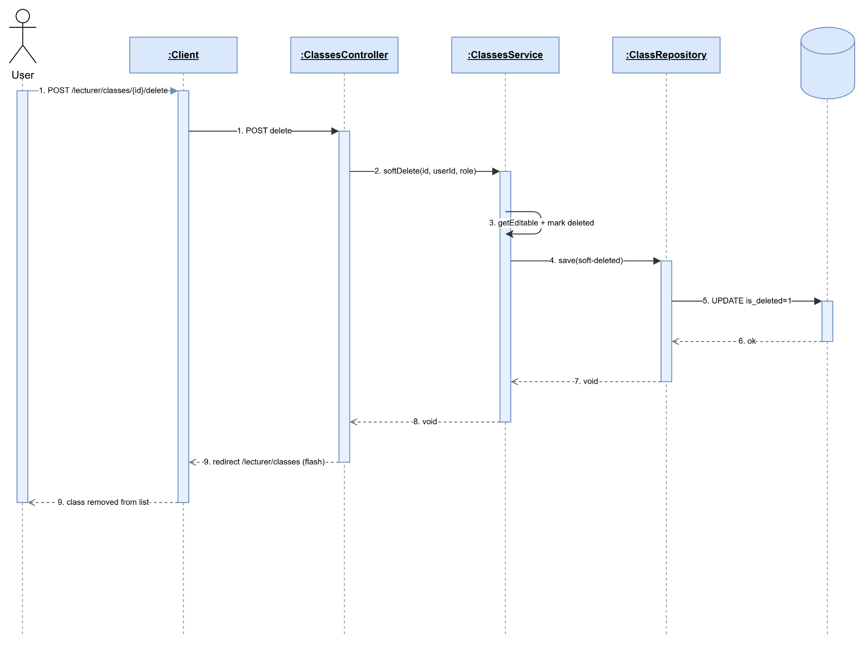

2.2.5 View Join Class
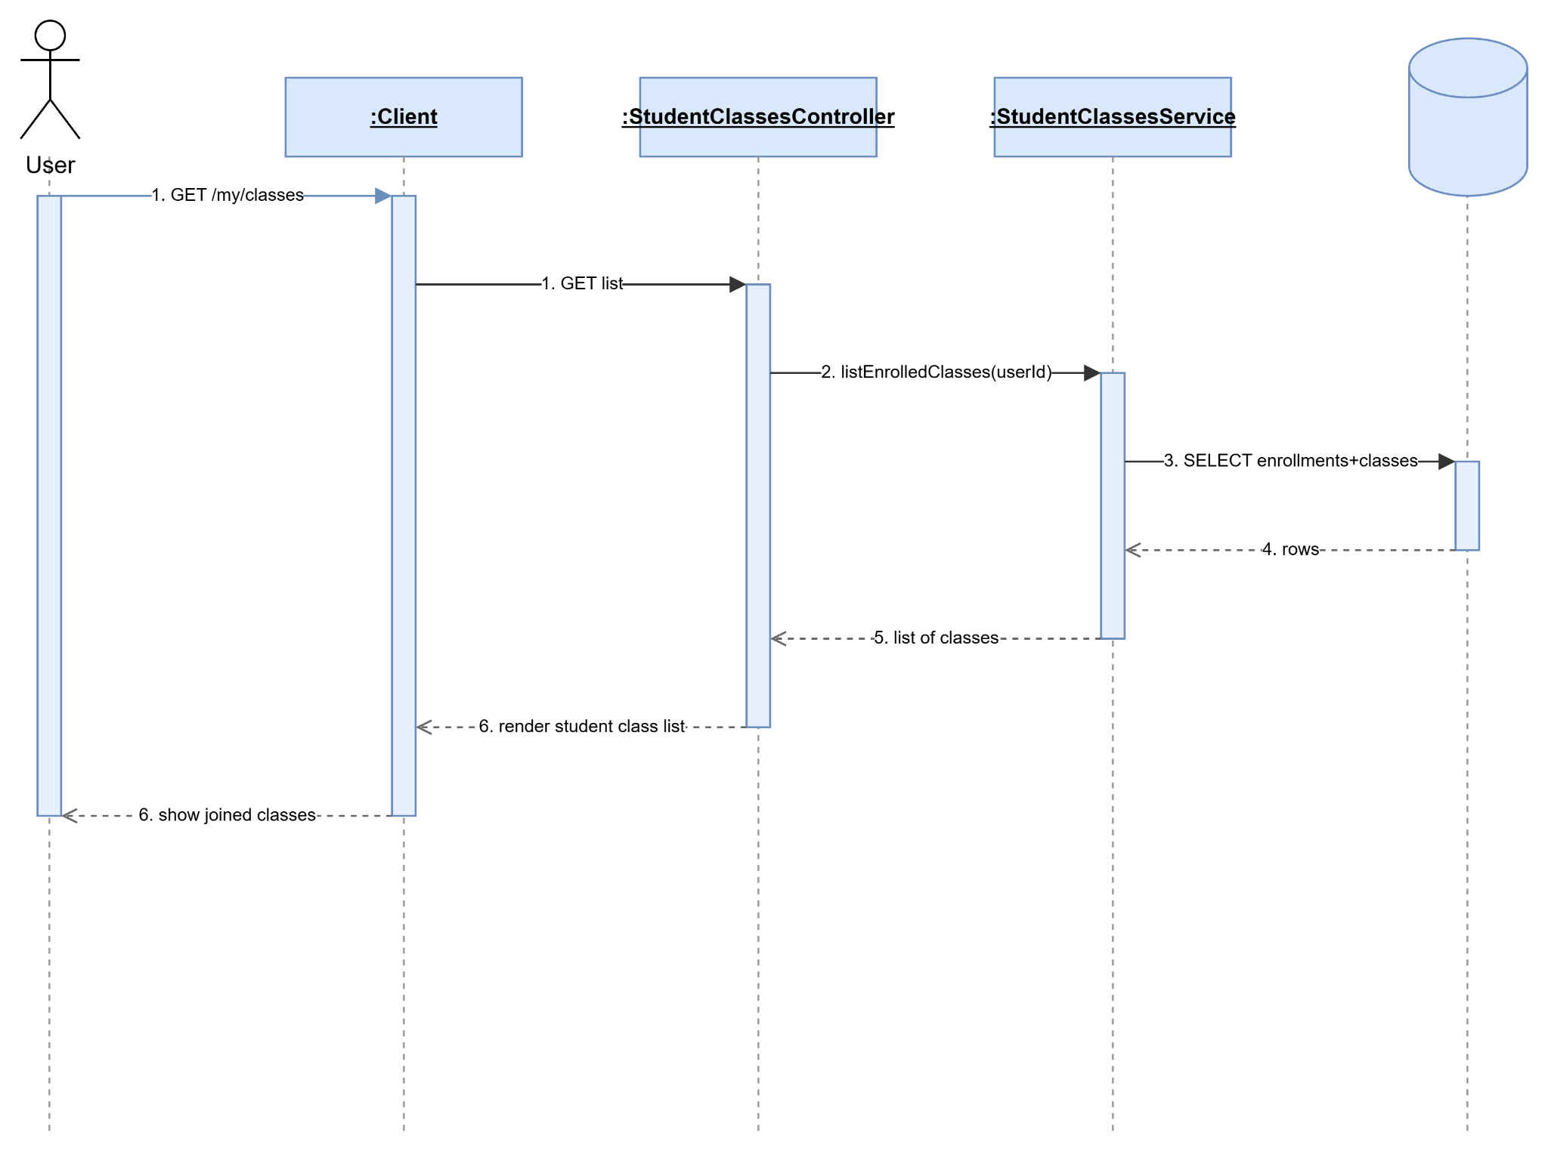

2.2.6 Join Class
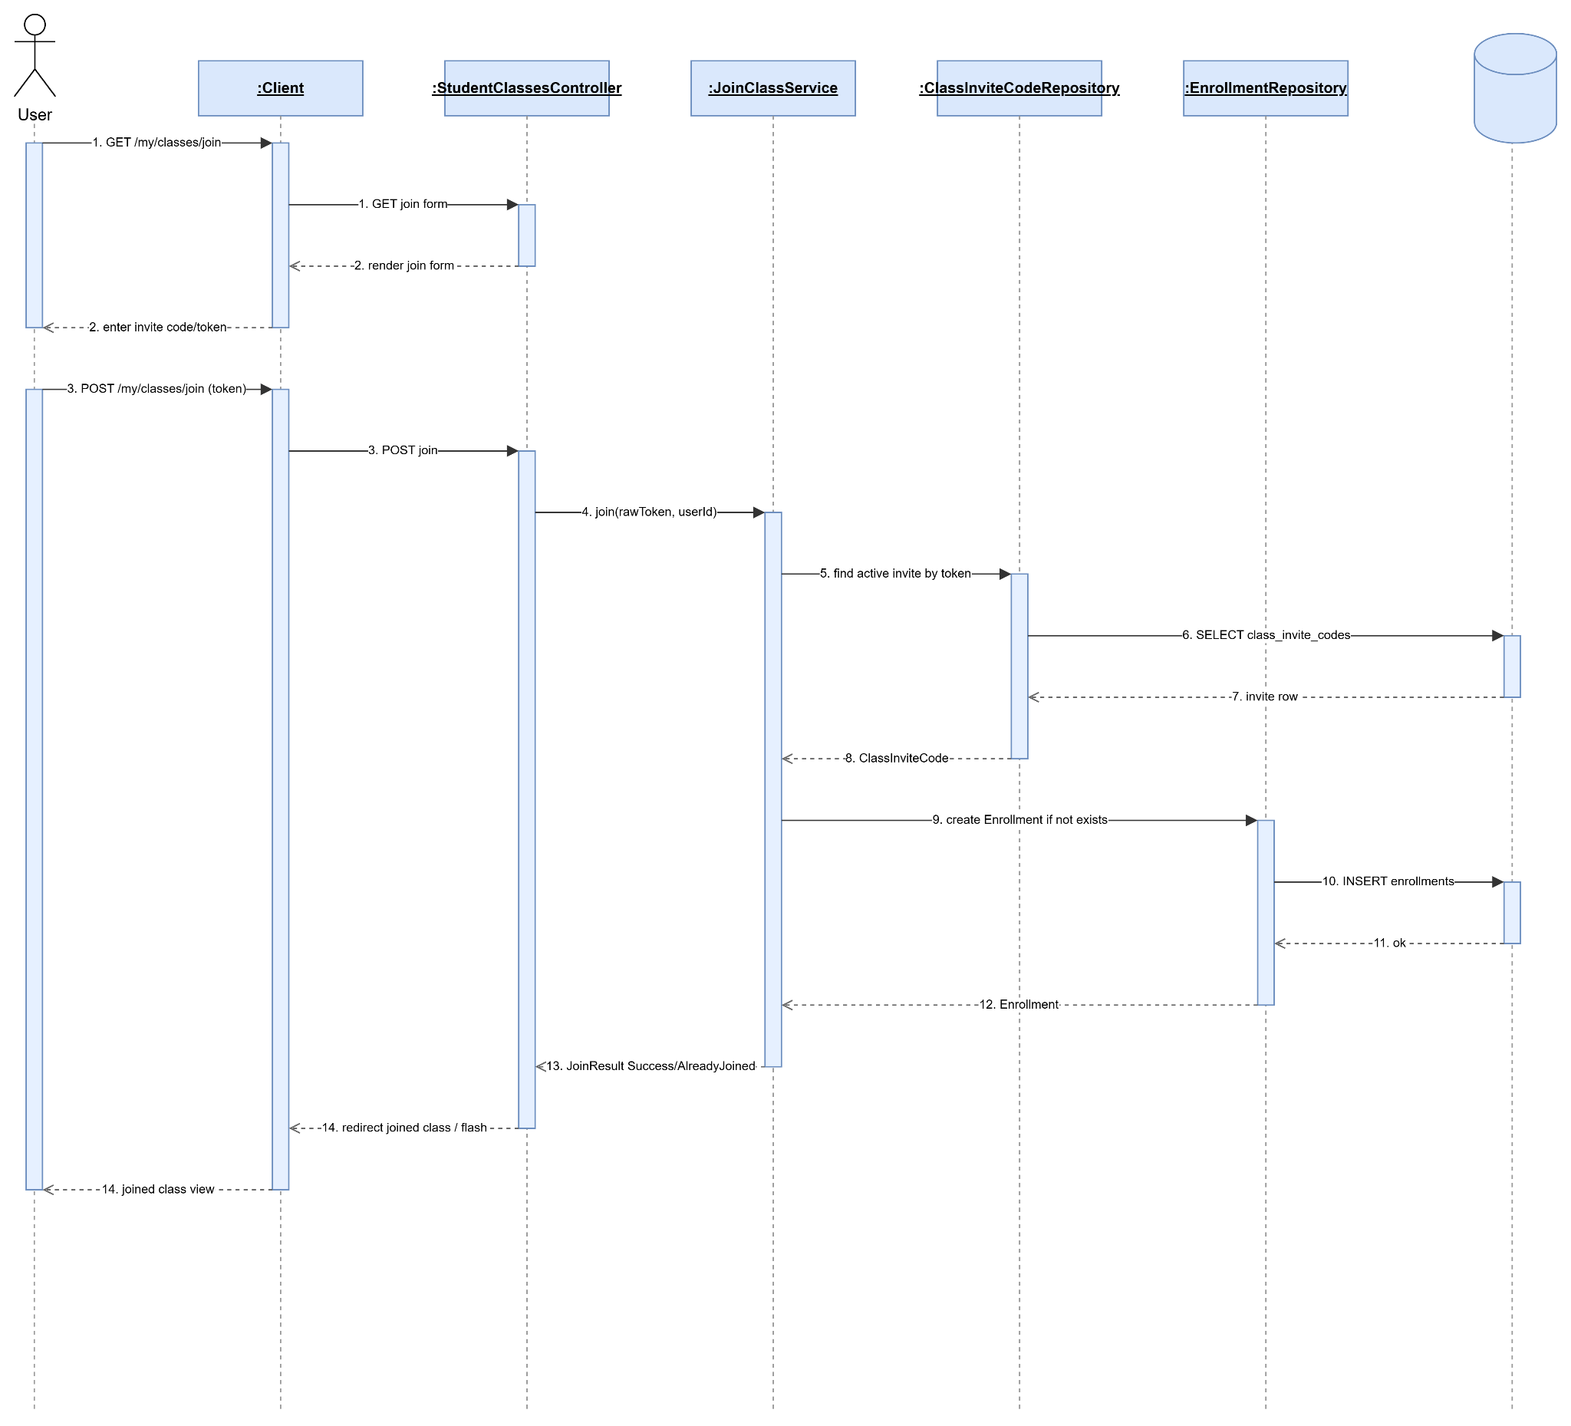

2.2.7 Leave Class
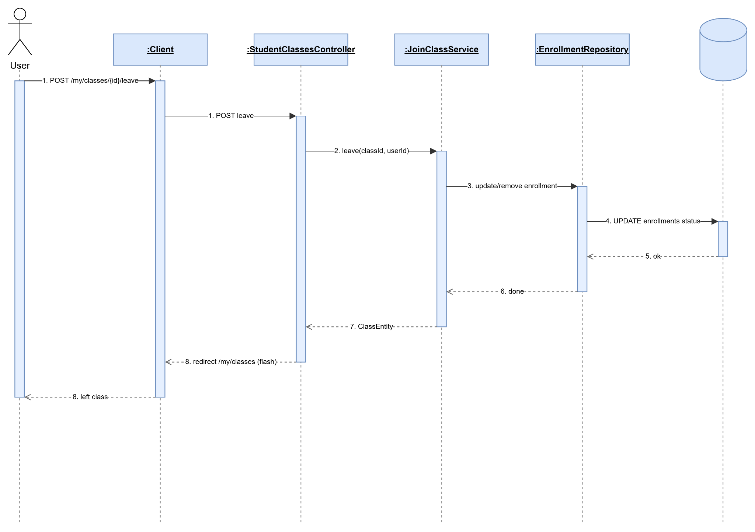

2.2.8 Create Class Invitation
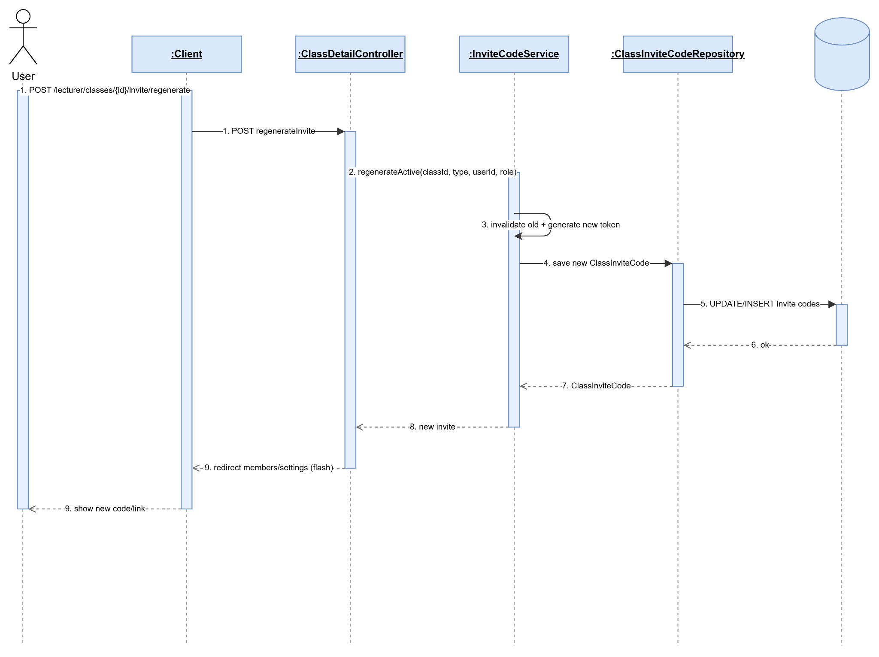

2.2.9 View Class Student
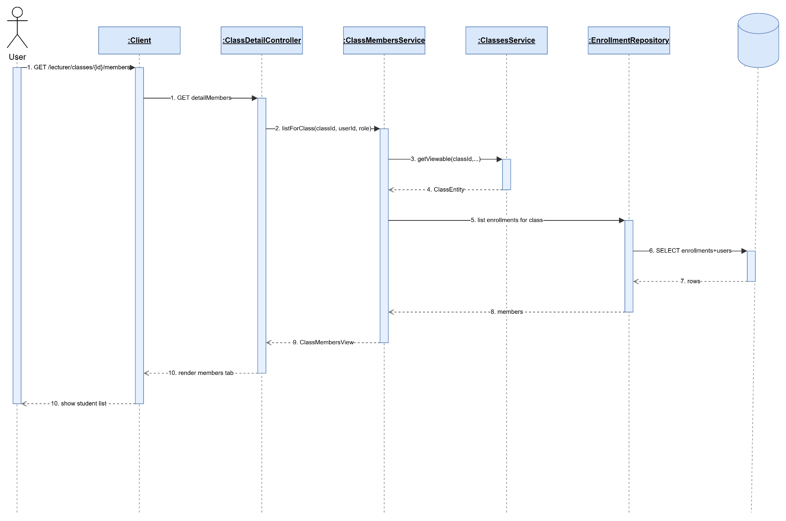

2.2.10 Import Student From Excel
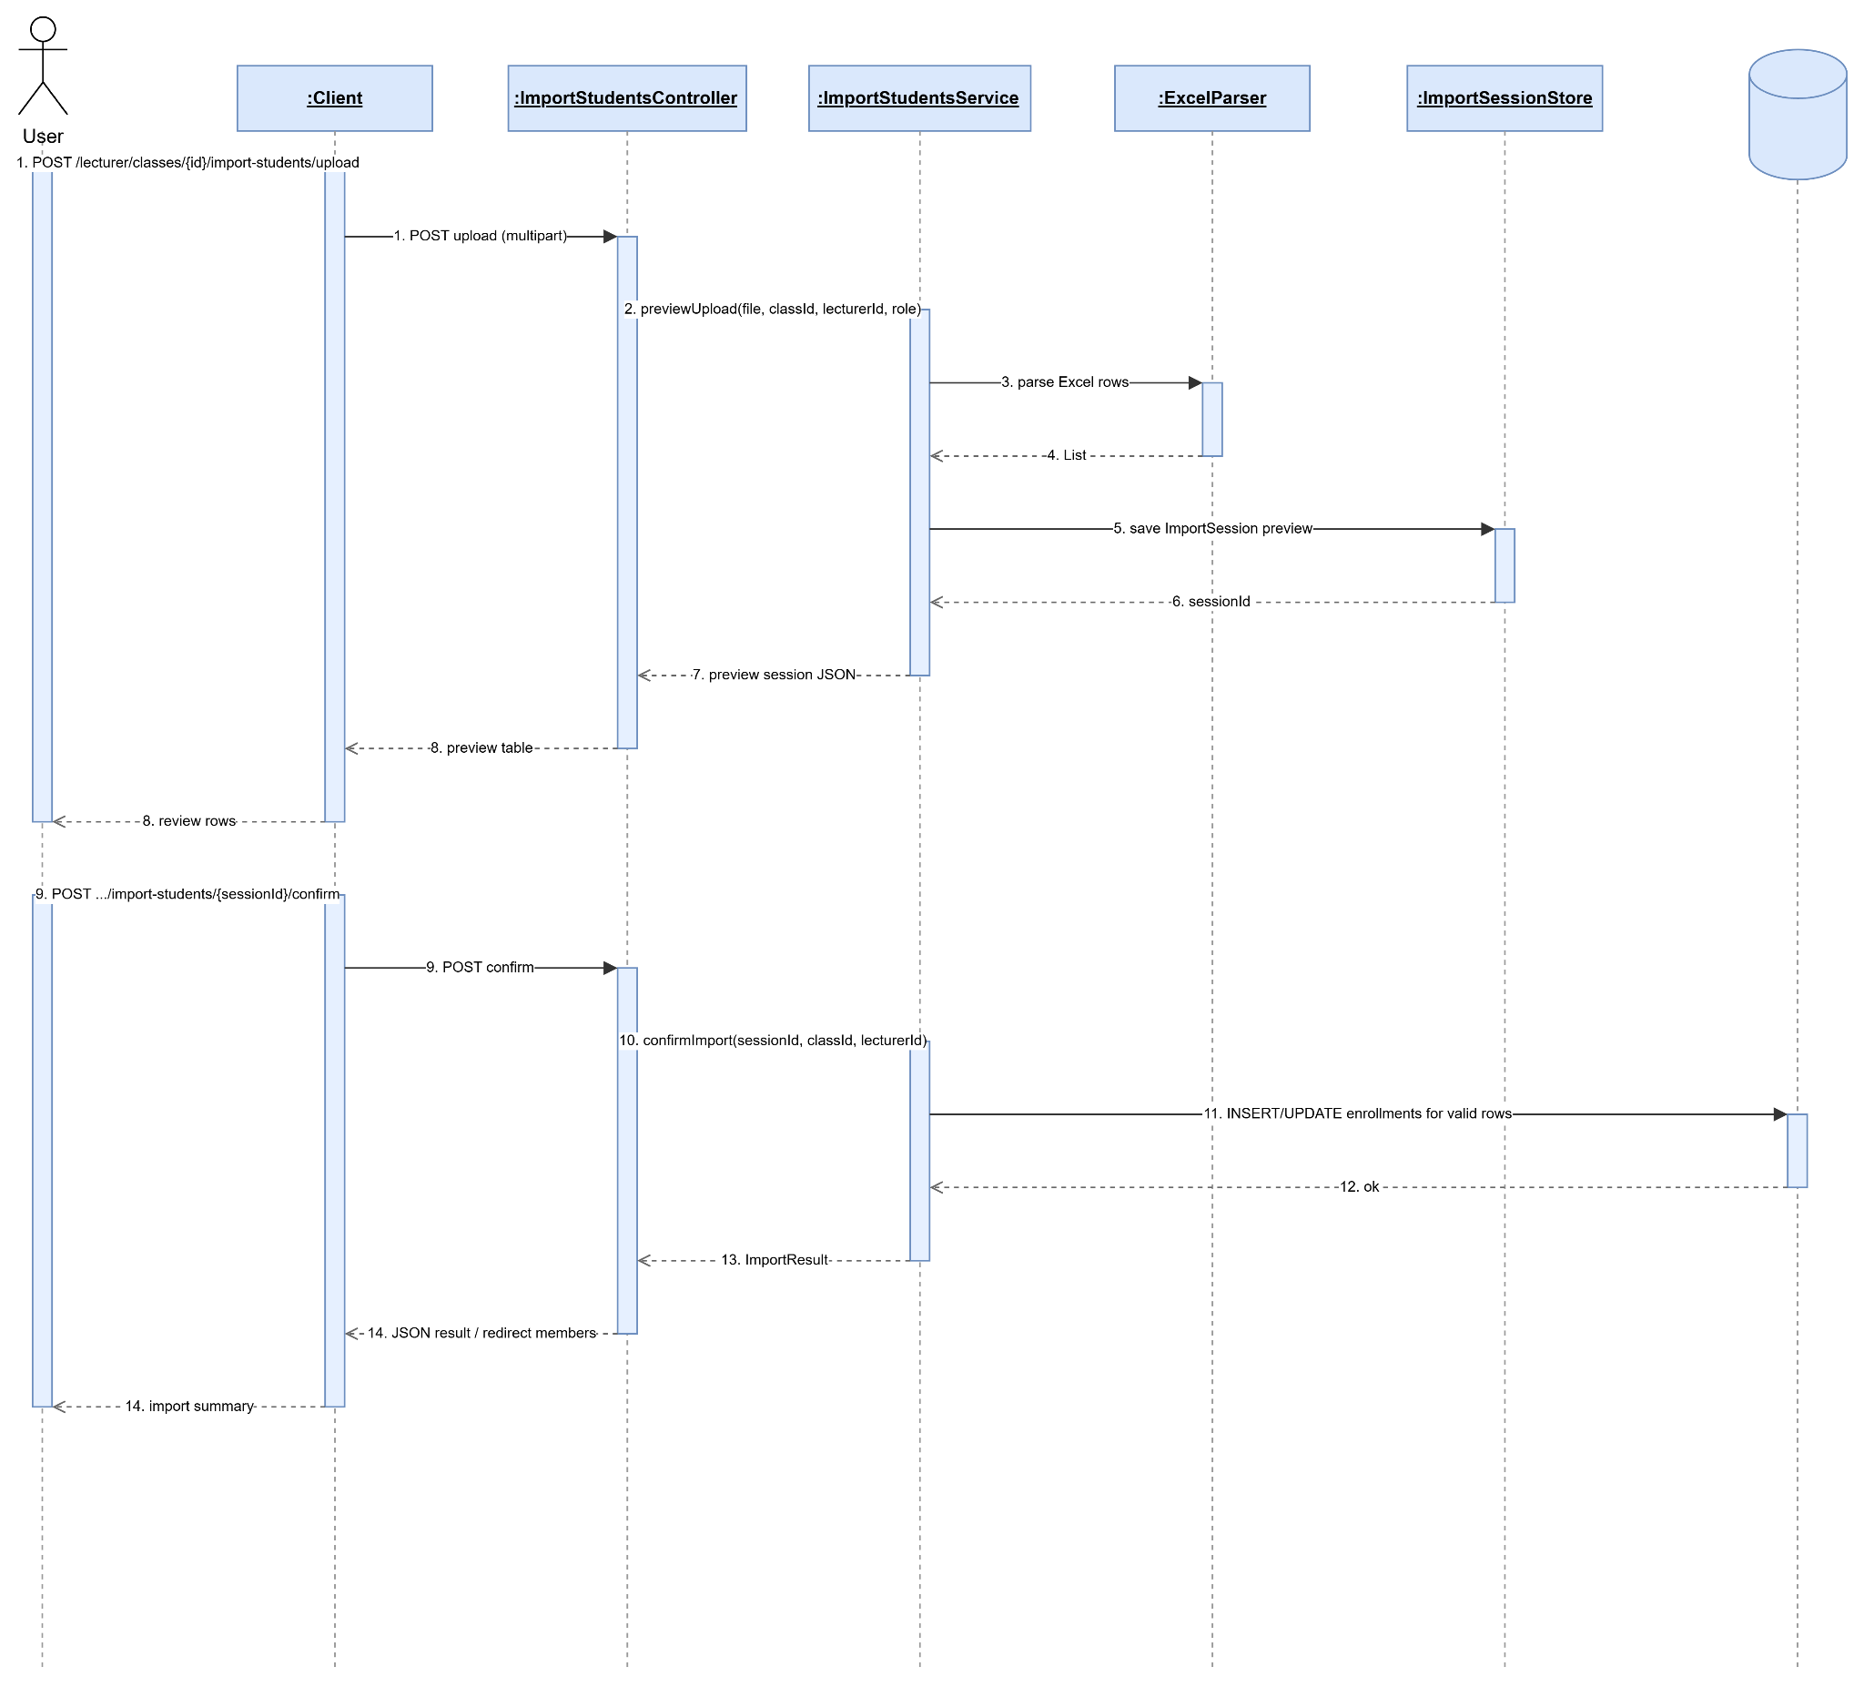

2.3 Flashcard
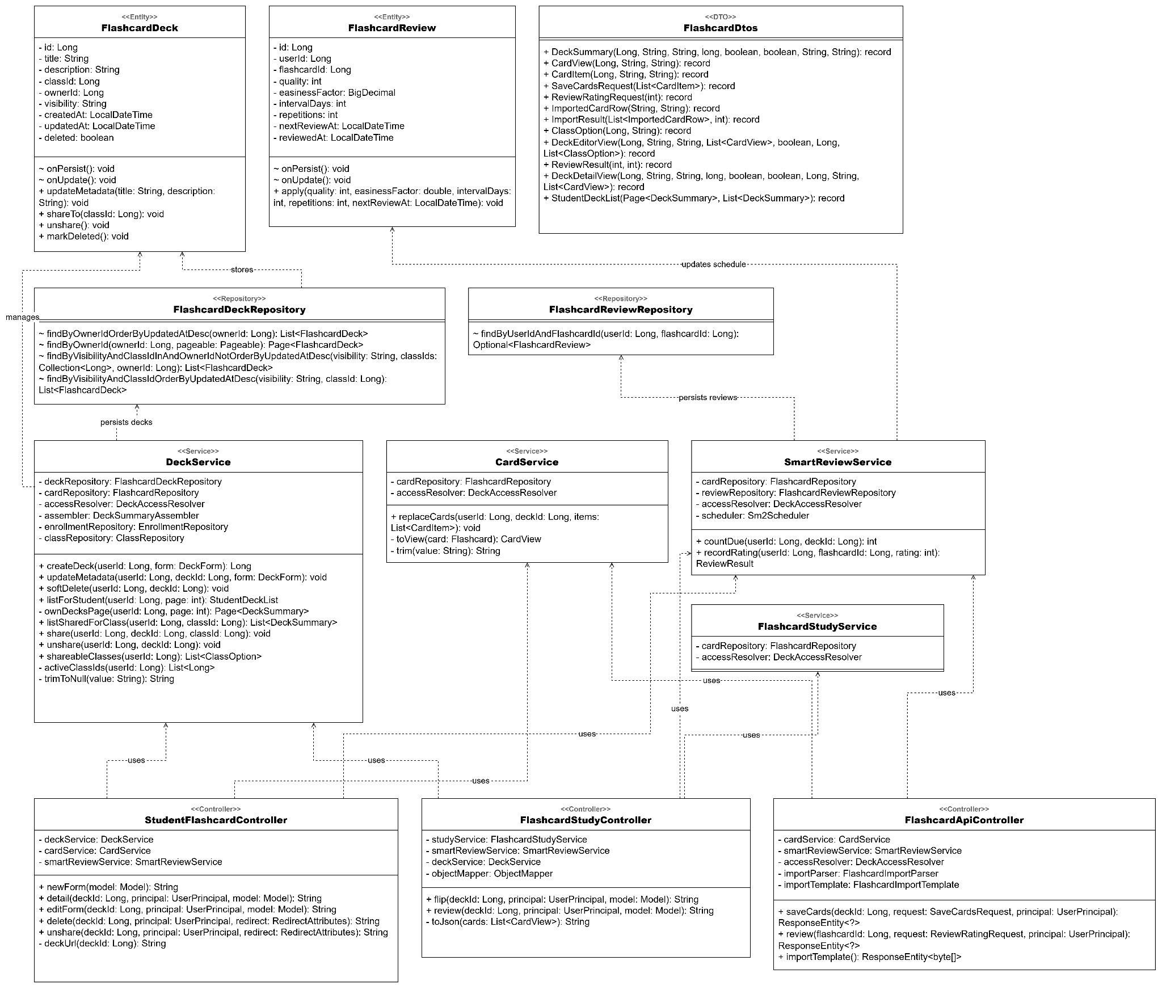

2.3.1 Create Personal FlashCard Set
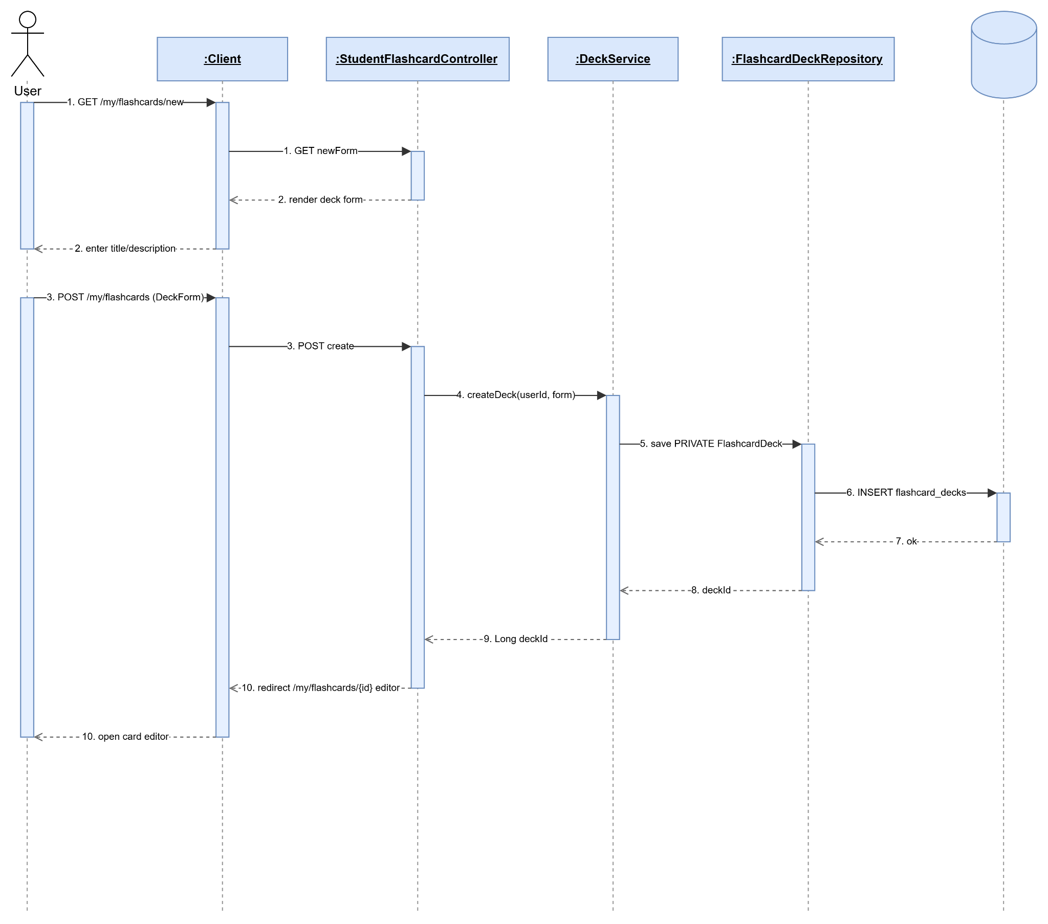

2.3.2 View personal Flashcard set
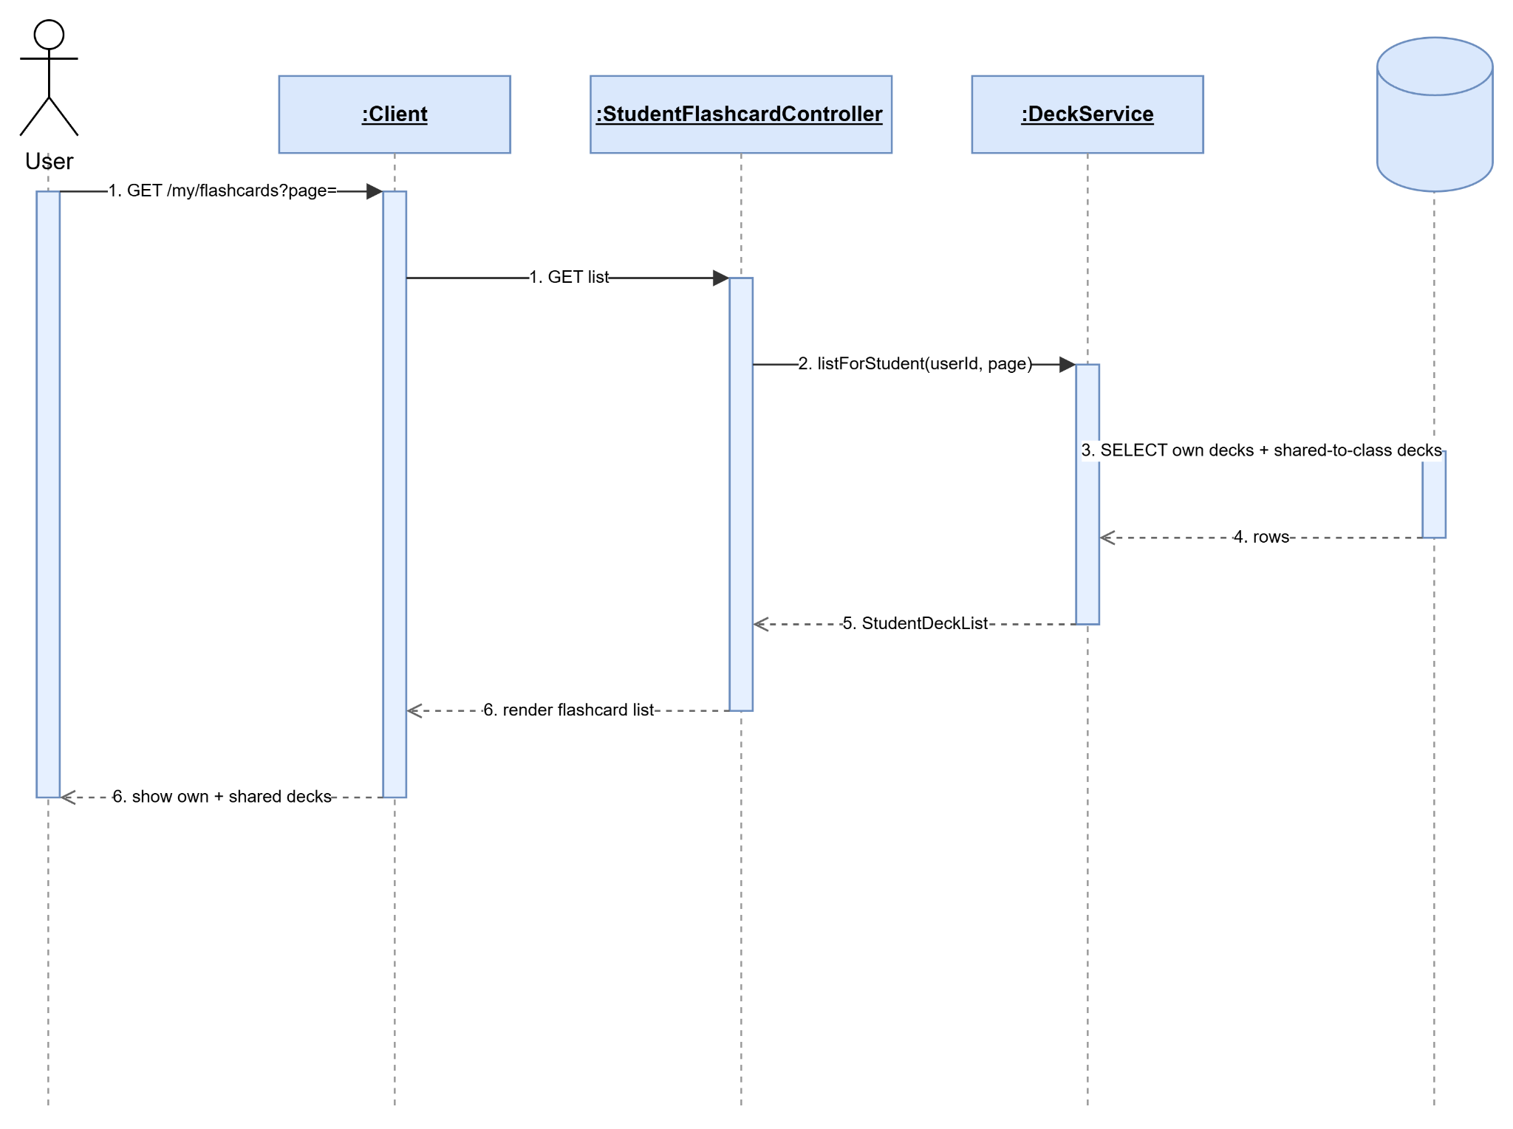

2.3.3 Update Personal Flashcard Set
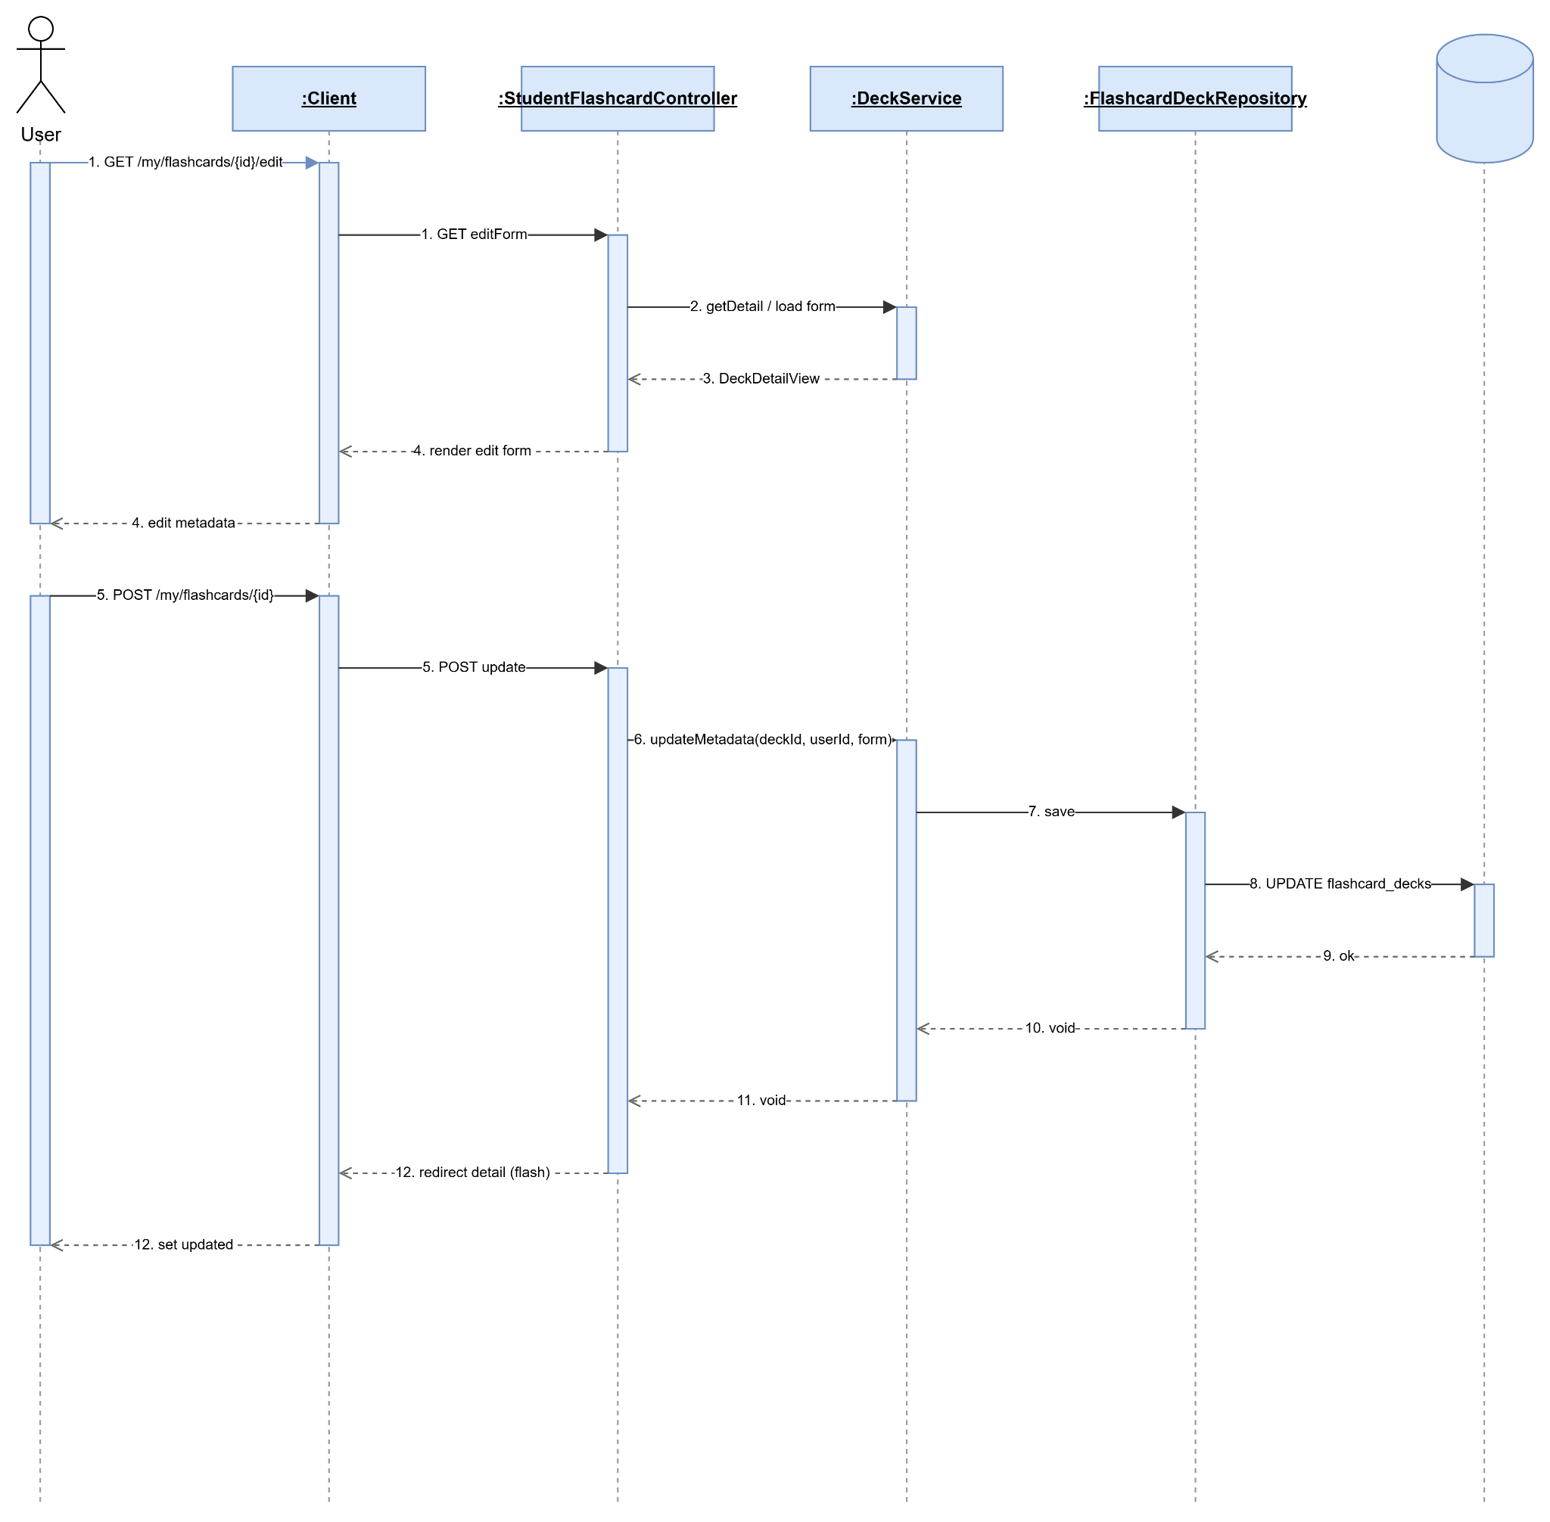

2.3.4 Delete Flashcard Set
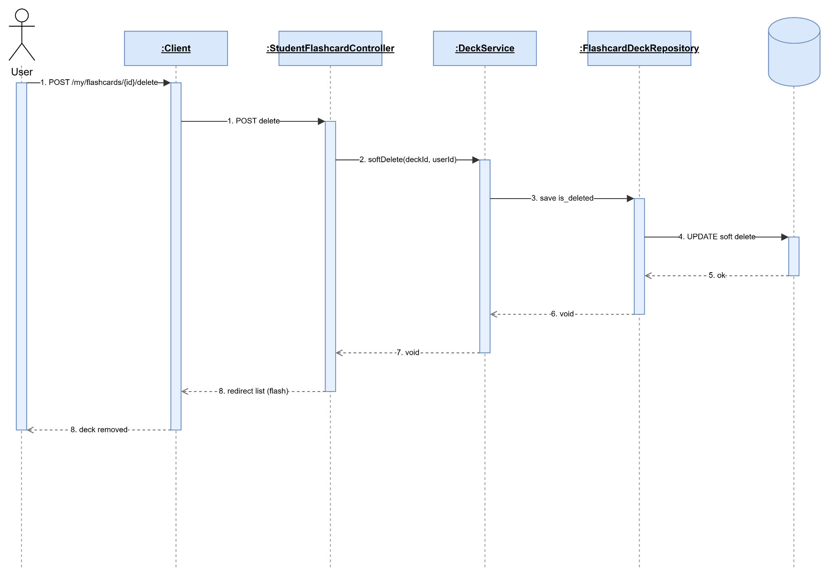

2.3.5 Create Personal Flashcard
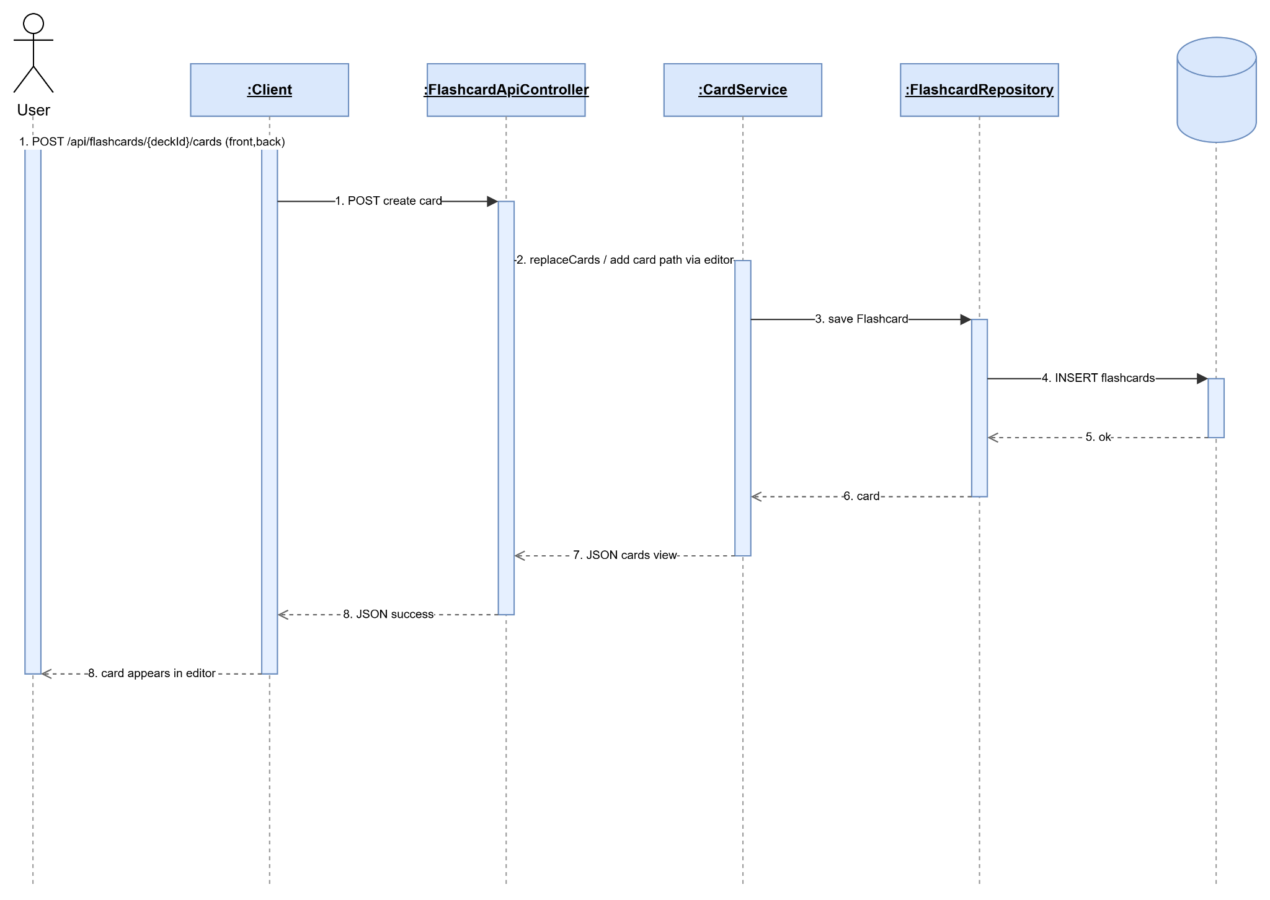

2.3.6 Update Personal Flashcard
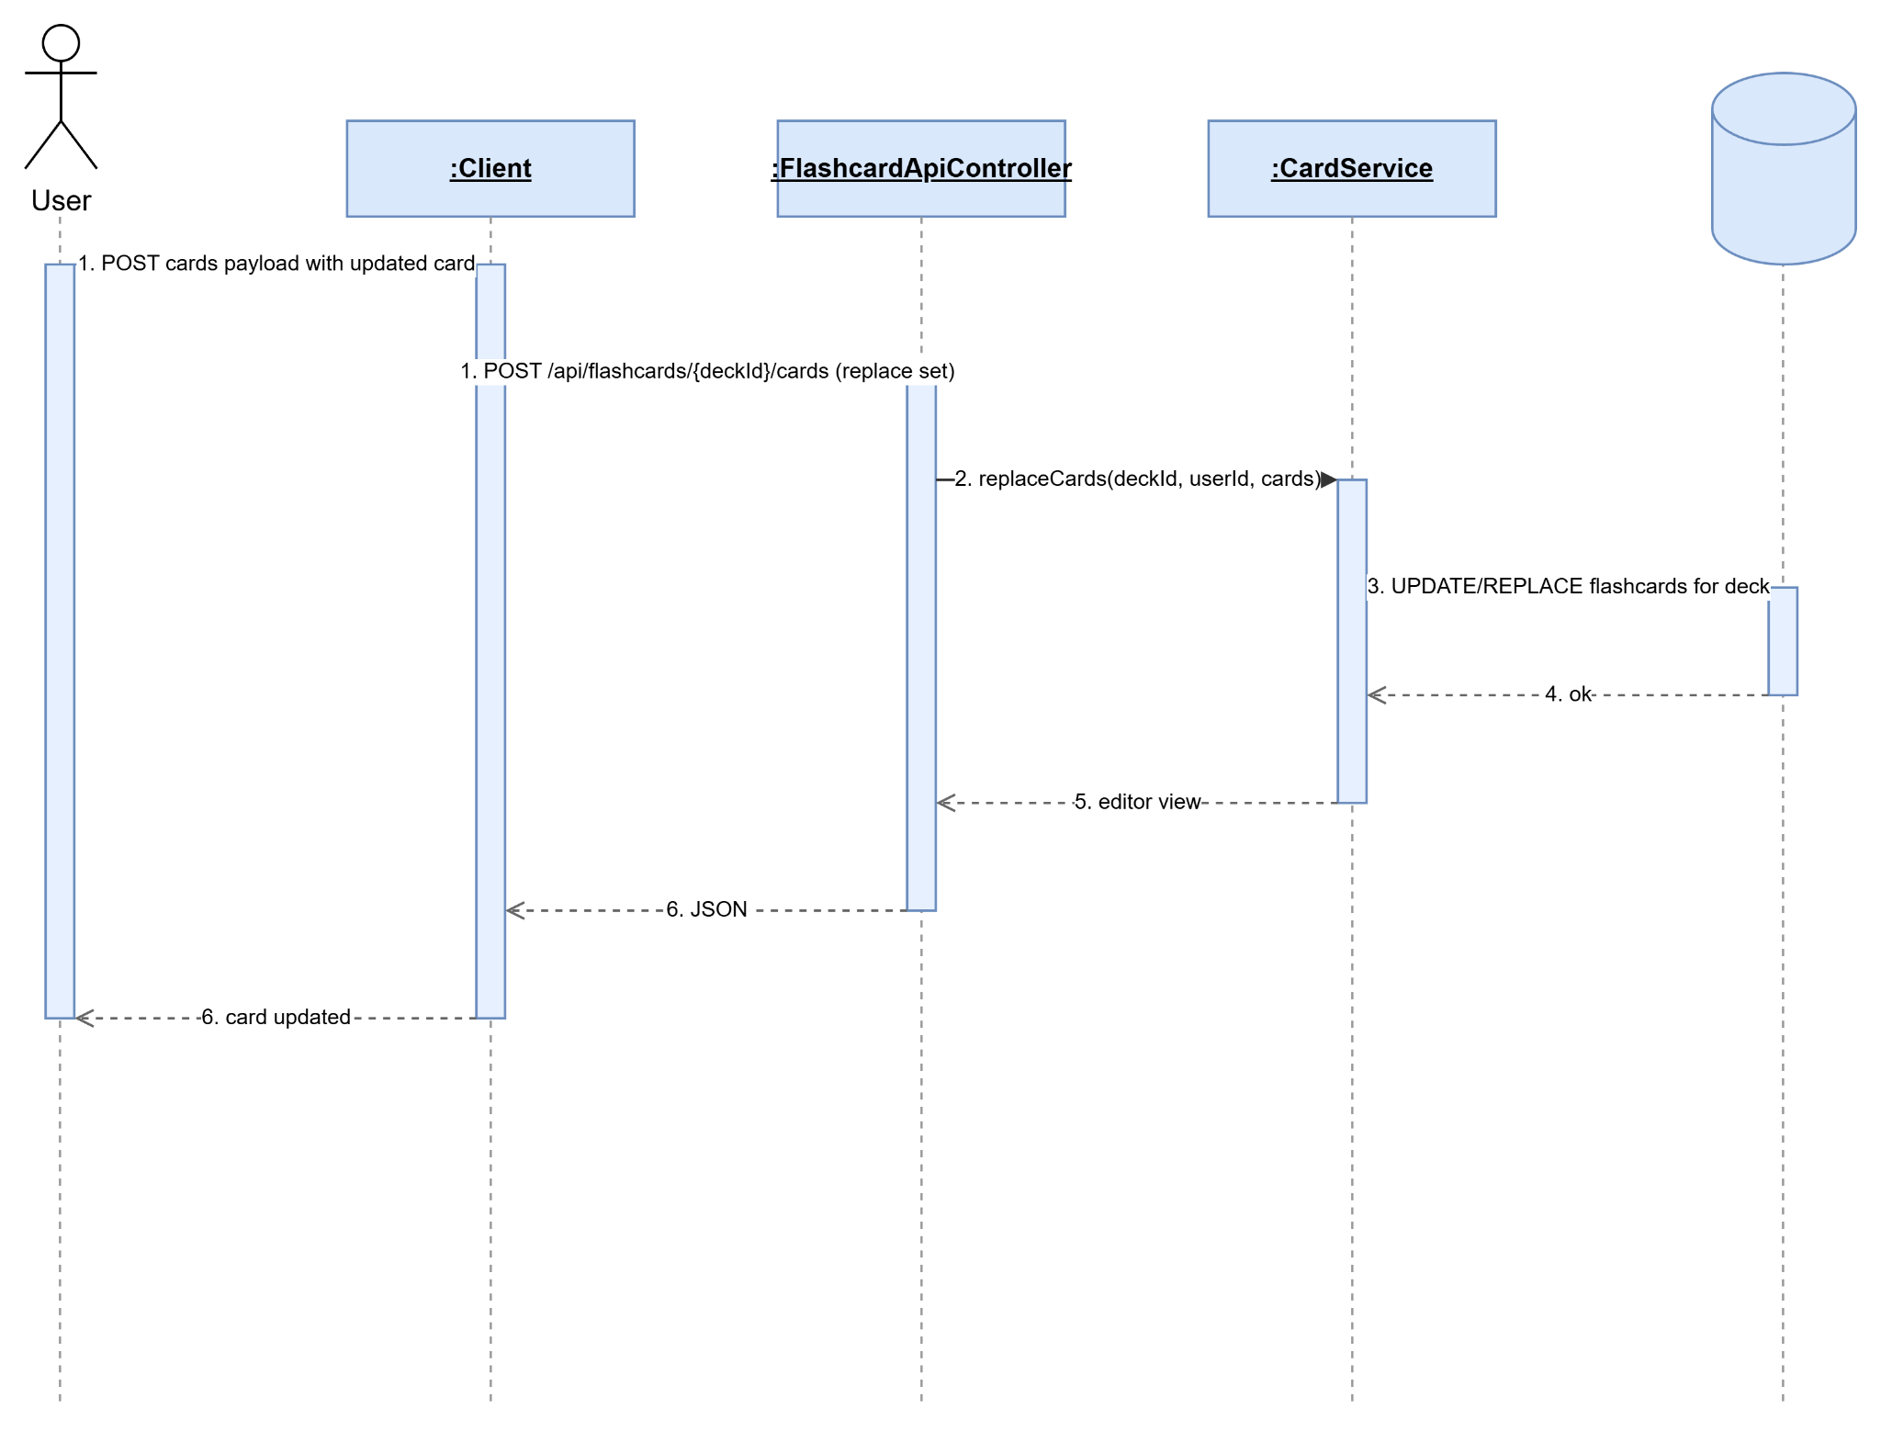

2.3.7 Delete Personal Flashcard
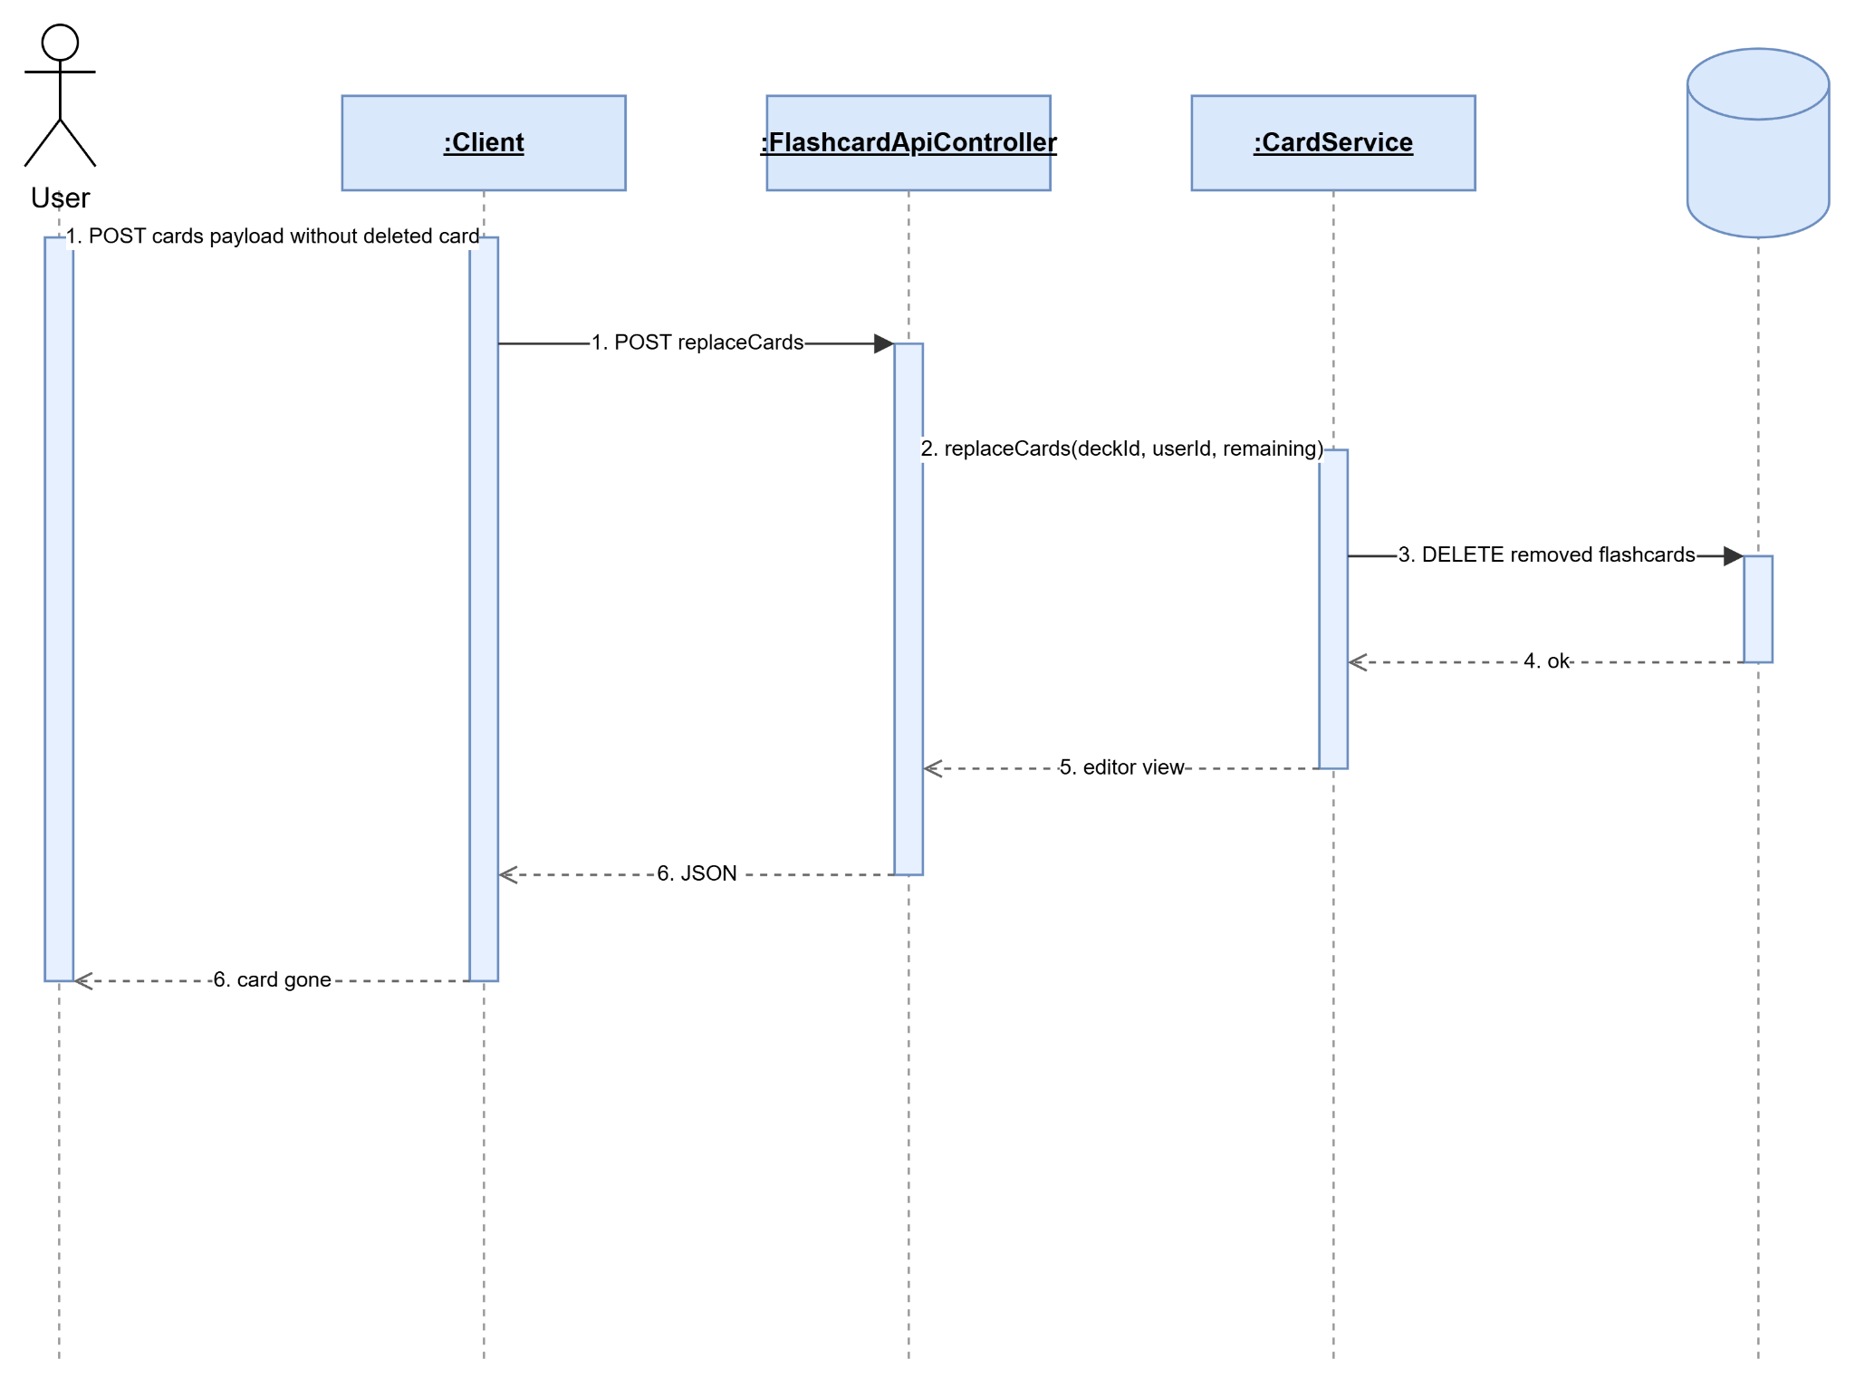

2.3.8 Study Personal Flashcard
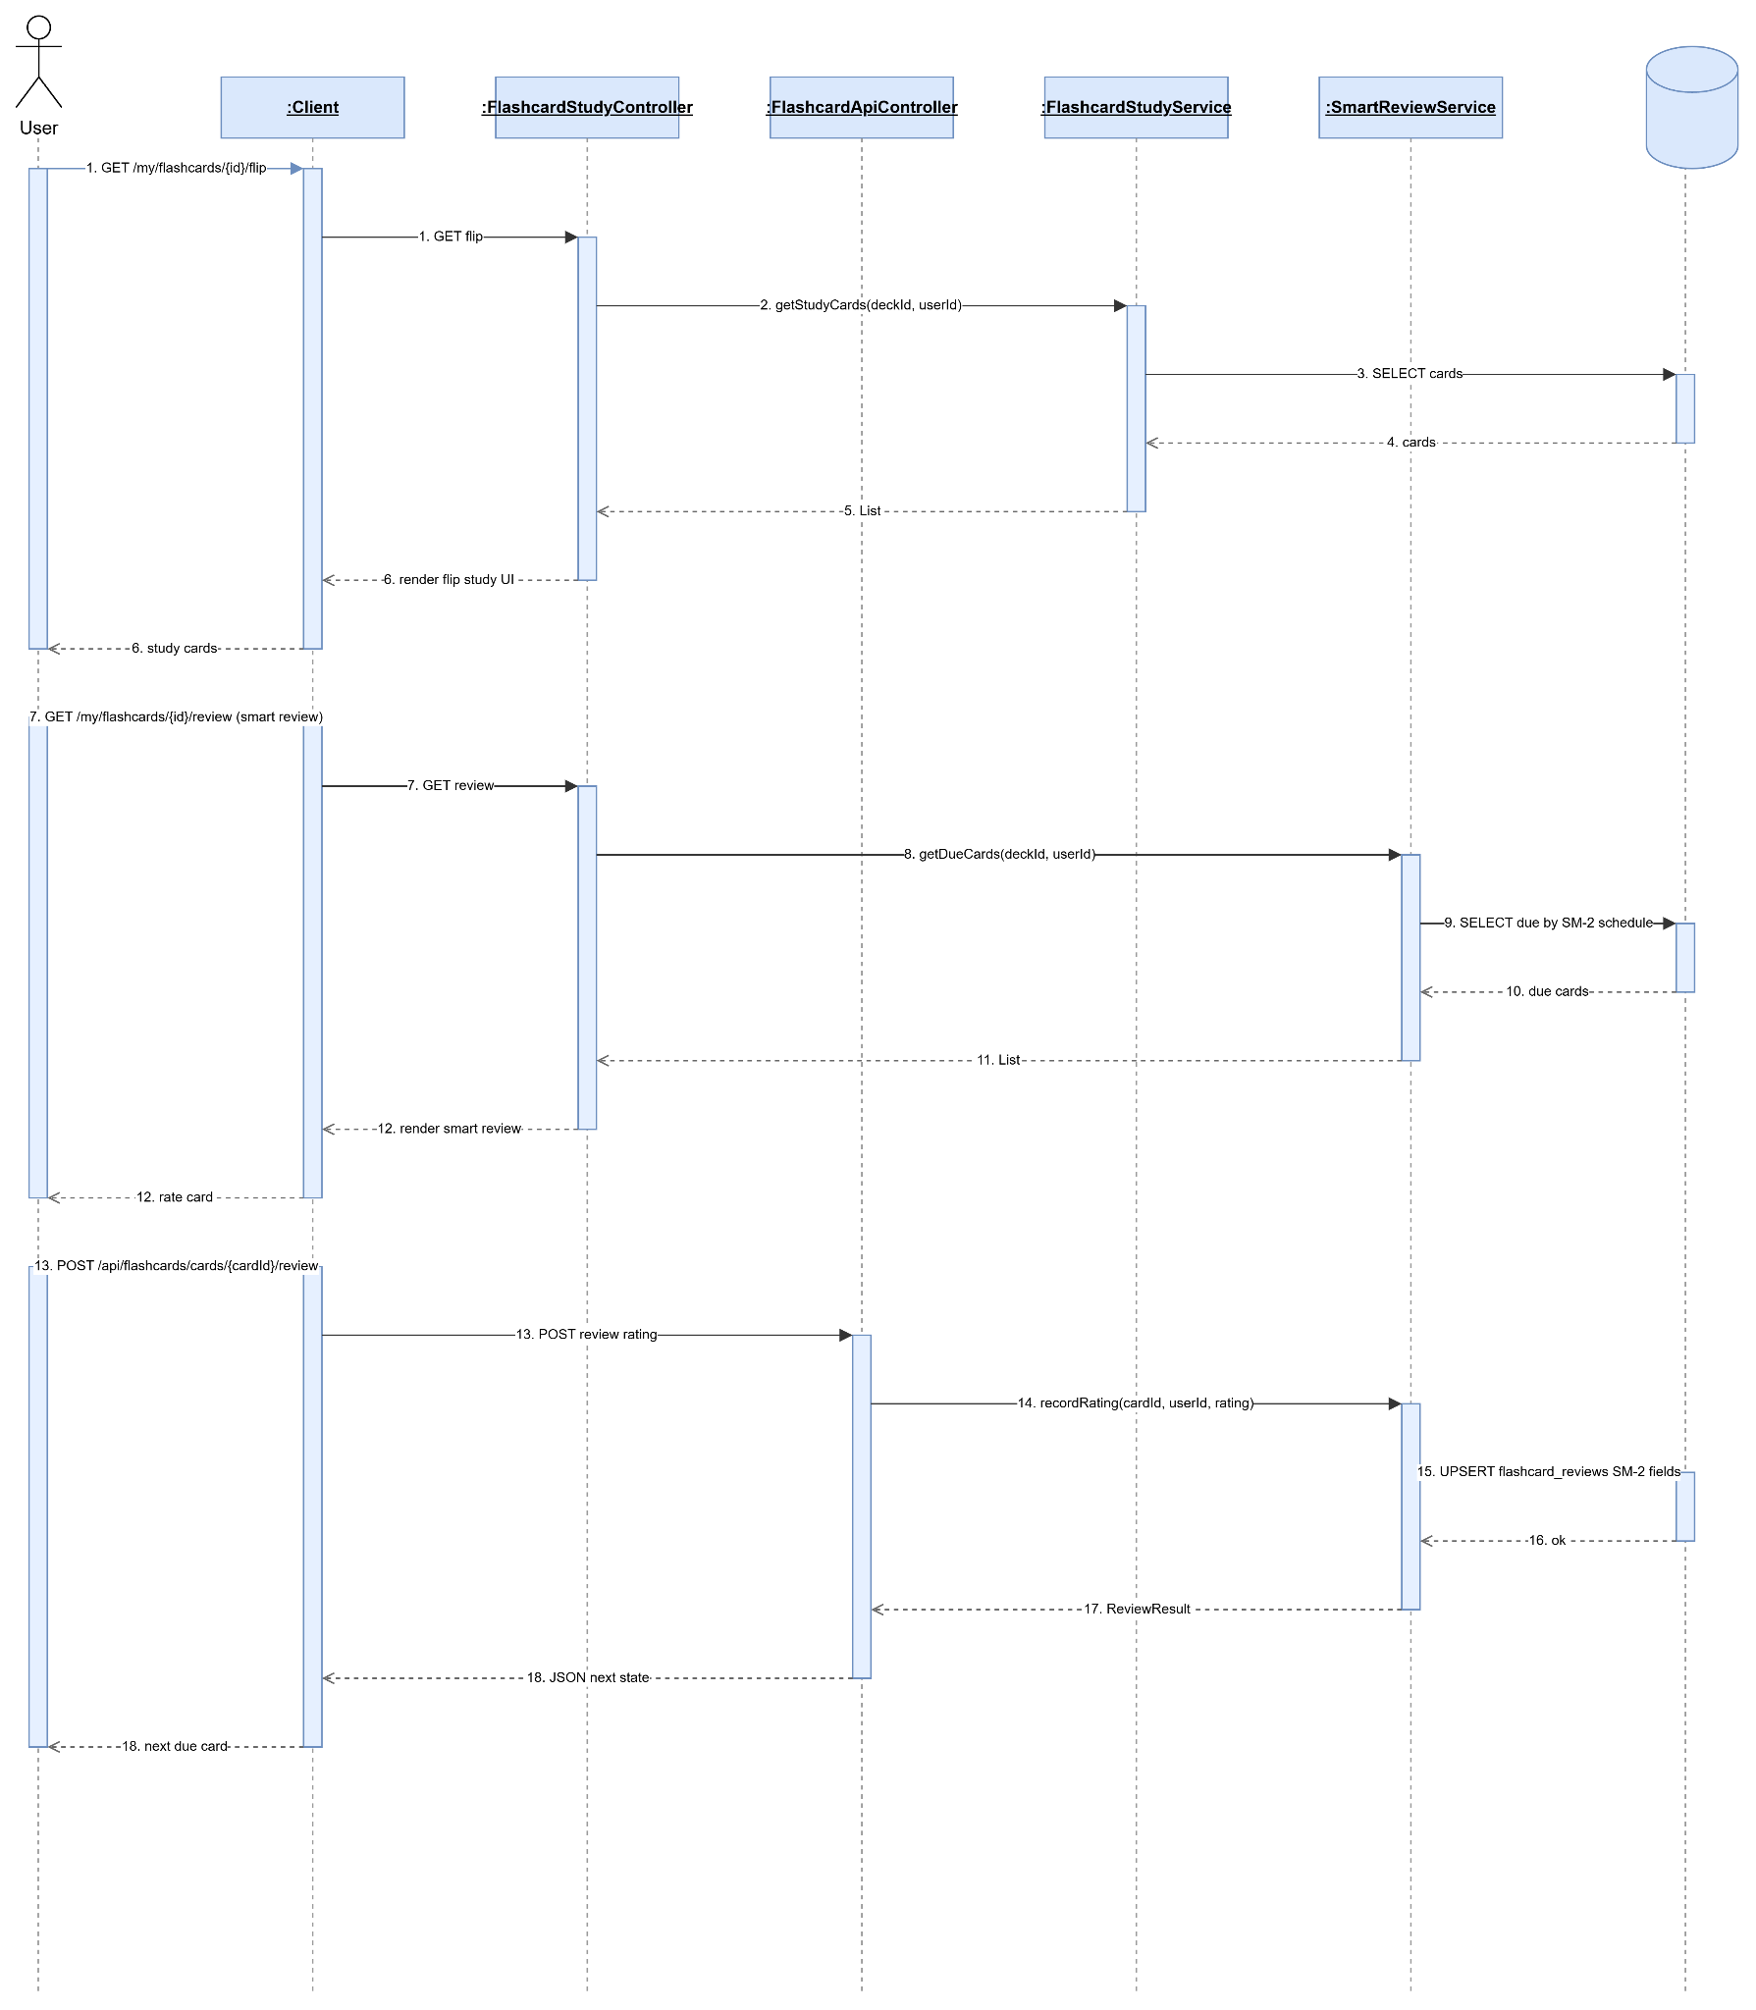

2.3.9 Share Personal Flashcard Set
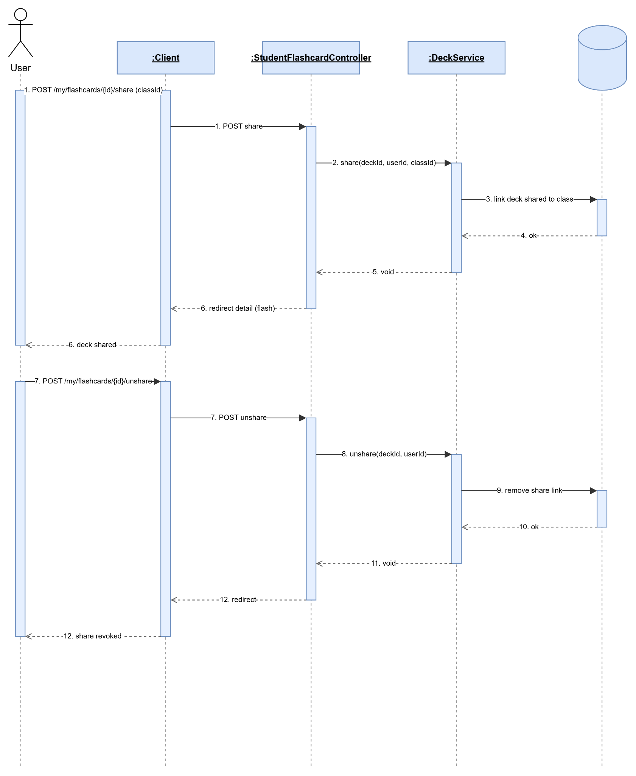

2.3.10 Study Class Flashcard

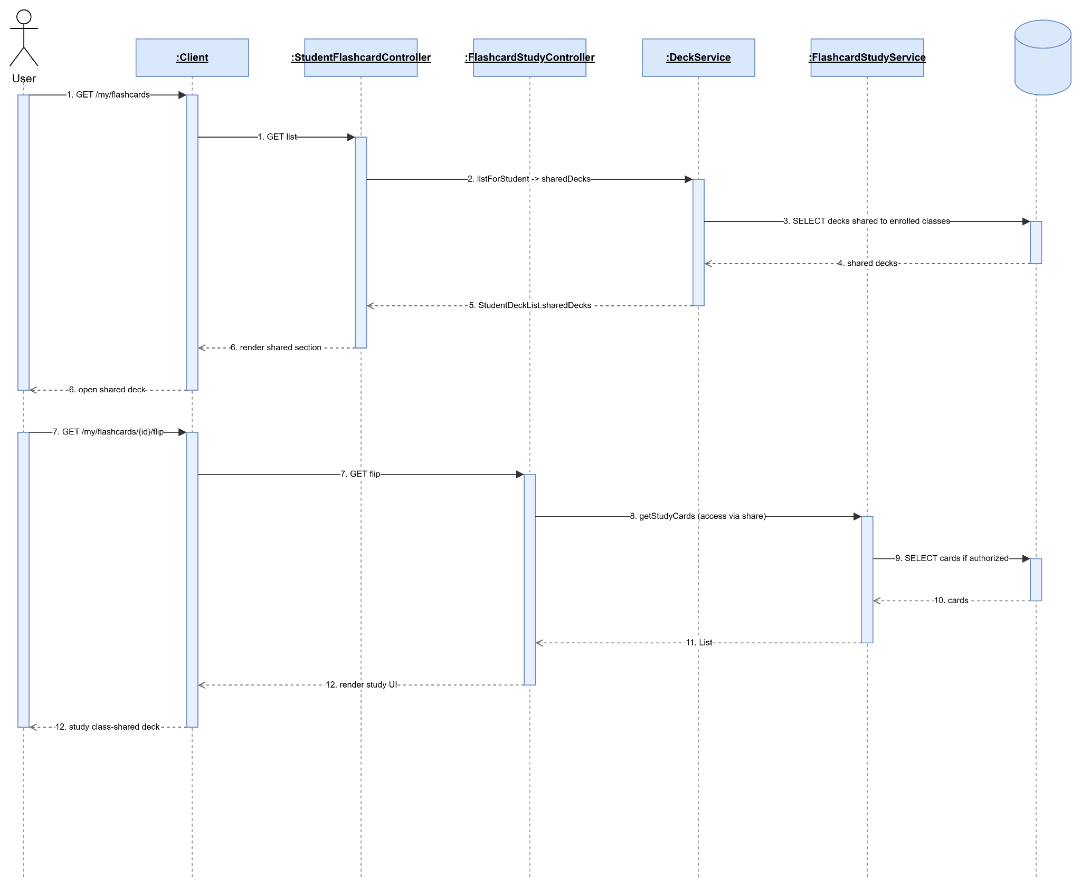

2.4 Manage Lesson Section

2.4.1 Create Section
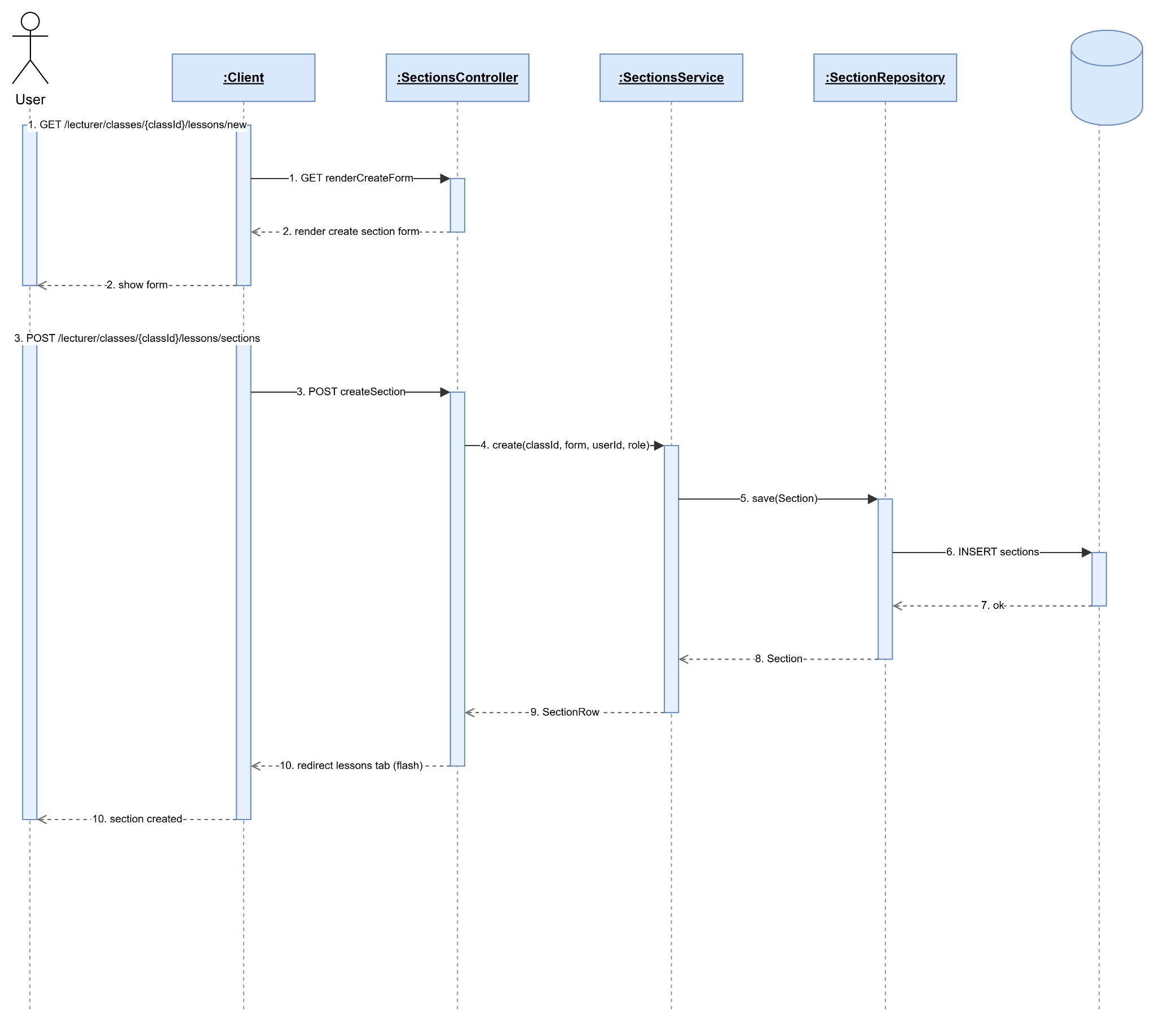

2.4.2 View Section
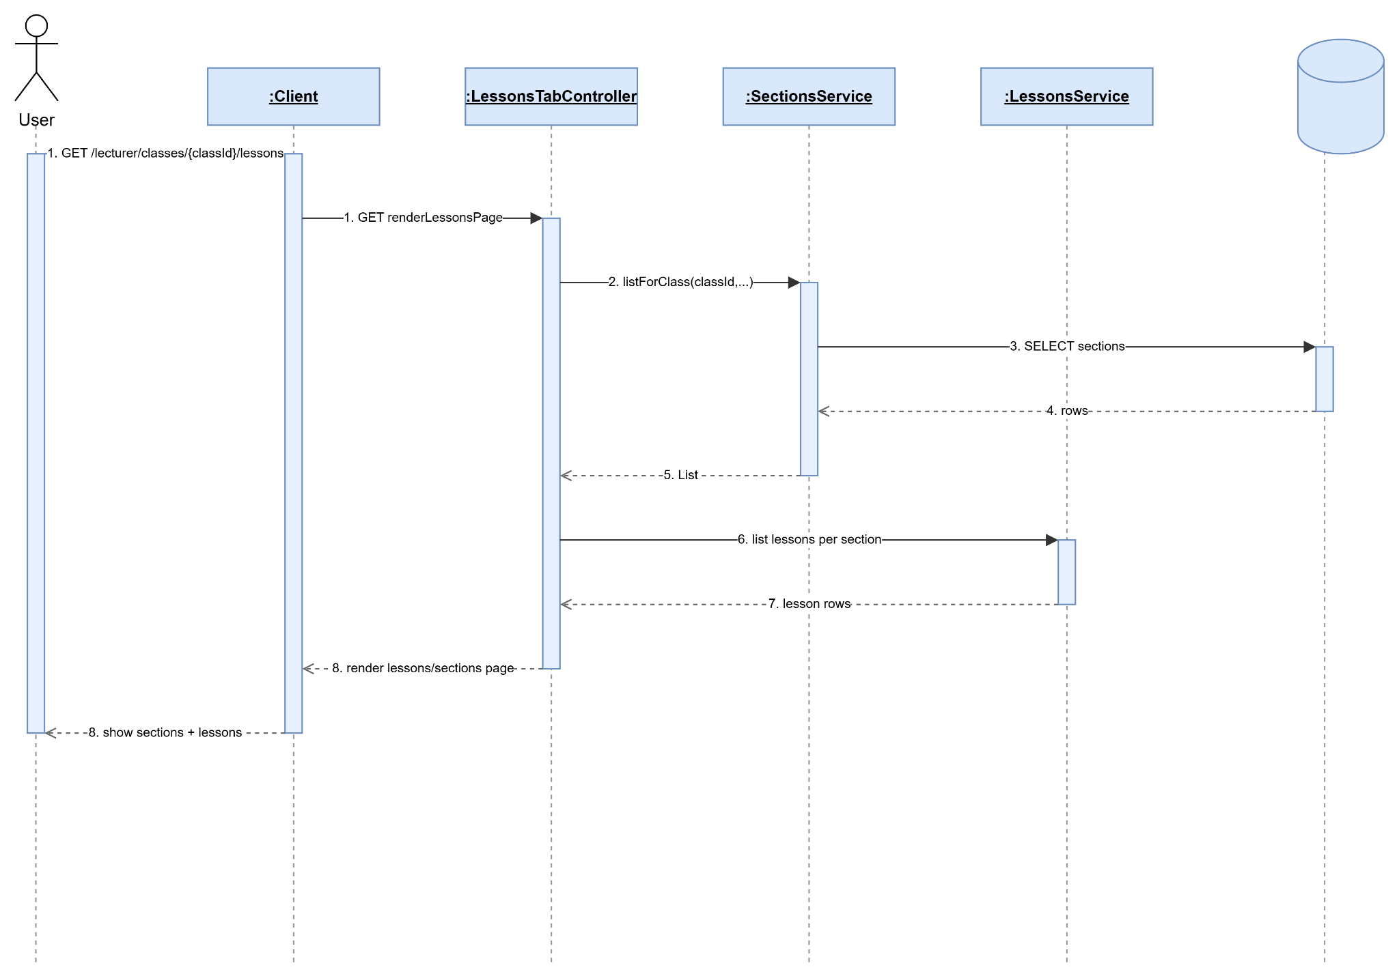

2.4.3 Update Section
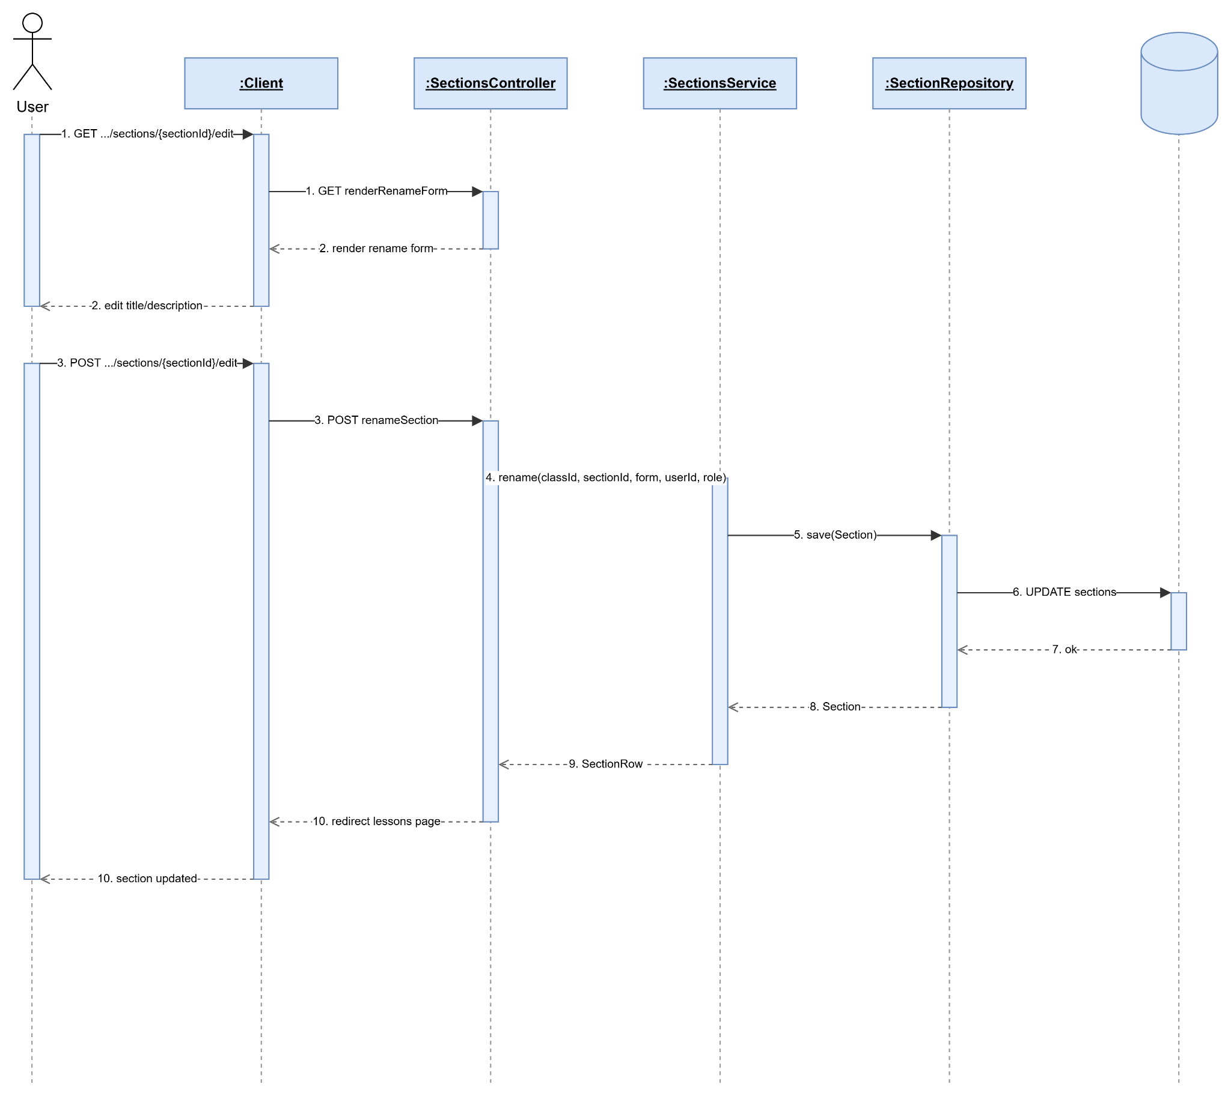

2.4.4 Delete Section
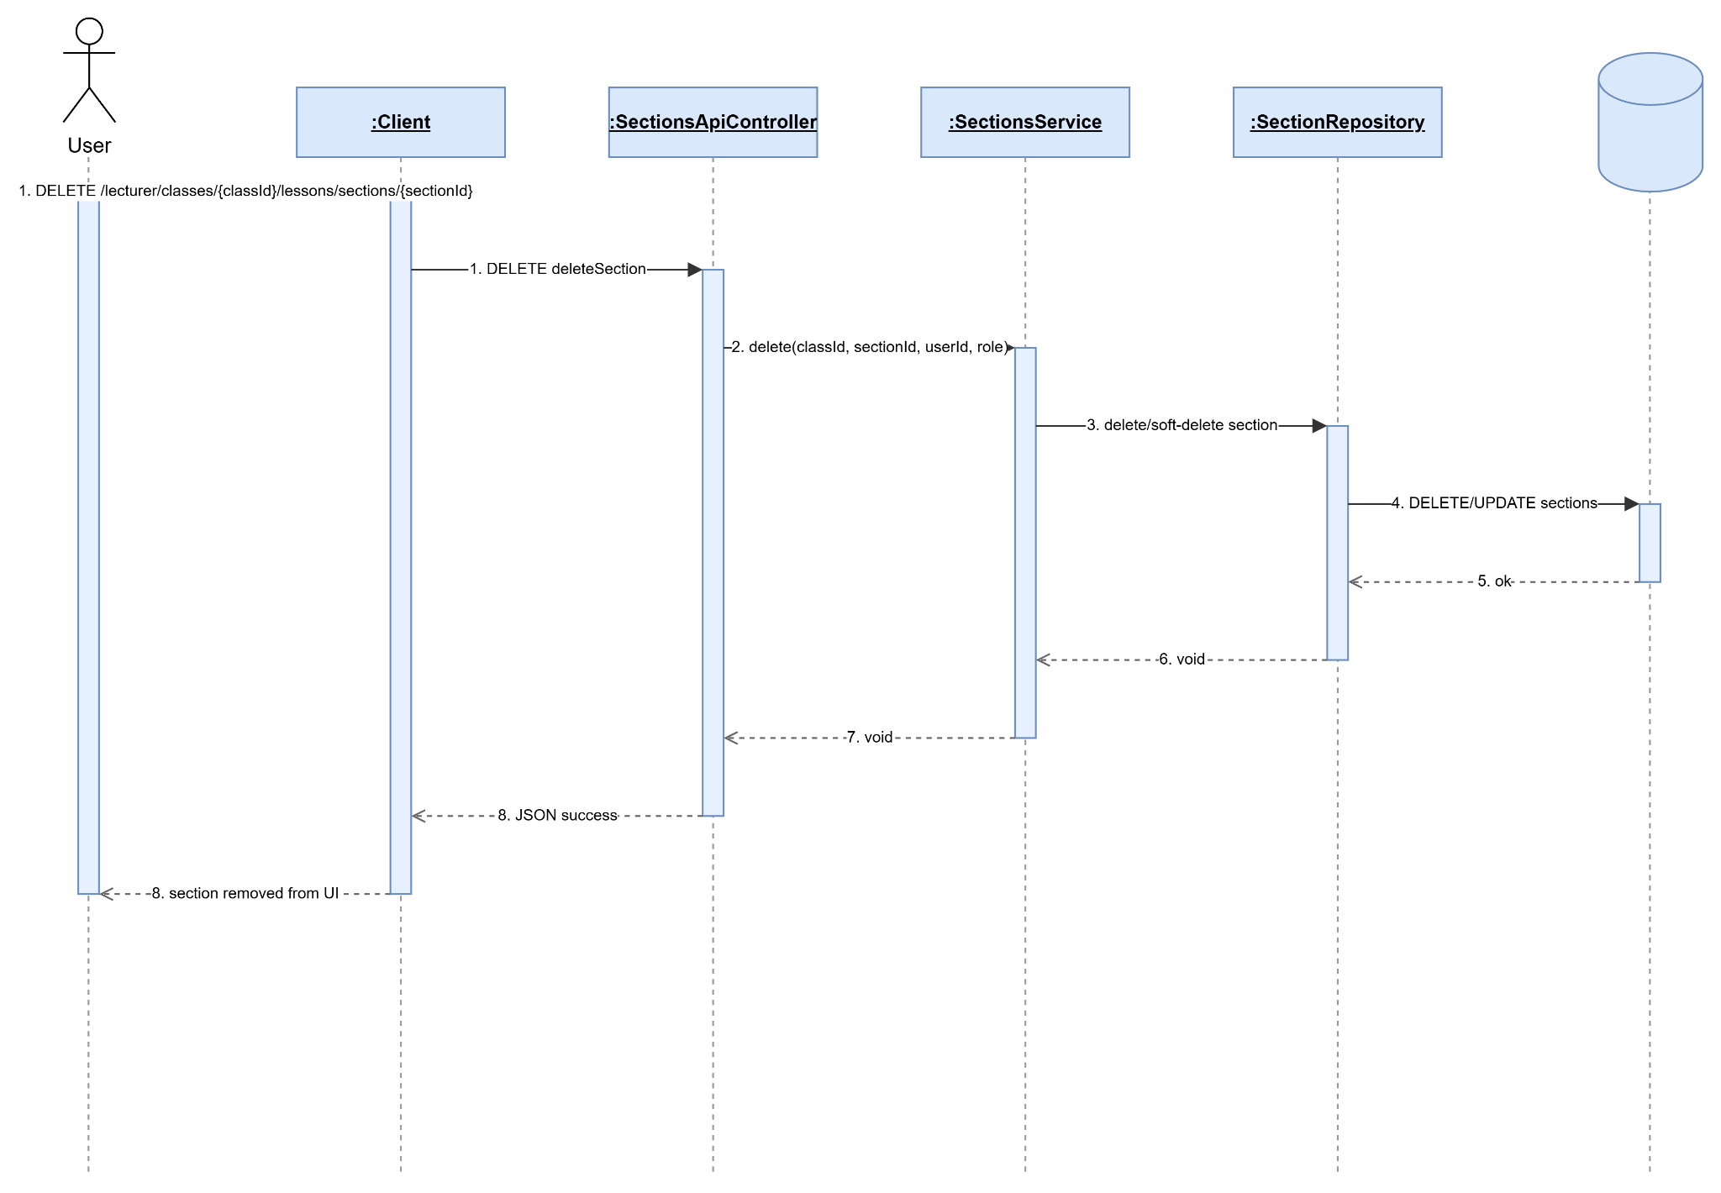

2.4.5 Create Lesson
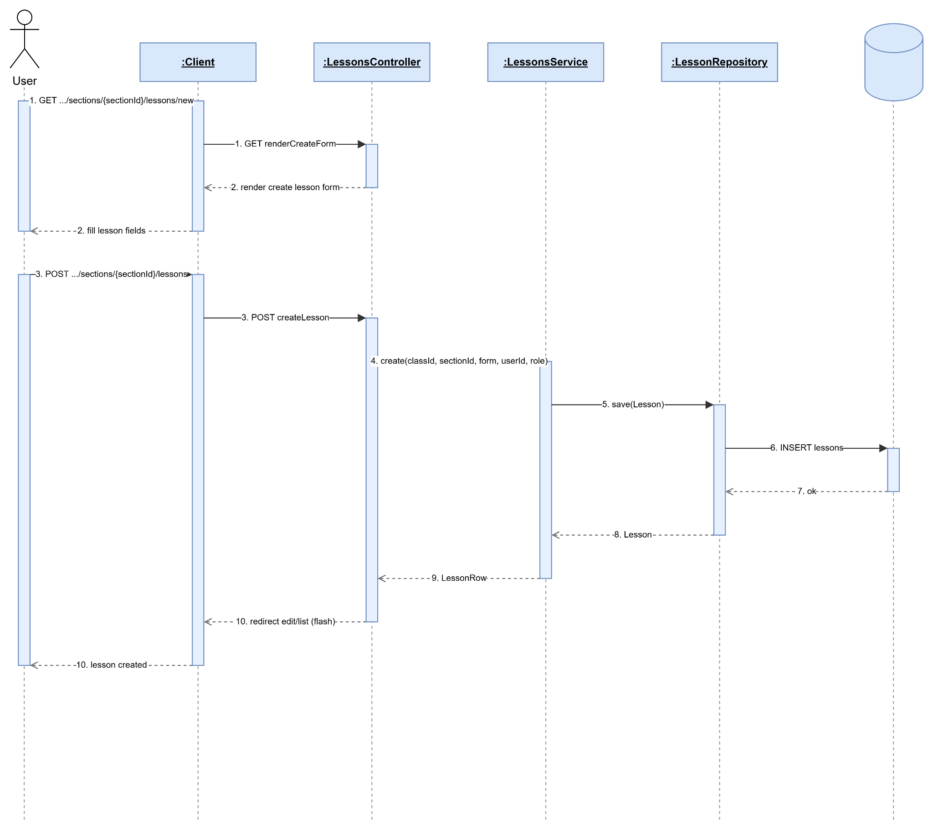

2.4.6 View Lesson
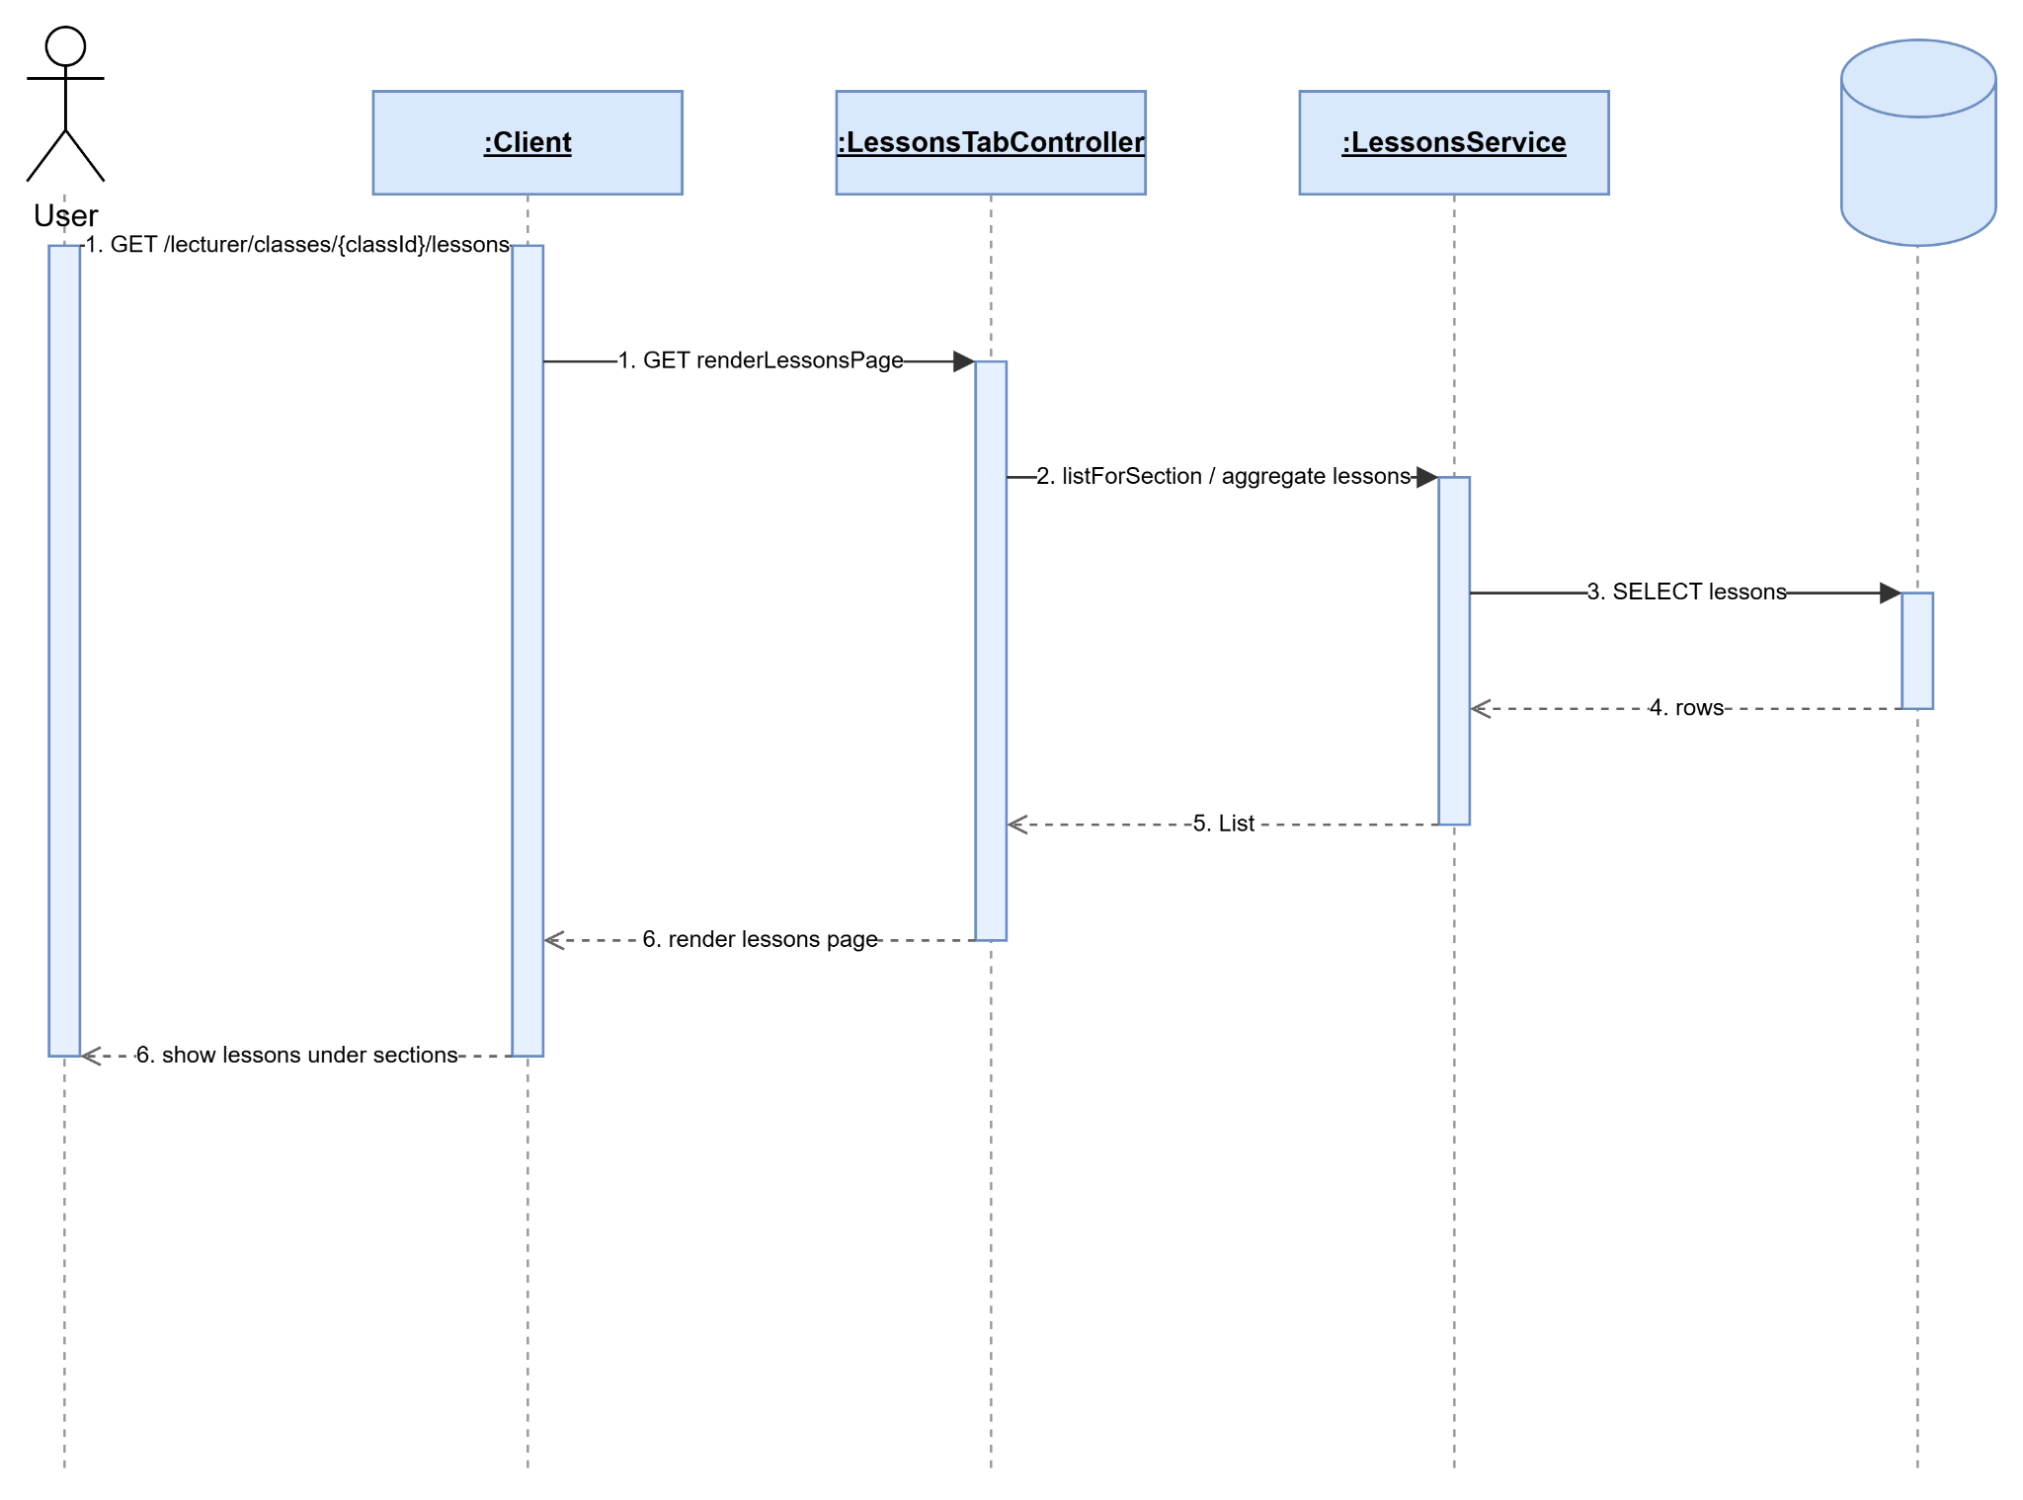

2.4.7 Update Lesson
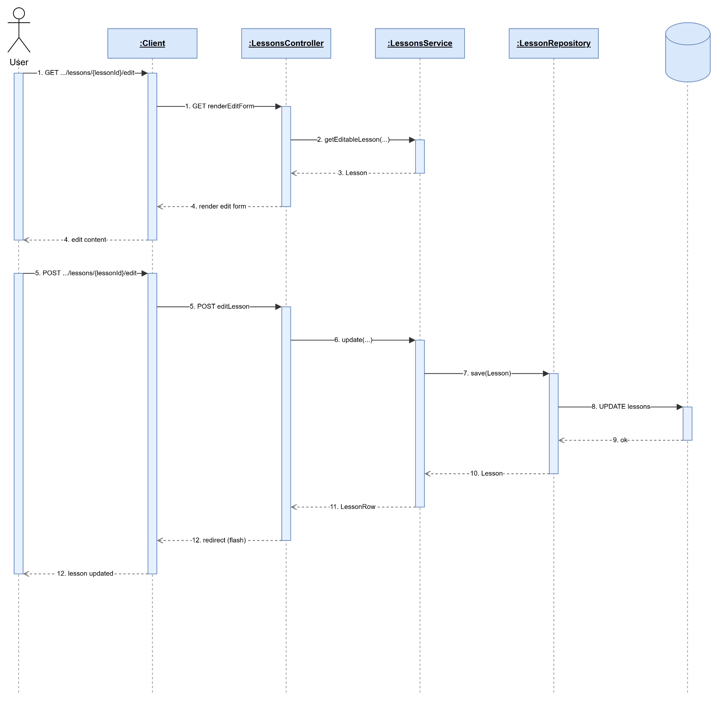

2.4.8 Delete Lesson
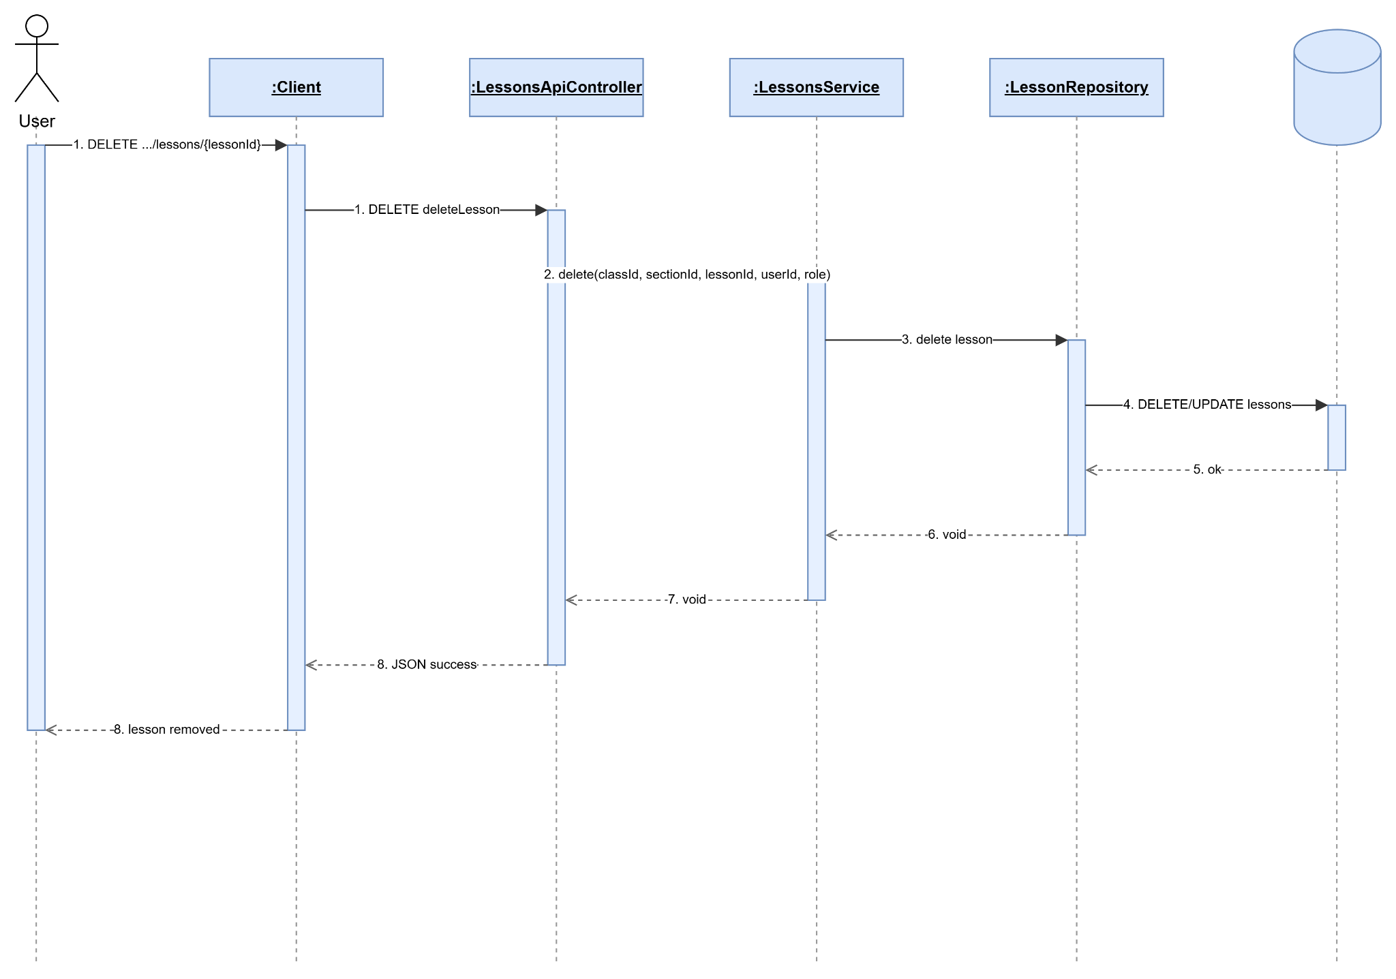

2.4.9 Add Learning Material To Lesson
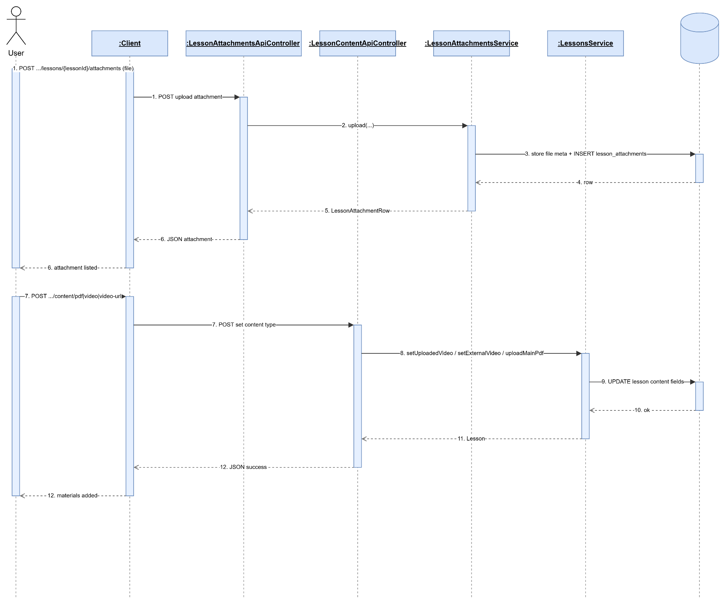

2.4.10 Update Learning Materials Lesson
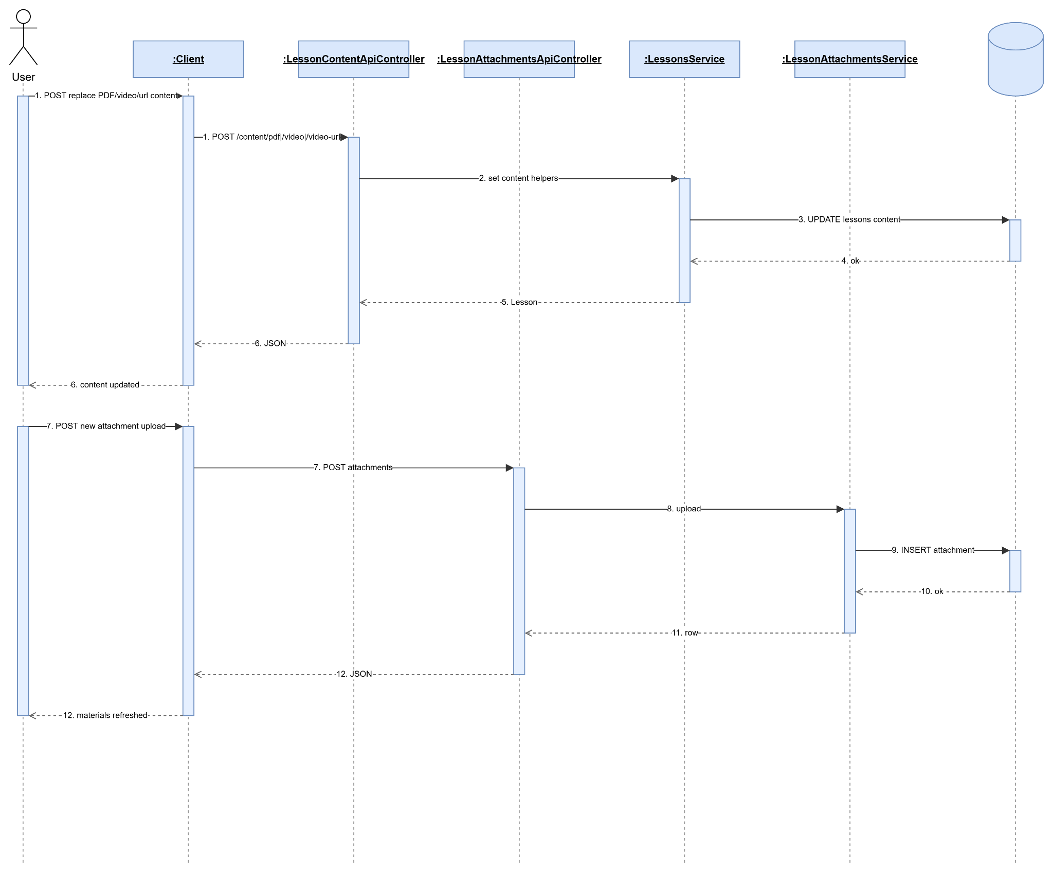

2.4.11 Remove Learning Material
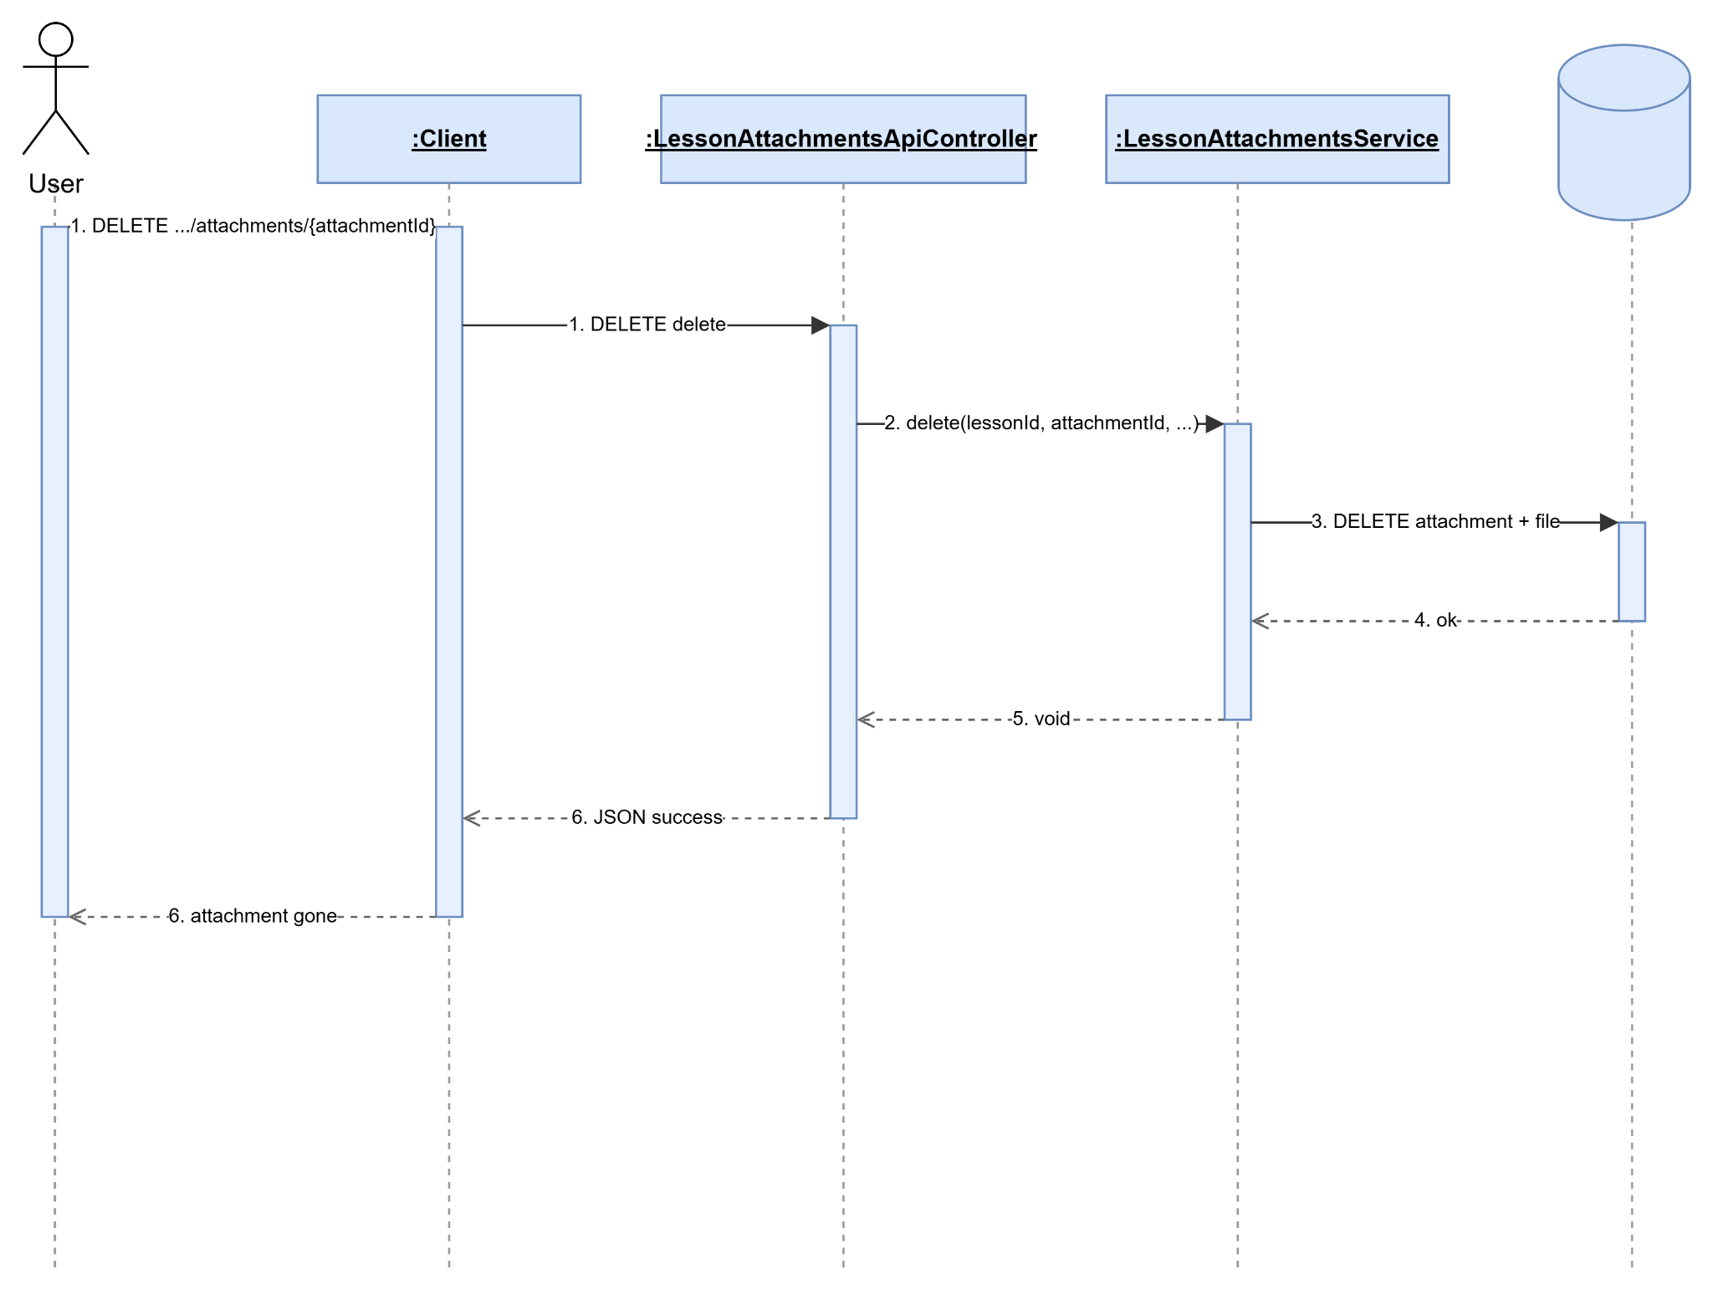

2.4.12 Publish Or Hide Lesson
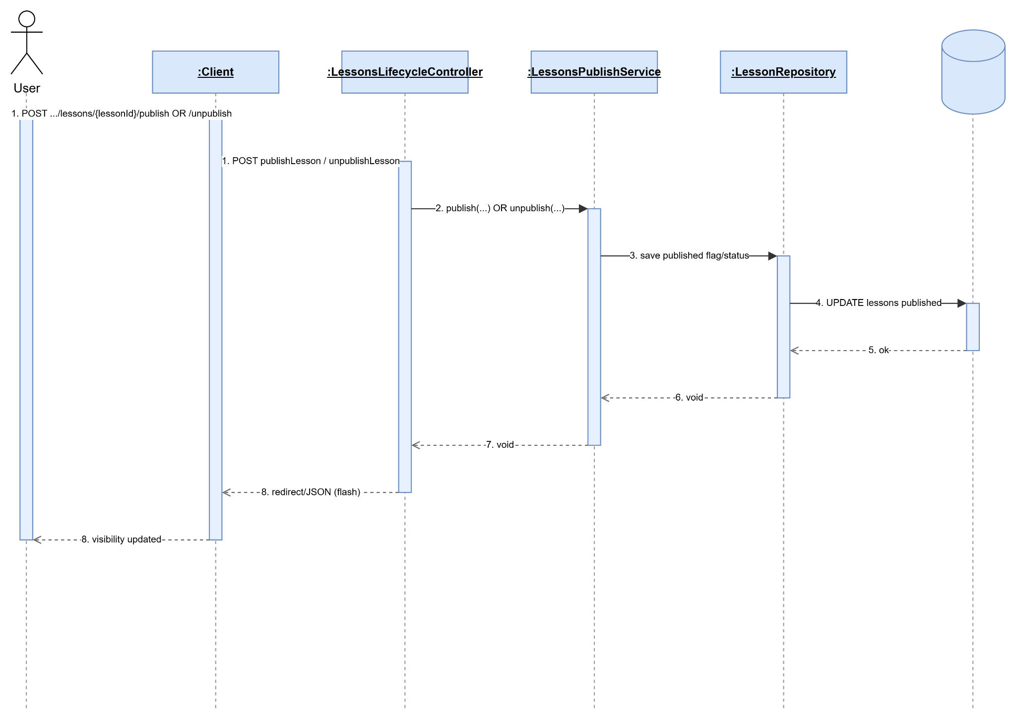

2.5 Lesson Learning QA

2.5.1 View Public Lesson Content
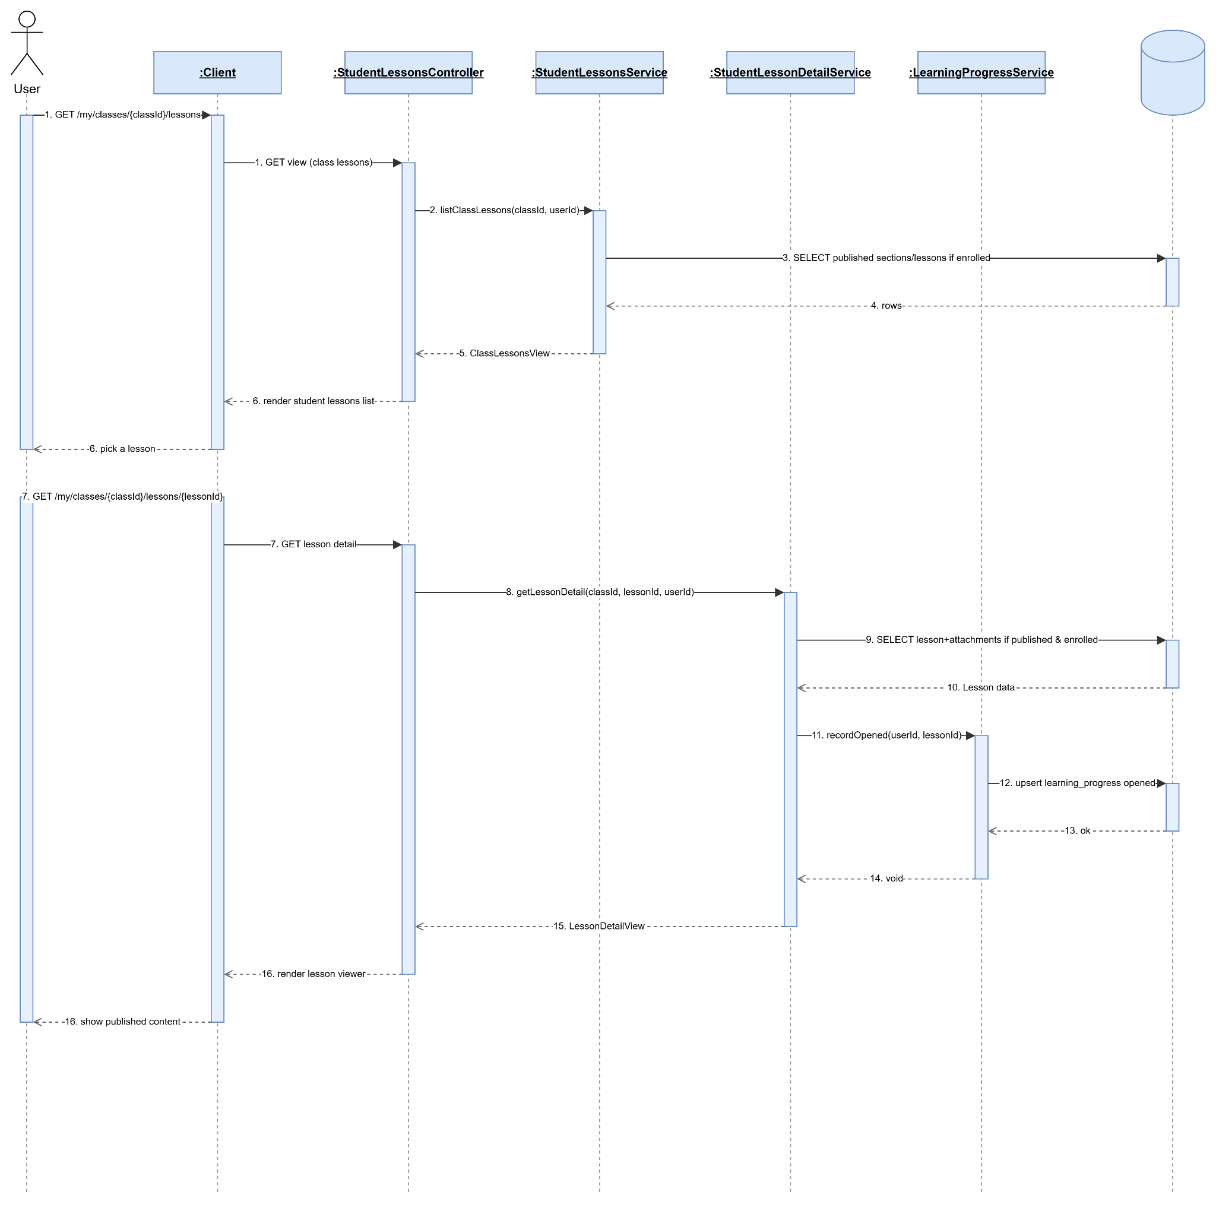

2.5.2 Track Learning Progress
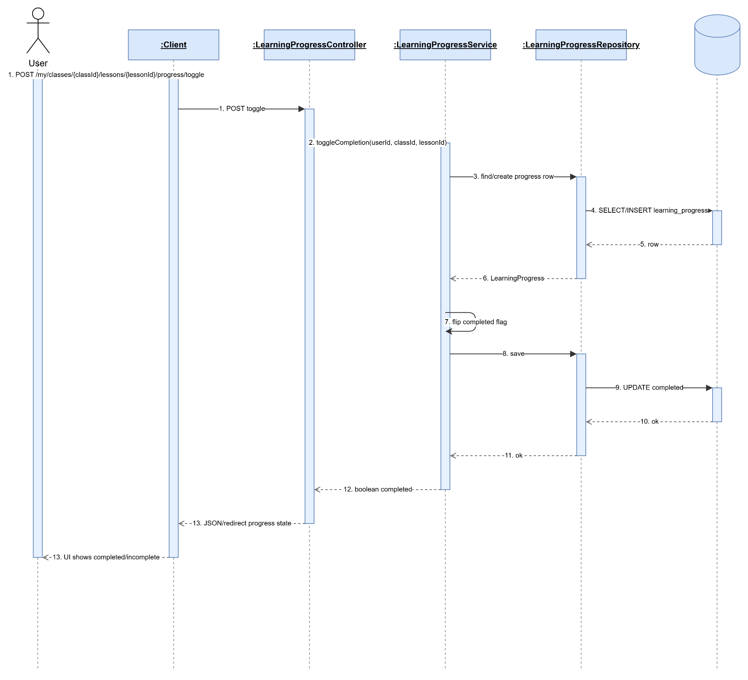

2.5.3 Create Question Lesson
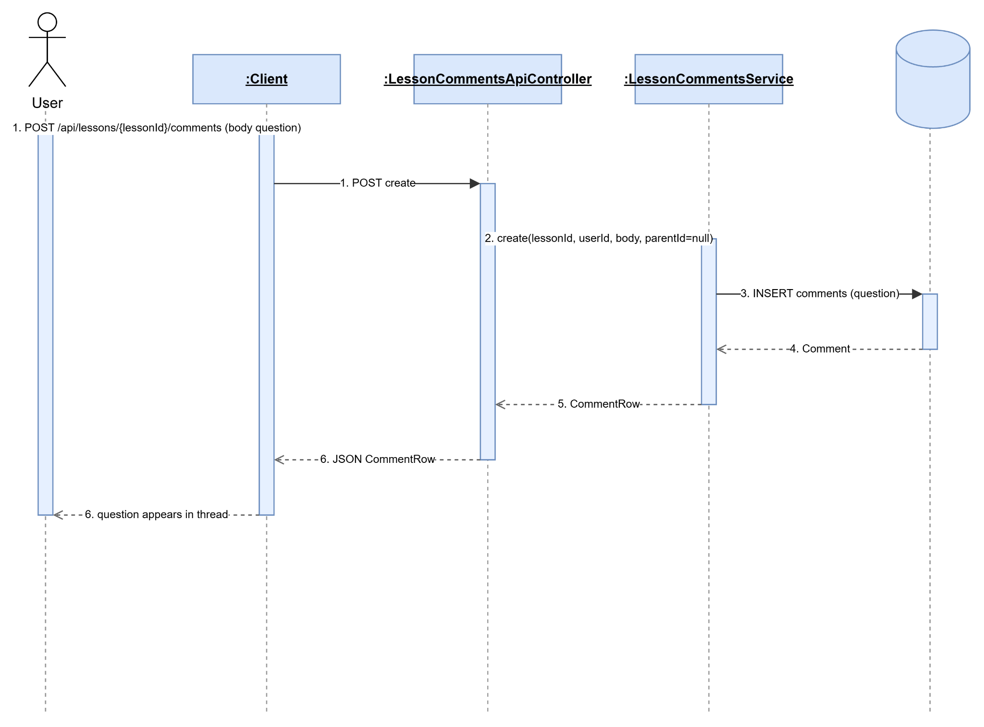

2.5.4 View Lesson Discussion
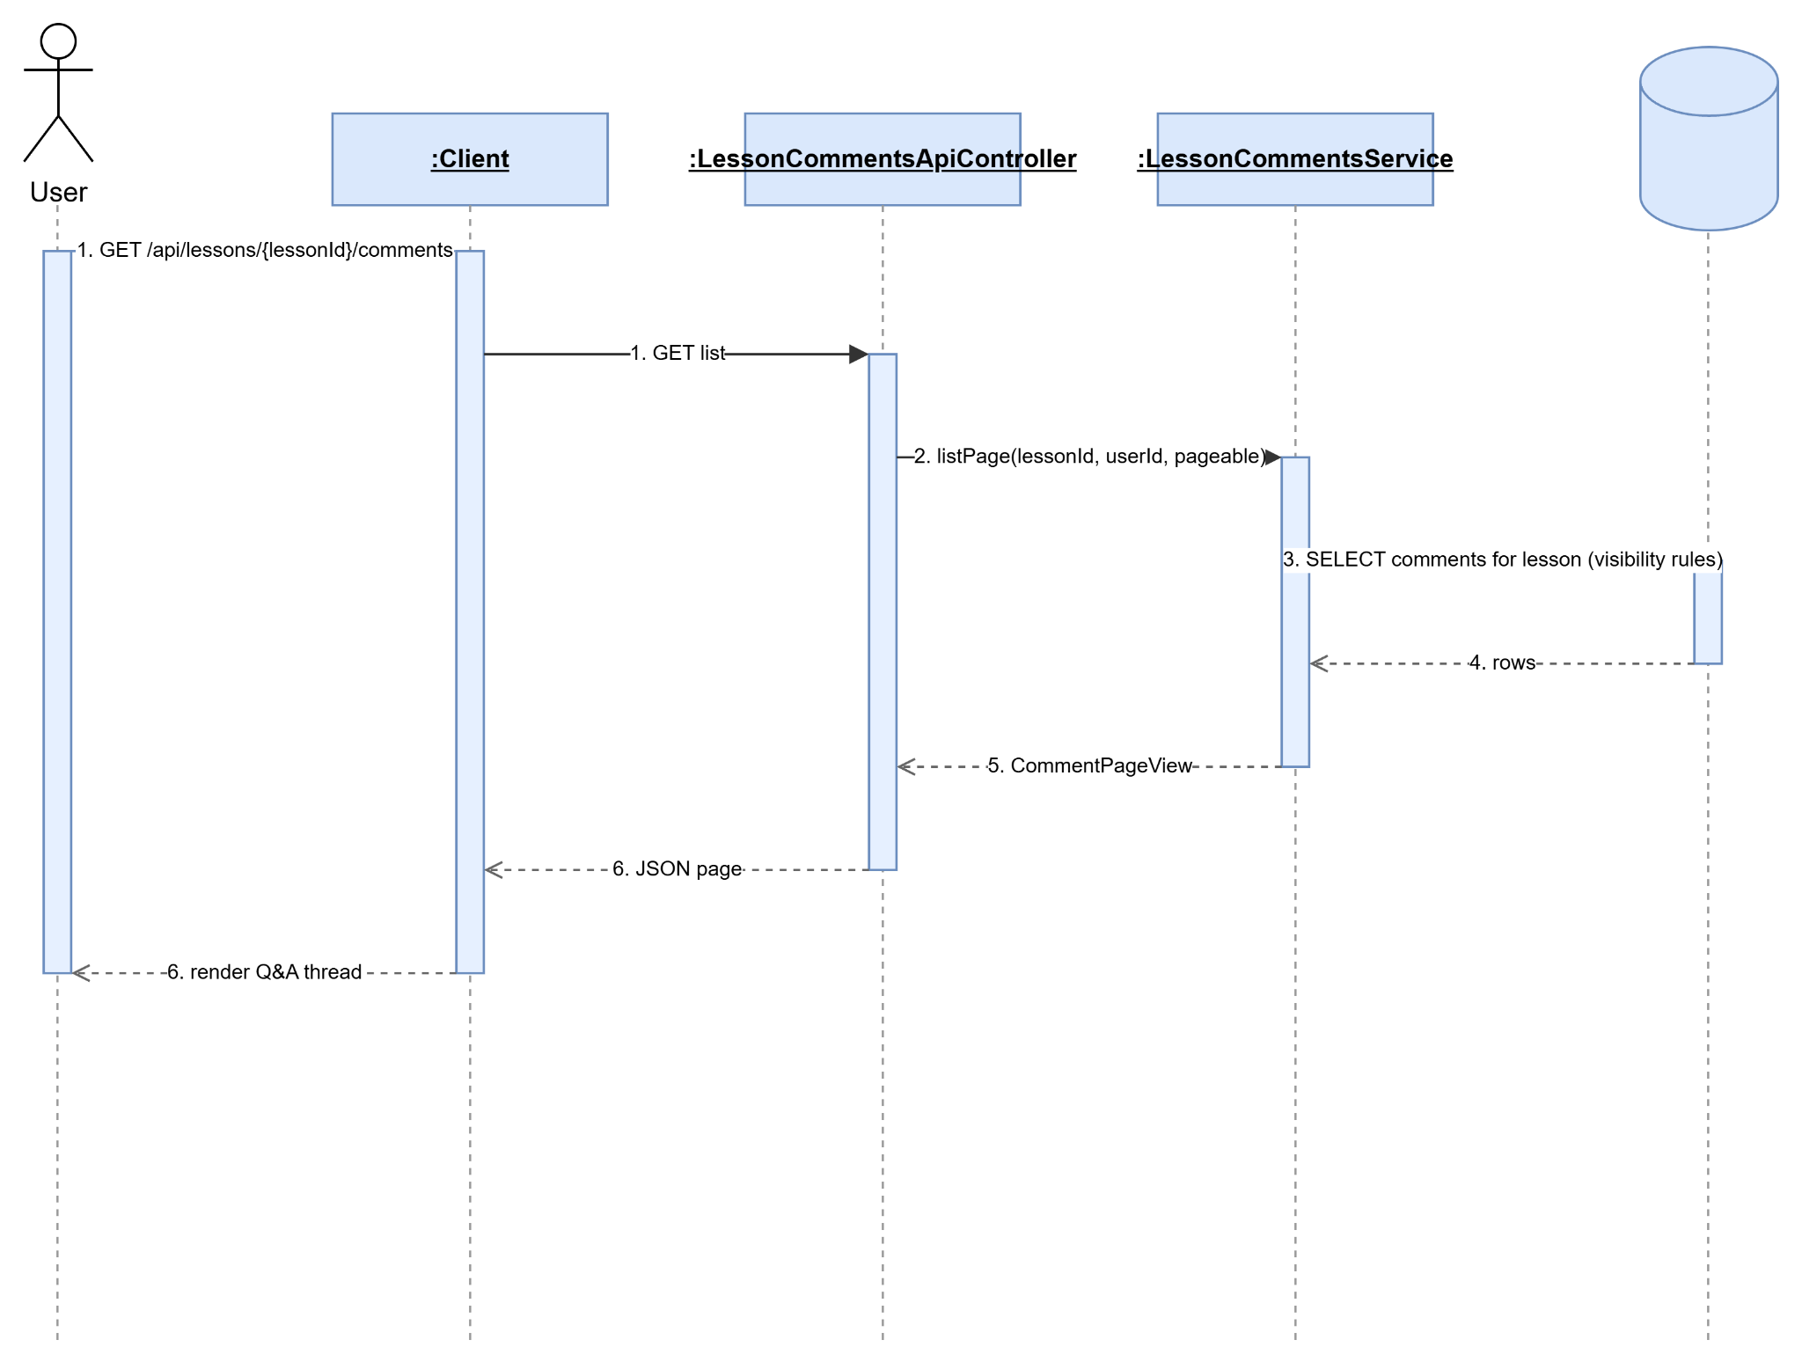

2.5.5 Create Lesson Reply
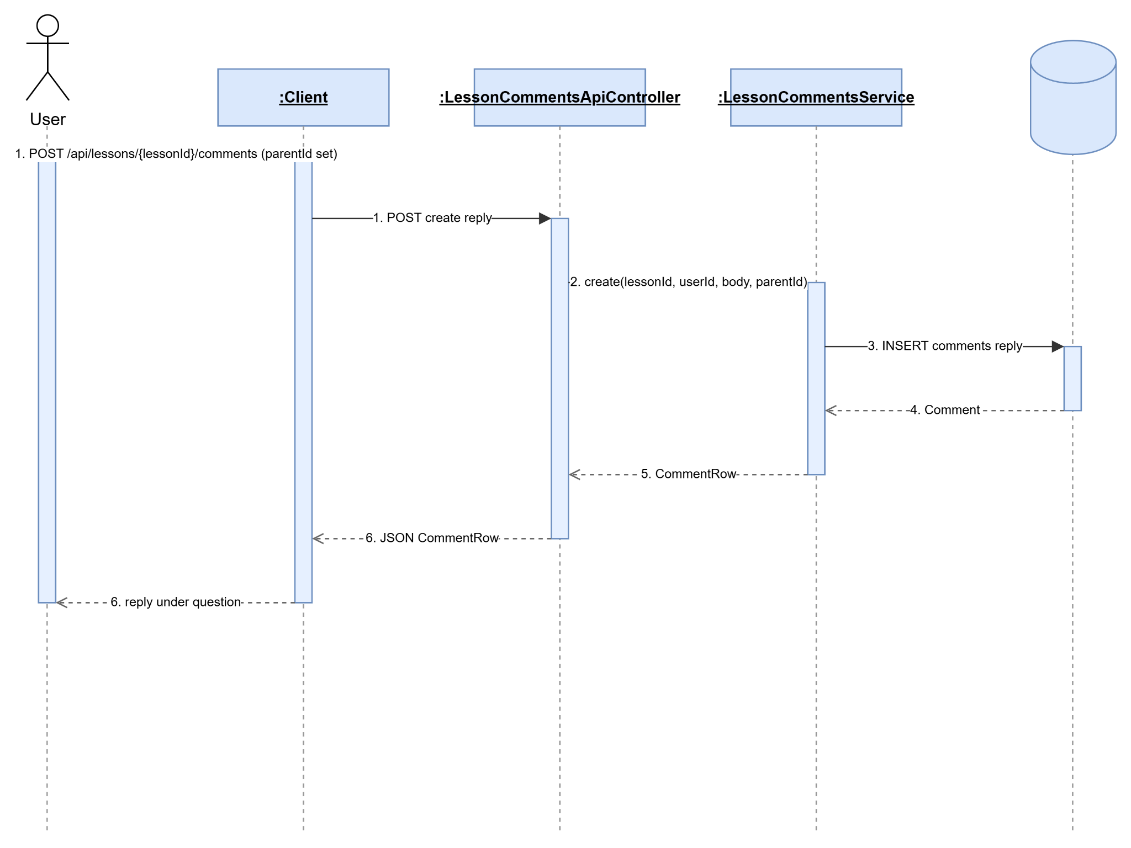

2.5.6 Update Lesson Comment
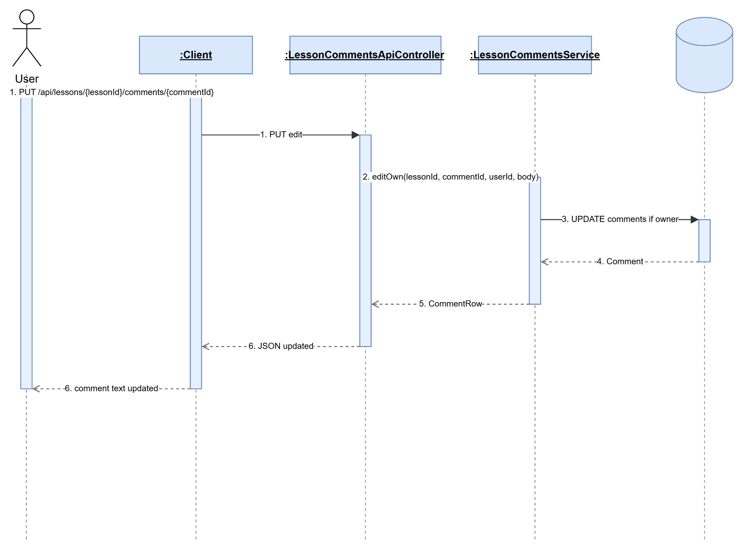

2.5.7 Delete Lesson Comment
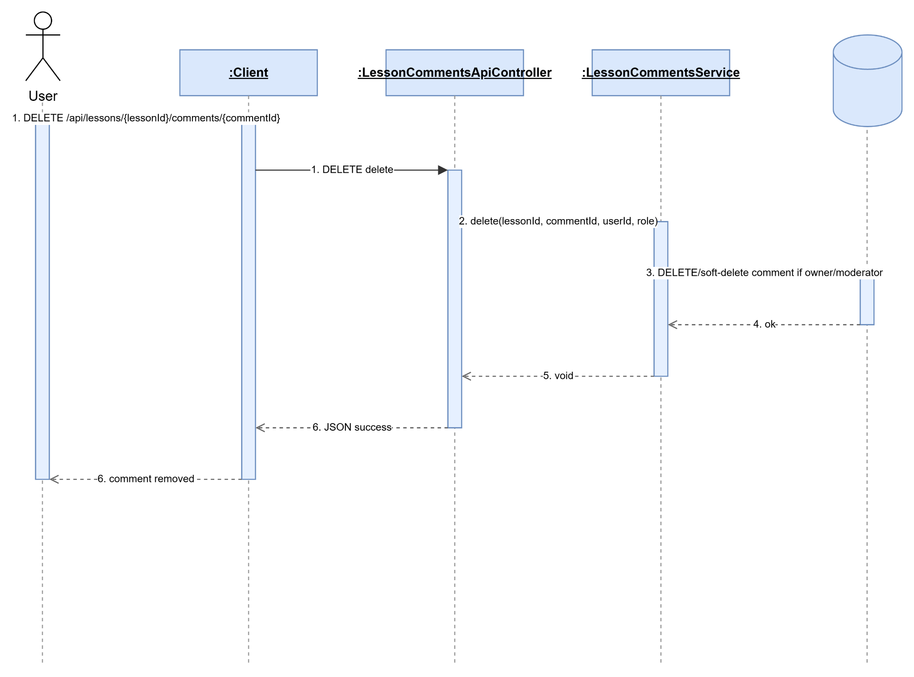

2.6 Manage Test

2.6.1 Create Question
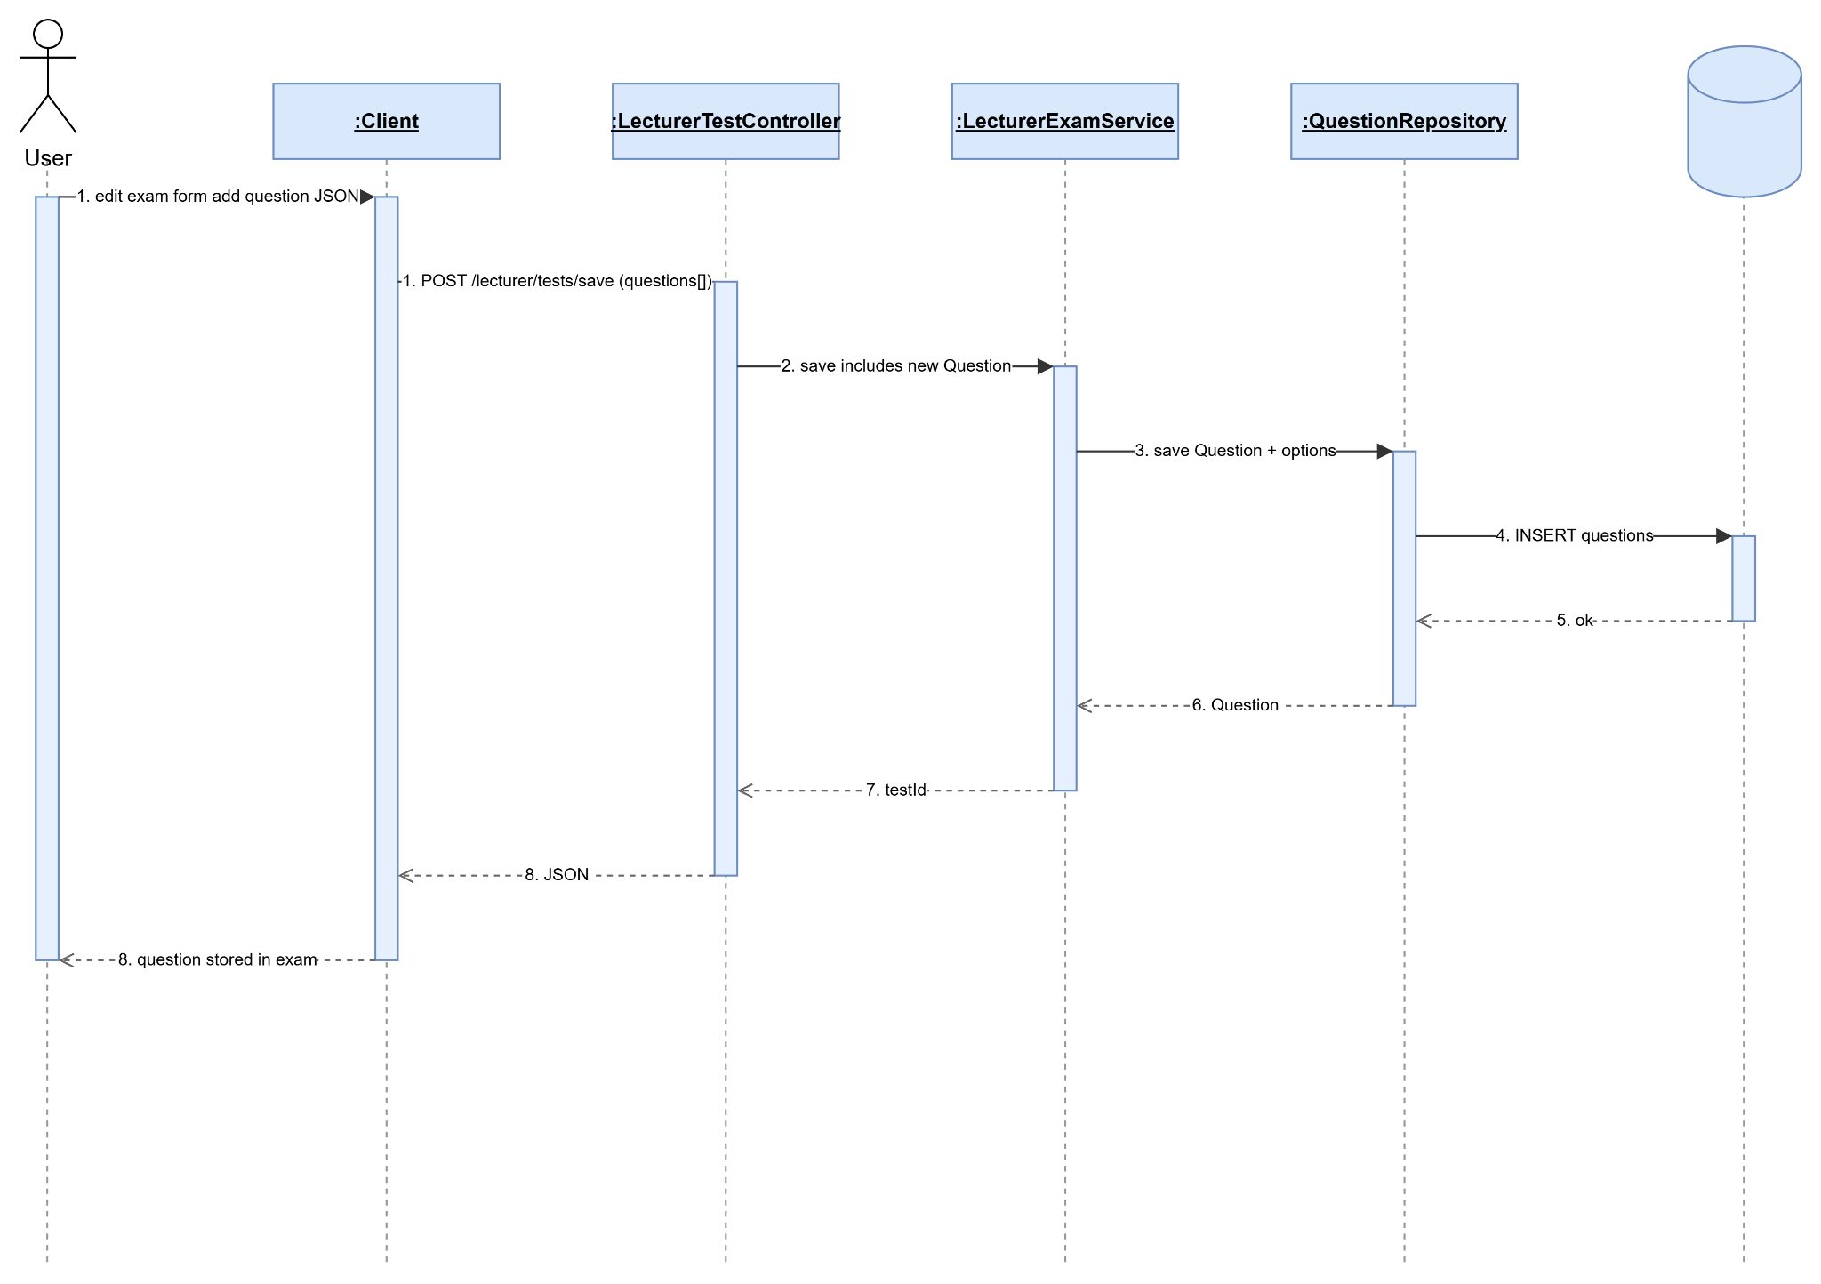

2.6.2 View Question
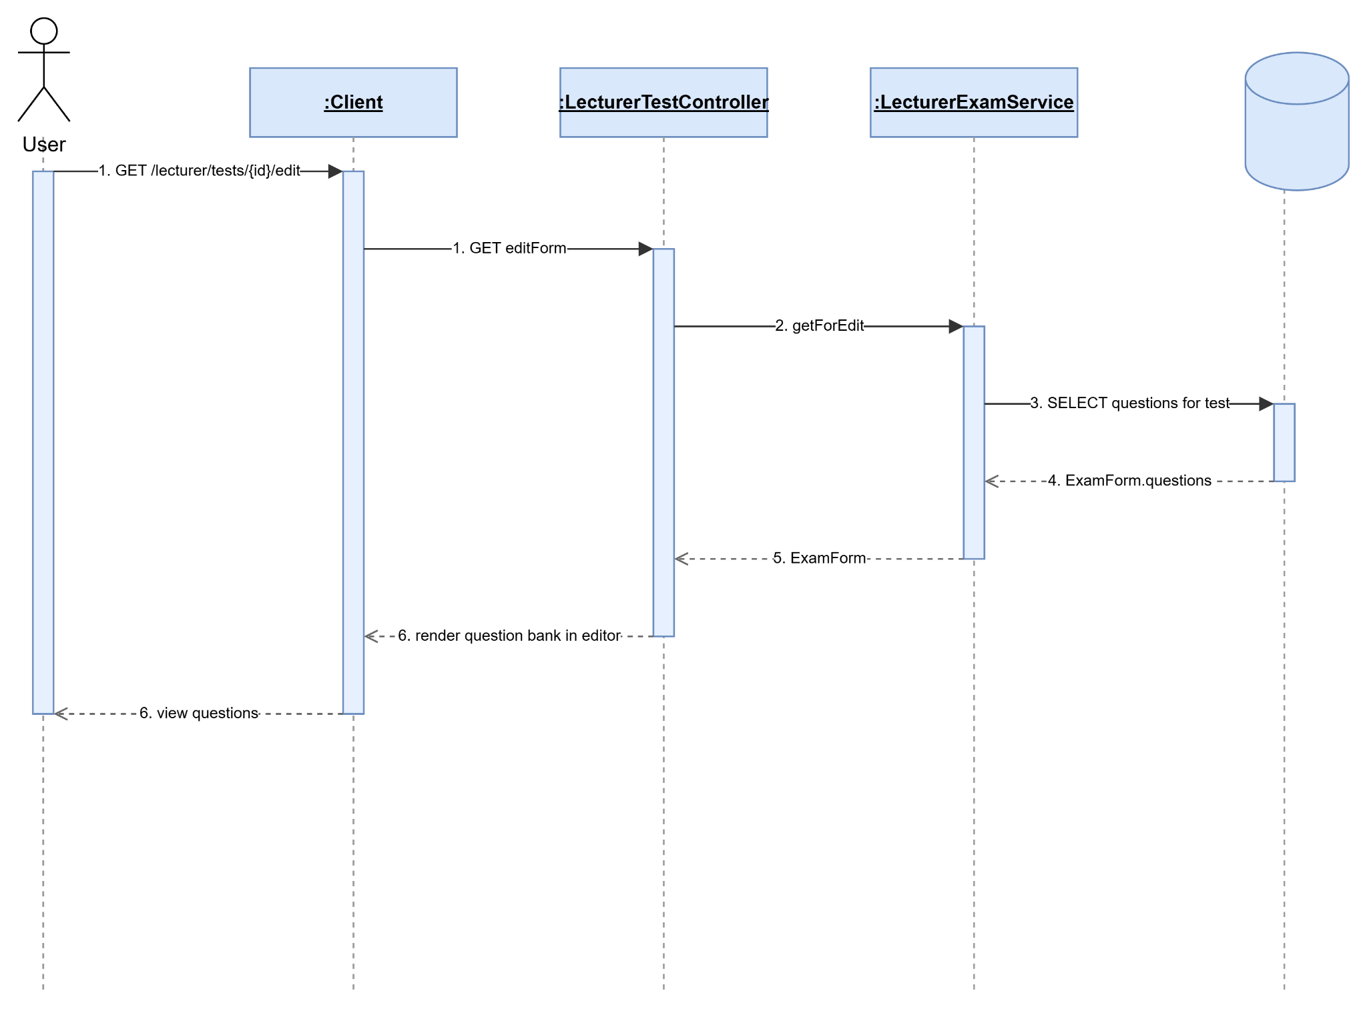

2.6.3 Update Question
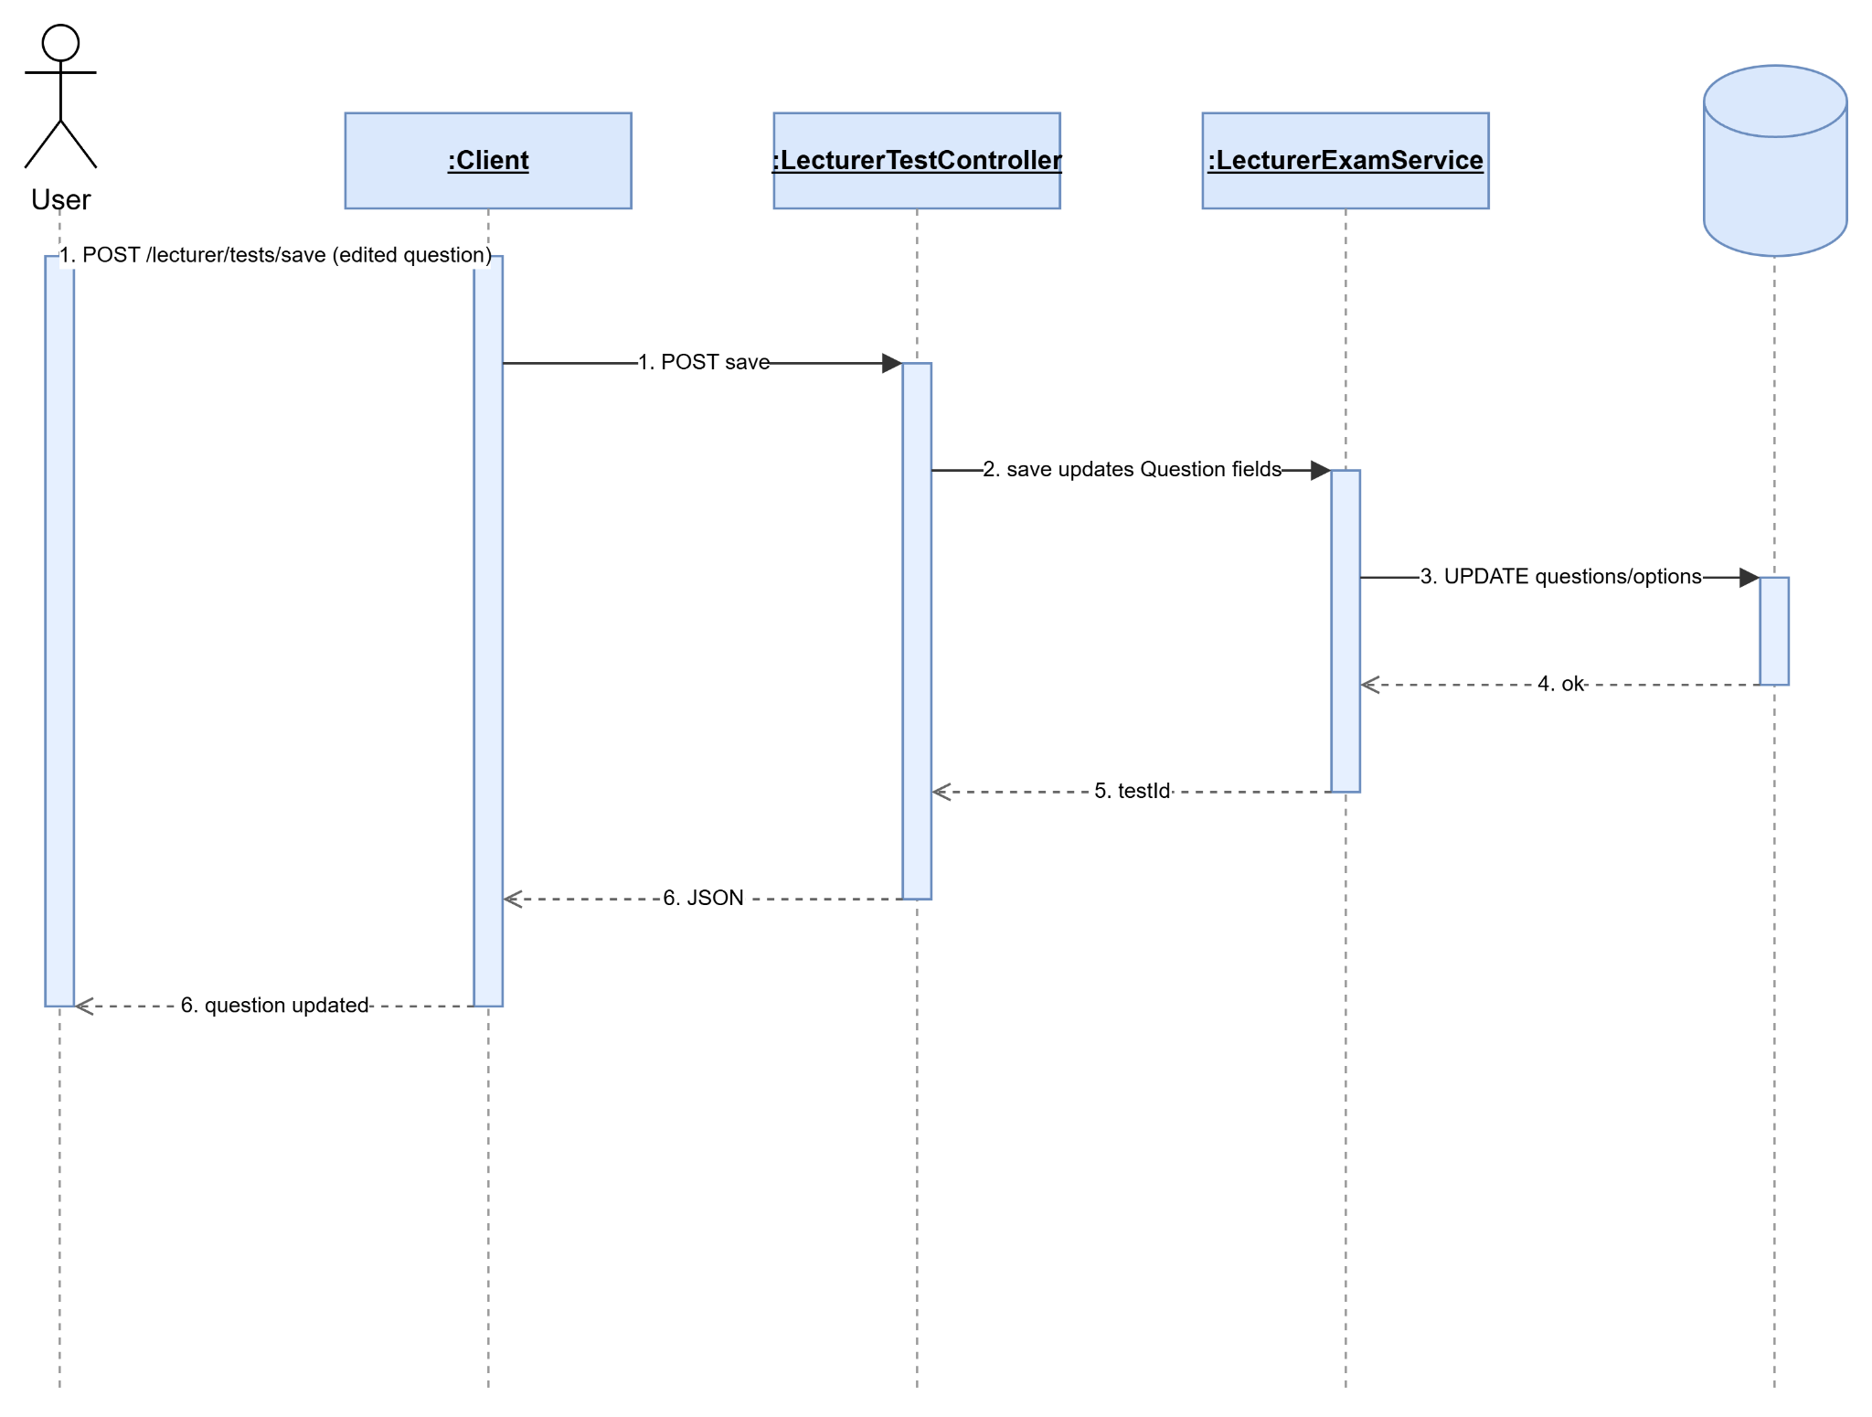

2.6.4 View Test
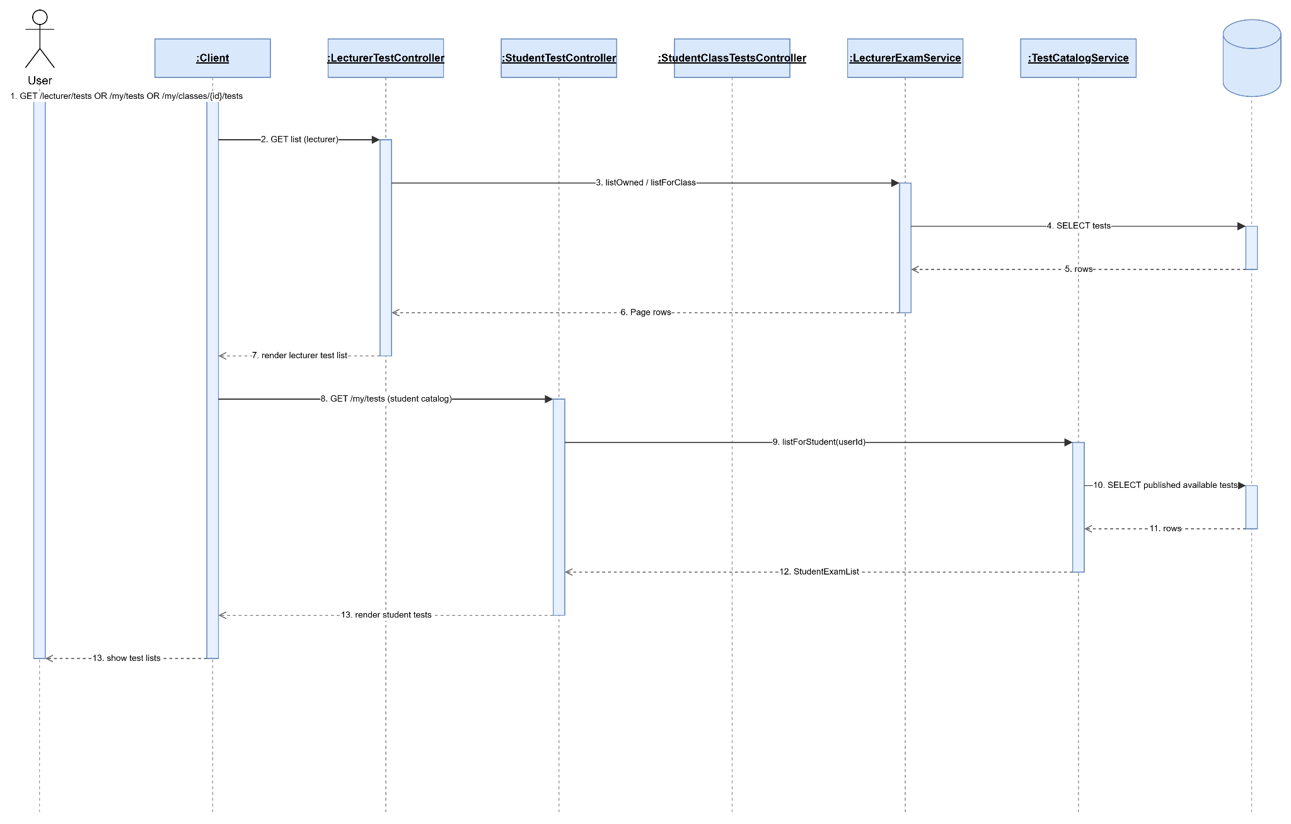

2.6.5 Update Test
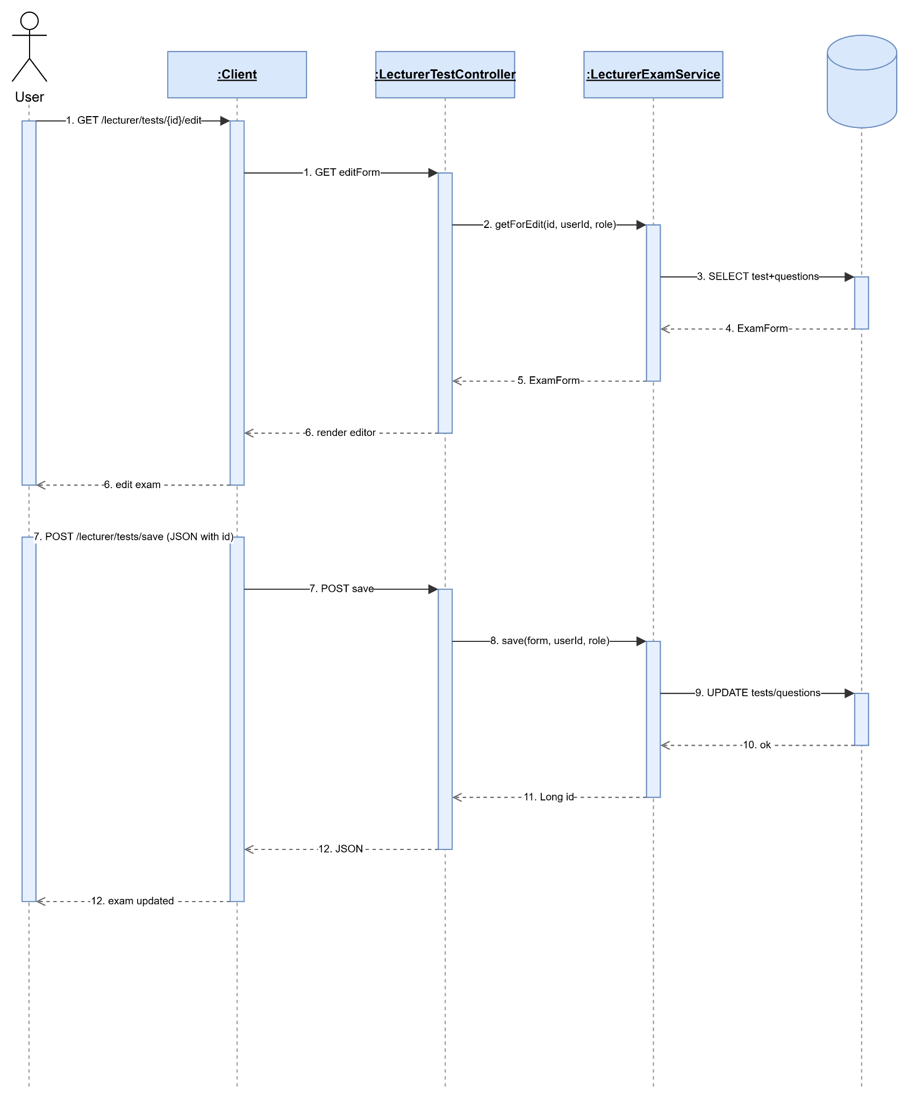

2.6.6 Take Test
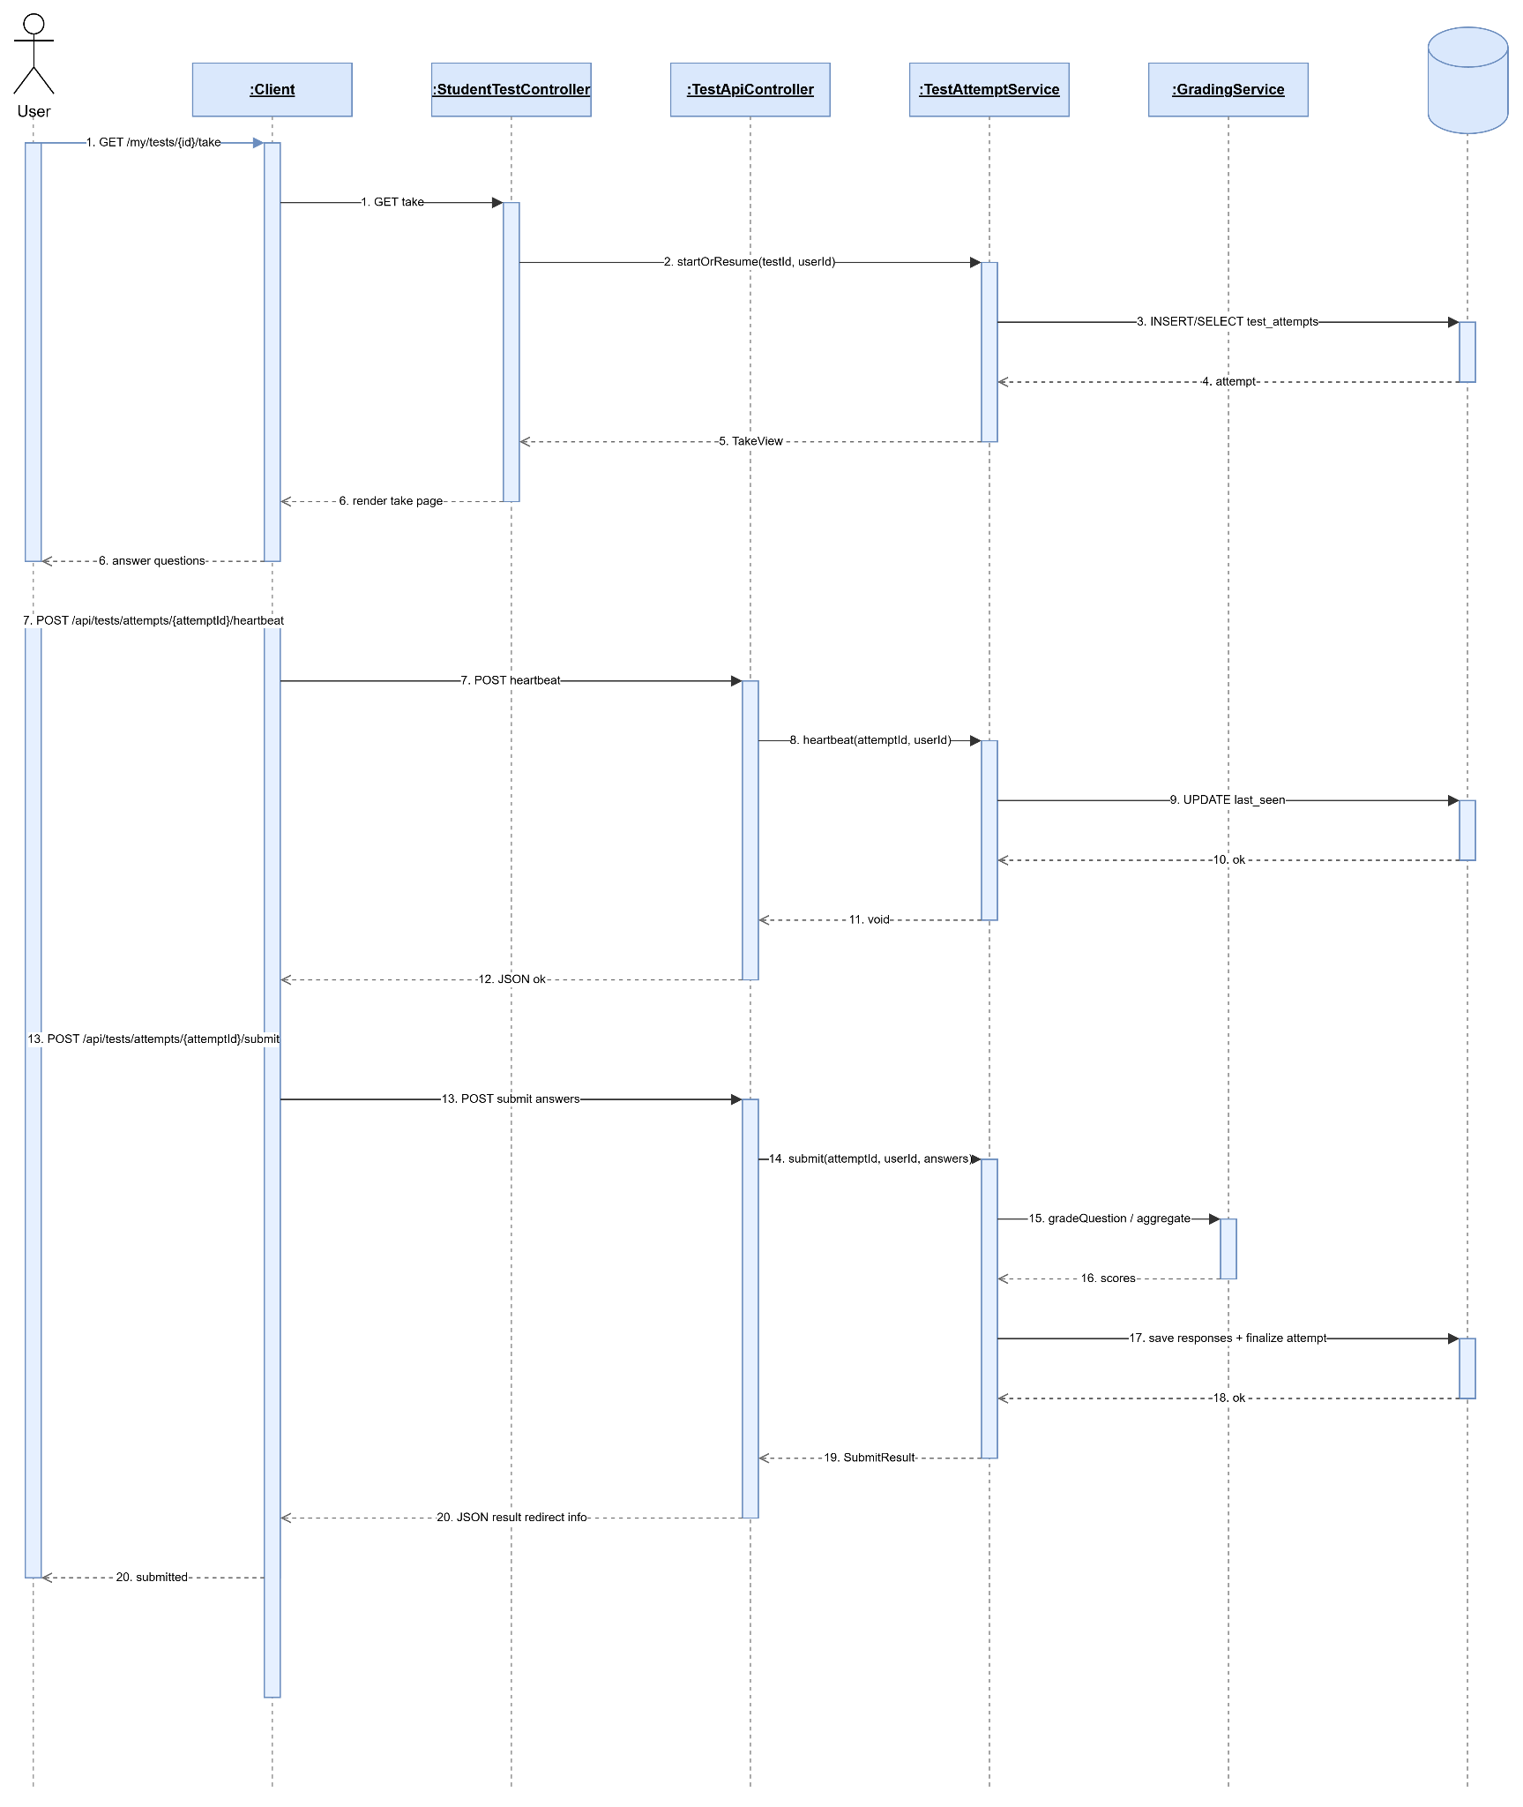

2.6.7 View Test Result
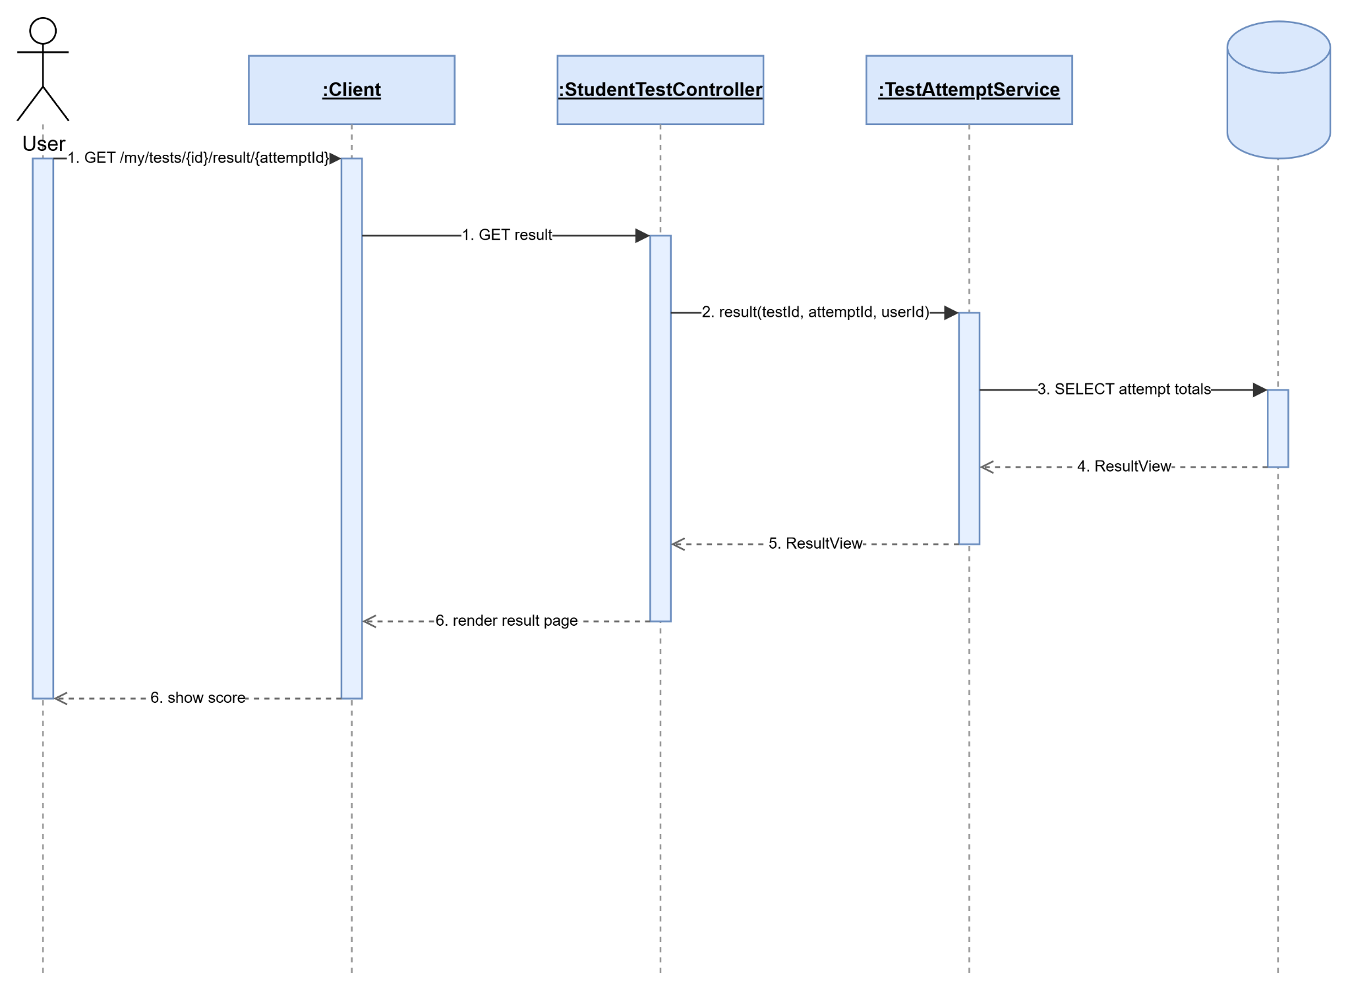

2.6.8 View Test Detail
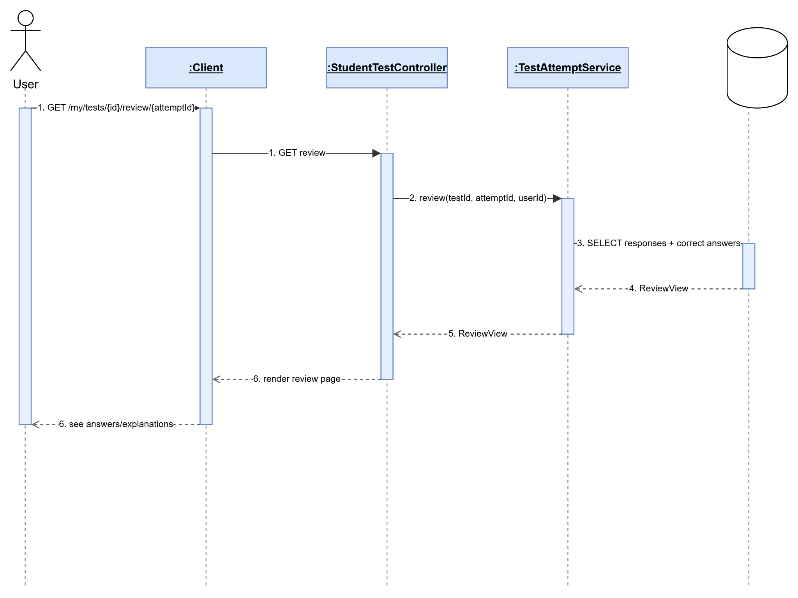

2.6.9 Create Custom Practice Test
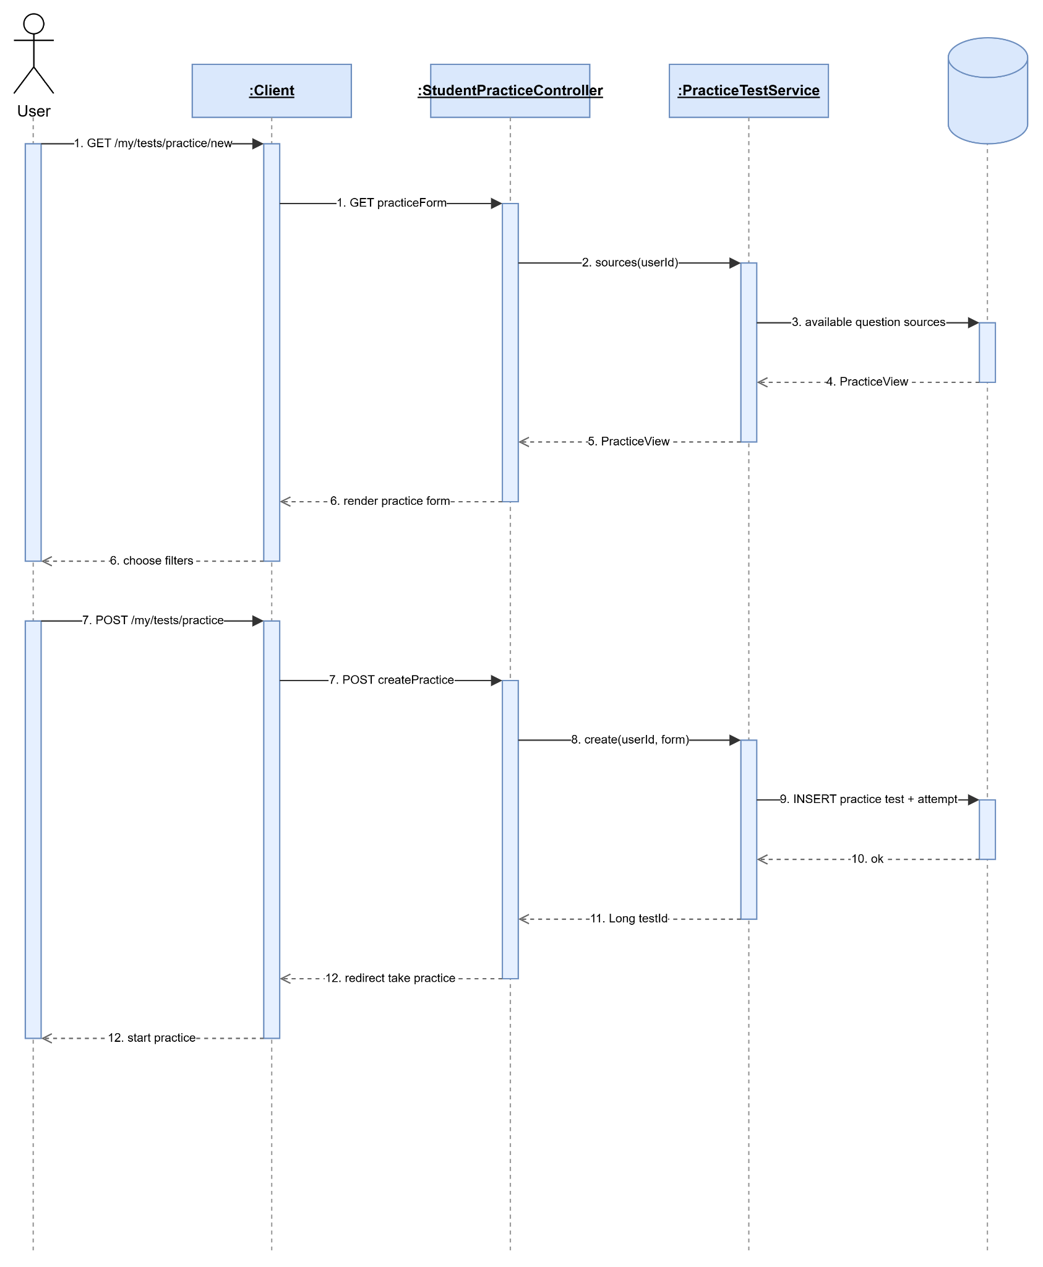

2.6.10 View Exam Readiness Score
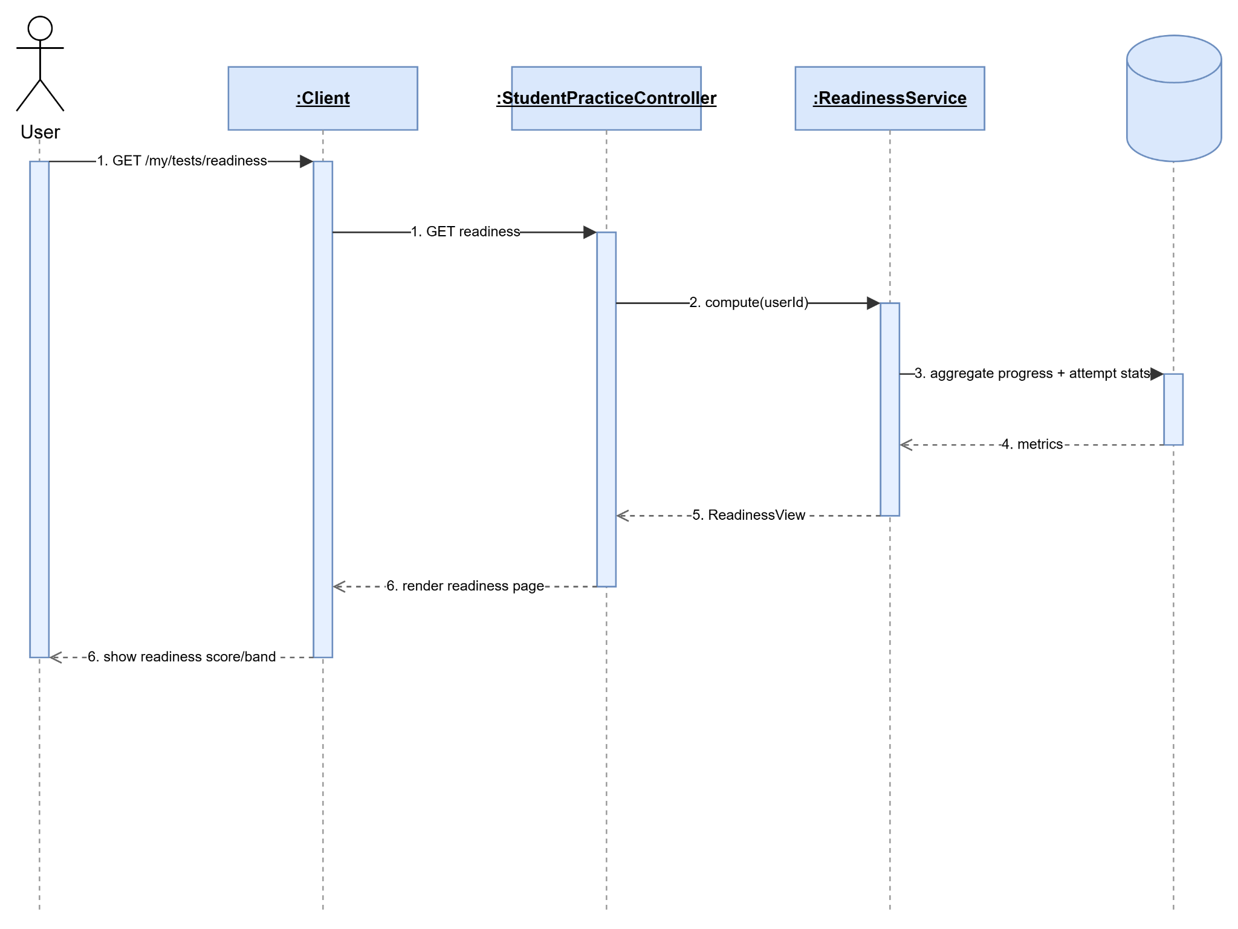

2.6.11 View Student Detail
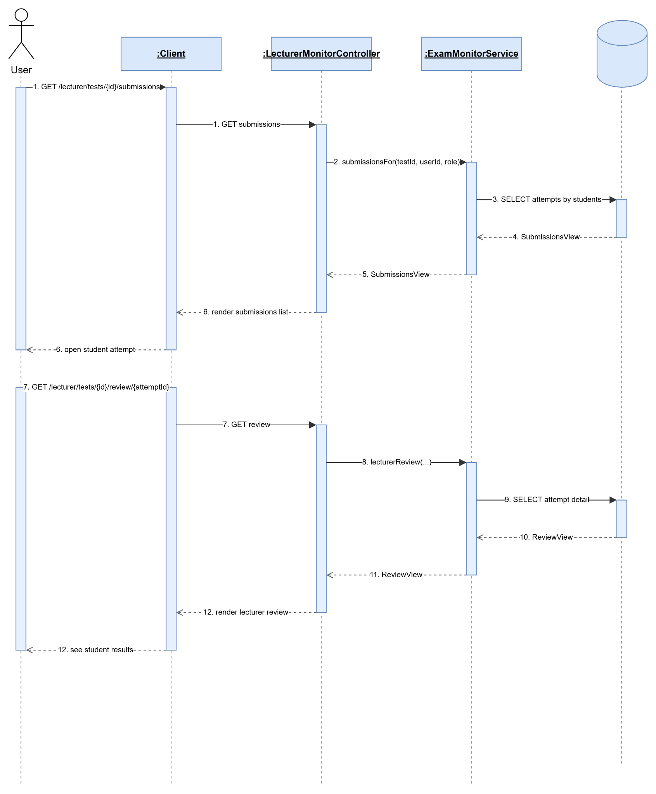

3. Class Specifications

3.1 package_name1
This section provides the detailed specifications for the classes in the package package_name1

3.1.1 ClassName1
[Provide brief description of the class here]
[Provide the class attributes and operations using below table format
No | Name | Description
Attributes
01 | <attributeName1> | Visibility: <attribute’s visibility: private, protected, default…>  Type: <data type of the attribute: int, String...>  Purpose: <description or purpose of the attribute>
02 | <attributeName2> | …
..
Methods/Operations
01 | <methodName1> | Visibility: <operation’s visibility: private, protected, default…>  Return: <void or return type of the operation: int, String,..>  Purpose: <description or purpose of the method>  Parameters: <<list out all the method parameters and provide details (name, data type, purpose/description) of each method parameter here  - paramName1:type1, purpose/description1  - paramName2:type2, purpose/description1  >>
02 | <methodName2> | …
..
]

3.1.1 ClassName2
…

4. Other Design Specifications
[Provide any other design specifications here: data design, system integrations, algorithms, etc.]

…

